THE COUNCIL OF THE CITY OF NEW YORK
RESOLUTION NO. 1836

Resolution approving with modifications the decision of the City Planning Commission on Application No. N 210277 ZRK, for an amendment of the text of the Zoning Resolution (Preconsidered L.U. No. 913).

By Council Members Salamanca and Moya

WHEREAS, Atlantic Brooklyn LLC, filed an application pursuant to Section 201 of the New York City Charter, for an amendment of the Zoning Resolution of the City of New York, modifying Appendix F for the purpose of establishing a Mandatory Inclusionary Housing area and to amend ZR Section 35-663 related to street wall regulations, which in conjunction with the related action action would facilitate the development of a 17-story mixed-use building with 426 dwelling units, and approximately 69,287 square feet of commercial space at 1045 Atlantic Avenue in the Bedford-Stuyvesant neighborhood of Brooklyn, Community District 3 (Application No. N 210277 ZRK) (the “Application”);

WHEREAS, the City Planning Commission filed with the Council on October 18, 2021, its decision dated October 18, 2021 (the “Decision”), on the Application;

WHEREAS, the Application is related to application C 210276 ZMK (Pre. L.U. No. 912), a zoning map amendment to change an M1-1 zoning district to a C6-3A zoning district;

WHEREAS, the Decision is subject to review and action by the Council pursuant to Section 197-d of the City Charter;

WHEREAS, upon due notice, the Council held a public hearing on the Decision and Application on October 25, 2021;

WHEREAS, the Council has considered the land use implications and other policy issues relating to the Decision and Application; and

WHEREAS, the Council has considered the relevant environmental issues, including the Negative Declaration issued June 21, 2021 (CEQR No. 21DCP168K), which includes an (E) designation to avoid the potential for significant adverse impacts related to hazardous materials and noise (the “E” Designation (E-550));

RESOLVED:

The Council finds that the action described herein will have no significant impact on the environment as set forth in the (E) Designation (E-550).

Pursuant to Sections 197-d and 200 of the City Charter and on the basis of the Decision and Application, and based on the environmental determination and consideration described in the report, N 210277 ZRK, incorporated by reference herein, and the record before the Council, the Council approves the Decision of the City Planning Commission with the following modifications:

Matter underlined is new, to be added;
Matter struck out is to be deleted;
Matter within # # is defined in Section 12-10;
* * * indicates where unchanged text appears in the Zoning Resolution
Matter double struck out is old, deleted by the City Council;
Matter double-underlined is new, added by the City Council

* * *

ARTICLE III

COMMERCIAL DISTRICT REGULATIONS

* * *

Chapter 5
Bulk Regulations for Mixed Buildings in Commercial Districts

* * *

35-66
Special Height and Setback Provisions for Certain Areas

* * *
35-663
Special height and setback provisions in C6-3A Districts along Atlantic Avenue within Community District 3, Borough of Brooklyn

In C6-3A Districts in Community District 3, in the Borough of Brooklyn, for a #zoning lot# with frontage along Atlantic Avenue, the #street wall# provisions of paragraph (a) of Section 35-651 shall apply along the Atlantic Avenue #street# frontage, and shall also apply along #street# frontages intersecting Atlantic Avenue, within 50 feet of the intersection.

* * *

APPENDIX F
Inclusionary Housing Designated Areas and Mandatory Inclusionary Housing Areas

* * *

Brooklyn

* * *

Brooklyn Community District 3
* * *
Map 7. [date of adoption]

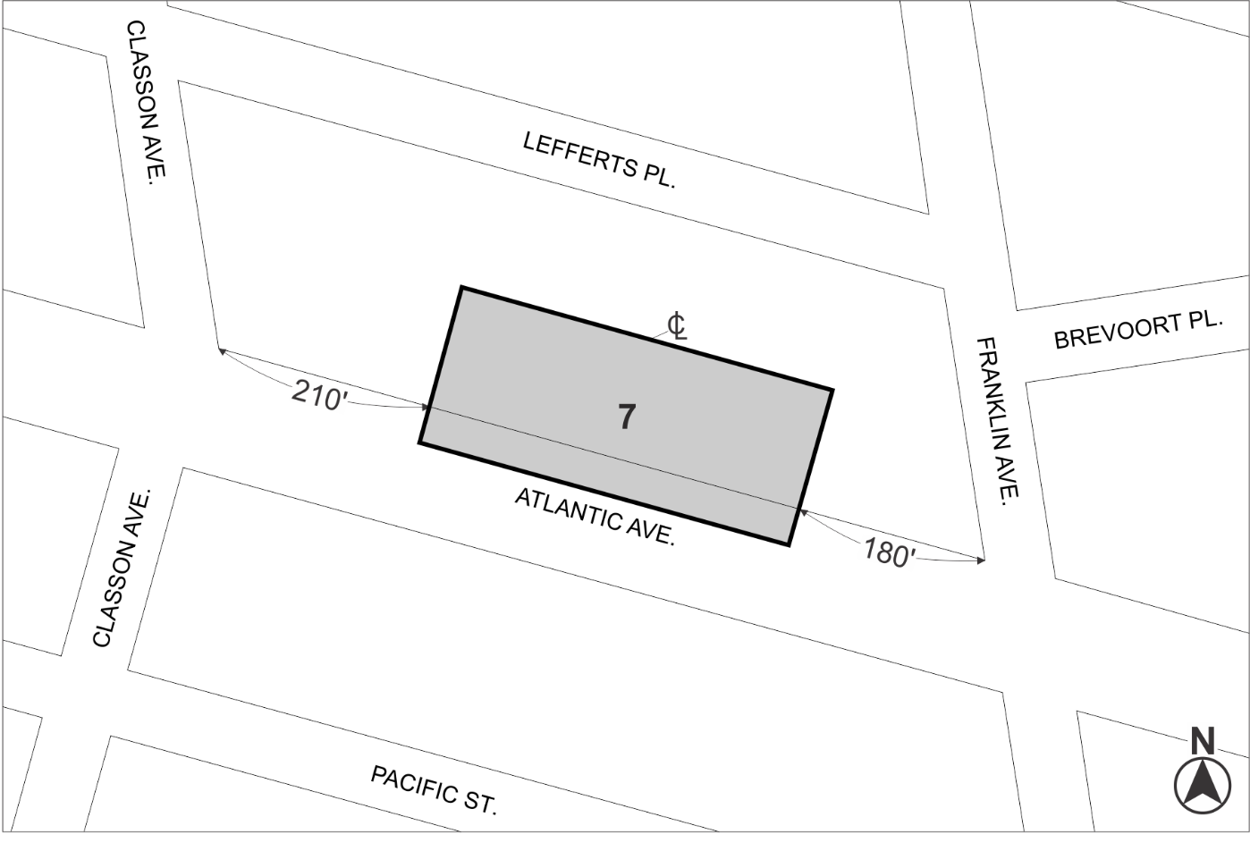

Mandatory Inclusionary Housing area (see Section 23-154(d)(3))
Area 7 — [date of adoption] MIH Program Option 2 and Workforce
Portion of Community District 3, Brooklyn

* * *

Adopted.

Office of the City Clerk, }
The City of New York, } ss.:

I hereby certify that the foregoing is a true copy of a Resolution passed by The Council of The City of New York on ________, 2021, on file in this office.

.....................................................
City Clerk, Clerk of The Council

