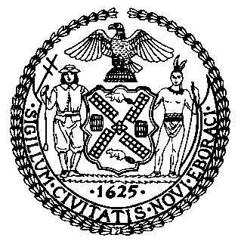 | The Council of the City of New York  Finance Division  Preston niblack, Director  jeffrey rodus, first deputy director  Fiscal Impact Statement  Intro. No: 1134-A  Committees: Health
Title: A Local Law to amend the administrative code of the City of New York, in relation to the creation of a Food Service Establishment Advisory Board. | Sponsor(S): Council Members Koo, Arroyo, Gentile, Gonzalez, Greenfield, Koslowitz, Palma, Rose, Vacca, Vallone, Rodriguez, Eugene, Van Bramer and Bramer.
Summary of Legislation: The Department of Health and Mental Hygiene shall create an advisory board to advise to DOHMH on the effect of the inspection program on restaurants, food safety and public health.

The Board would be comprised of ten mayoral appointees and nine Council appointees, with the DOHMH Commissioner to serve ex officio. The Board would meet quarterly, and the agenda for its first four meetings would include the following topics: appropriate point values for violations; inspector training curriculum; the relationship between DOHMH and restaurants; and the impact of letter grading on health and safety, including a discussion of any changes in food-borne illness rates.
Finally, the Board would be required to submit an annual report to the Mayor and the Council on the impact of letter grading on health and safety, including food-borne illness rates, and the Board’s specific recommendations for improvements to the inspection process.

Effective Date: Ninety days after its enactment into law.
Fiscal Year In Which Full Fiscal Impact Anticipated: Fiscal 2015
Fiscal Impact Statement:

 | Effective FY14 | FY Succeeding  Effective FY15 | Full Fiscal  Impact FY14
Revenues | $0 | $0 | $0
Expenditures | $0 | $0 | $0
Net | $0 | $0 | $0

Impact on Revenues: N/A

Expenditures: The Department of Health and Mental Hygiene can use existing resources to comply with this local law resulting in minimal to no impact on expenditures from the enactment of this legislation.
Source of Funds To Cover Estimated Costs:
Source of Information: New York City Council Finance Division
Estimate Prepared By: Crilhien R. Francisco, Legislative Financial Analyst

Estimate Reviewed By: Latonia McKinney, Deputy Director
Tanisha Edwards, Finance Counsel
Legislative History: Introduced as Intro.1134 on August 22th, 2013 and referred to the Committee on Health. A hearing was held on August 23, 2013 and the bill was laid over by the Health Committee on August 23, 2013. Intro. 1134 has been amended, and the amended version, Proposed Int. 1134-A, will be considered by the Health Committee on October7th, 2013.
Date Submitted To Council: October 9th, 2013

