THE COUNCIL OF THE CITY OF NEW YORK
RESOLUTION NO. 857

Resolution approving the decision of the City Planning Commission on Application No. N 190103 ZRX, for an amendment of the text of the Zoning Resolution (L.U. No. 383).

By Council Members Salamanca and Moya

WHEREAS, the City Planning Commission filed with the Council on March 15, 2019 its decision dated March 13, 2019 (the "Decision"), on the application submitted by Azimuth Development Group, LLC, pursuant to Section 201 of the New York City Charter, for an amendment of the text of the Zoning Resolution of the City of New York, modifying Appendix F for the purpose of establishing a Mandatory Inclusionary Housing Area utilizing Option 1, which in conjunction with the related actions would facilitate a mixed-use development of two buildings to include 65 affordable homeownership units, 265 rental units, 18,032 square feet of retail, and 159 parking spaces in the Unionport neighborhood of Bronx Community District 9, (Application No. N 190103 ZRX), (the "Application");

WHEREAS, the Application is related to application C 190102 ZMX (L.U. No. 382), a zoning map amendment to change an R5 zoning district to an R7A/C2-4 district;

WHEREAS, the Decision is subject to review and action by the Council pursuant to Section 197-d(b)(1) of the City Charter;
WHEREAS, upon due notice, the Council held a public hearing on the Decision and Application on April 2, 2019;

WHEREAS, the Council has considered the land use implications and other policy issues relating to the Decision and Application; and

WHEREAS, the Council has considered the relevant environmental issues, including the negative declaration issued January 7th, 2019 (CEQR No. 19DCP082X) which include an (E) designation to avoid the potential for significant adverse impacts related to hazardous materials, air quality, and noise (the “E” Designation (E-515)).

RESOLVED:

The Council finds that the action described herein will have no significant impact on the environment as set forth in the (E) Designation (E-515) and Negative Declaration.

Pursuant to Sections 197-d and 200 of the City Charter and on the basis of the Decision and Application, and based on the environmental determination and consideration described in the report, N 190103 ZRX, incorporated by reference herein, and the record before the Council, the Council approves the Decision of the City Planning Commission.

Matter underlined is new, to be added;
Matter struck out is to be deleted;
Matter with # # is defined in Section 12-10;
*** indicates where unchanged text appears in the Zoning Resolution.

* * *

APPENDIX F
Inclusionary Housing Designated Areas and Mandatory Inclusionary Housing Areas

* * *

The Bronx

* * *

The Bronx Community District 9

* * *

Map 5 – [Date of Adoption]

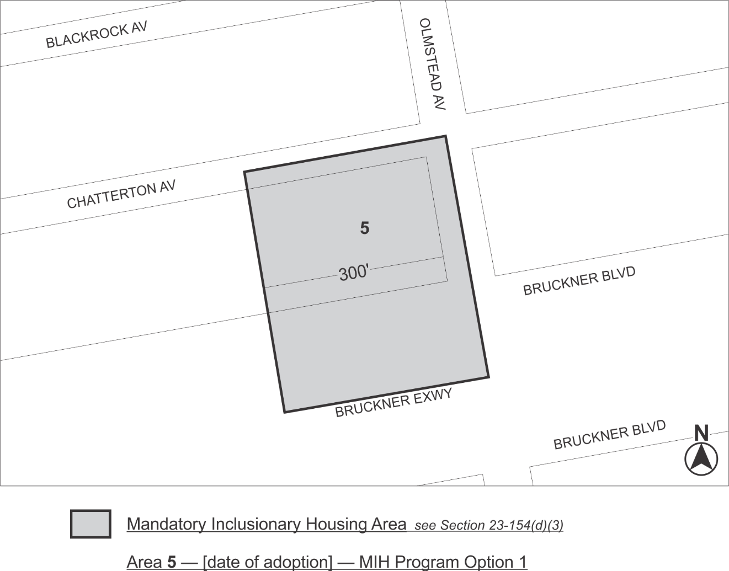

Portion of Community District 9, The Bronx

* * *

Adopted.

Office of the City Clerk, }
The City of New York, } ss.:

I hereby certify that the foregoing is a true copy of a Resolution passed by The Council of The City of New York on April 18, 2019, on file in this office.

.....……......................................... City Clerk, Clerk of The Council

