Civil Service & Labor Committee Staff
Bianca Vitale, Legislative Counsel
Elizabeth Arzt, Policy Analyst
Nevin Singh, Financial Analyst

THE COUNCIL

briefing paper OF THE HUMAN SERVICES DIVISION
Jeffrey Baker, Legislative Director
Andrea Vazquez, Deputy Director

COMMITTEE ON CIVIL SERVICE & LABOR
Hon. I. Daneek Miller, Chair

October 28, 2021

Oversight: Changes to Municipal Retirees’ Healthcare Plan

- Introduction
On October 28, 2021, the Committee on Civil Service and Labor, chaired by Council Member I. Daneek Miller, will hold an oversight hearing on recent changes to municipal retirees’ healthcare benefits. Witnesses invited to testify include representatives from the Mayor’s Office of Labor Relations (OLR), the Mayor’s Office of Management and Budget (OMB), municipal labor organizations and other interested parties.
- Background
In June of 2018, the administration of Mayor Bill de Blasio (“Administration”) and the Municipal Labor Committee (MLC) reached an agreement to generate employee healthcare cost savings of $1.1 billion over three fiscal years (2019-2021). Under the June 2018 agreement, the Administration and MLC intended to find savings of $200 million in Fiscal Year 2019, $300 million in Fiscal Year 2020, $600 million in Fiscal Year 2021 and $600 million annually for every year thereafter. In an effort to achieve the future annual savings goals of $600 million, the City and the MLC agreed to reform the health insurance program for city retirees and their dependents who are on traditional government-administered Medicare.
Under the new agreement, the City’s 245,000 municipal retirees would automatically be enrolled into a Medicare Advantage plan administered by a private insurer unless they opted out of the new program by October 31, 2021. This new arrangement was scheduled to begin on January 1, 2022. However, the New York State Supreme Court recently issued a decision and order which effectively enjoined the City from enforcing the October 31, 2021 deadline for city retirees to opt-out of the new program. In reaching its decision, the Court found that the City’s implementation of the new Medicare Advantage Plan during the pandemic was irrational and would cause the city’s retirees and their dependents, many of whom are elderly, irreparable harm. The Court observed that much of the program’s terms were still unsettled and that there was little clarity about which health care providers would be accepting the new Medicare Advantage plan.
Pursuant to the Court’s decision and order, the City must retain the status-quo enrollment for retirees and their dependents until the deficiencies with the implementation of the proposed new Medicare Advantage Plan are cured. The Court further directed the City to update the plan and send such changes to the attorney representing the municipal retirees for input before the proposed new plan is submitted to the court for final review and determination.
The 2018 Savings Agreement
In 2018, the City and the MLC committed to a plan to save $1.1 billion over three fiscal years (2019-2021), and $600 million per year thereafter. This agreement has decreased the City budget for retiree health insurance to $2.14 billion for Fiscal 2022. According to the agreement, switching retirees to Medicare Advantage was one of eight possibilities considered by the tripartite task force. The annual savings of $600 million is projected to be achieved by switching the 245,000 municipal retirees to Medicare Advantage plans. That savings will be used to fortify the Health Insurance Stabilization Fund (HISF), a fund jointly controlled by the City and the MLC. The purpose of the HISF, primarily funded by City taxpayers, is to keep the premiums of two different health insurance plans at the same rate, ensuring city employees do not have to pay part of their premium out of pocket.
The pandemic caused budget shortfalls and as a result, the Administration withdrew $1.0 billion of funds set aside in the Retiree Health Benefits Trust (RHBT) to assist in balancing the Fiscal 2020 budget. The administration also planned to use $1.6 billion of RHBT funds to balance the following year’s budget. However, with the disbursement of federal relief funds, the withdrawal was cancelled and the Administration was able to replenish the fund’s balance to $3.8 billion.
- The Switch to Medicare Advantage for Municipal Retirees
On July 14th, 2021, the MLC voted to approve a contract with the OLR to implement the NYC Medicare Advantage Plus Program for City retirees. The agreement stems from the June 2018 Healthcare Savings Agreement which established a Tripartite Labor Management Task Force to study ways to implement health care cost savings. The administration has framed this as a necessary measure, which “will provide new and better benefits for retirees while controlling costs.”
Current Medicare plan v. Medicare Advantage Plan
The City’s most popular plan for Medicare eligible retirees is GHI/Empire Blue Cross Blue Shield Senior Care Plan, with approximately 200,000 members. This is a comprehensive PPO medical plan which is fully insured under a minimum premium arrangement. The City also pays for a supplemental “Medigap” plan for services not covered by traditional Medicare. Retirees who choose to remain enrolled in their current GHI/BCBS Senior Care Plan will be responsible for a monthly premium of $191.57 per person per month as well as $2.83 for the monthly 365-day hospital rider.
The NYC Medicare Advantage Plus Program replaces both the City’s existing Medicare and Medicare supplement plan with a single program that will be administered jointly by Empire BlueCross BlueShield and EmblemHealth.
Medicare Advantage plans are required to provide the same benefits as original Medicare, but may apply different rules, costs, and restrictions. The NYC Medicare Advantage Plus Plan contains new co-pays for retirees, including $15 specialist visits, urgent care visits, diagnostic tests, mental health, substance use disorder and rehabilitation services. However, the plan includes measures that will save retirees money on out-of-pocket costs. The current Senior Care plan has no cap on out-of-pocket costs, while the new NYC Medicare Advantage Plus Plan caps costs at $1,470 annually.
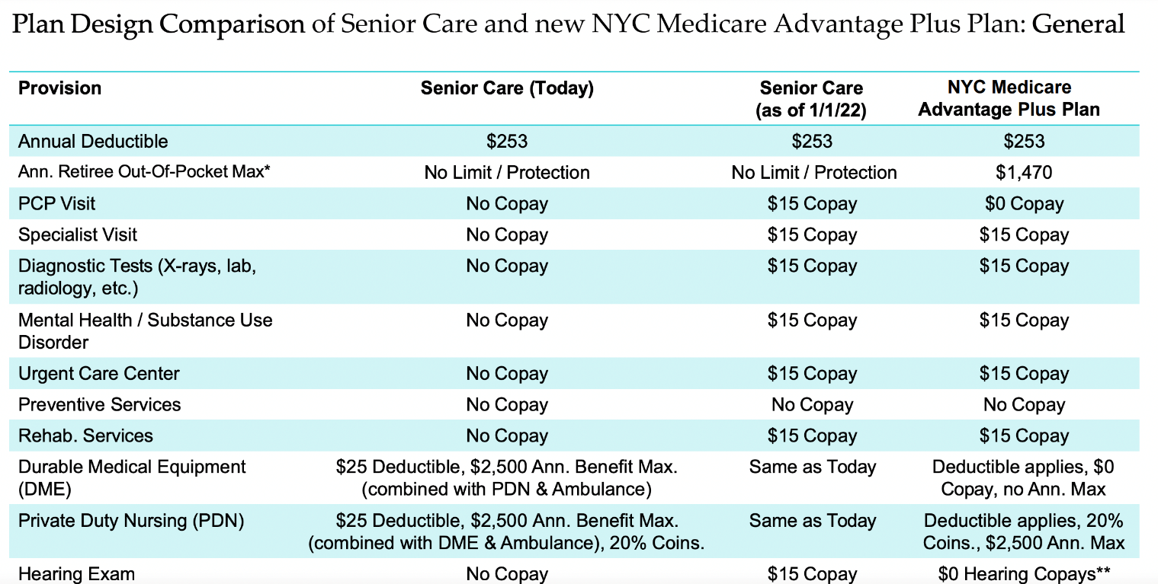New York City Office of Labor Relations, Plan Design Comparison of Senior Care and New NYC Medicare Advantage Plus Plan
The new plan will also bring new cost savings measures for retirees, including no co-insurance for long-term hospital stays up to 365 days and no deductibles or annual limits on ambulance services.
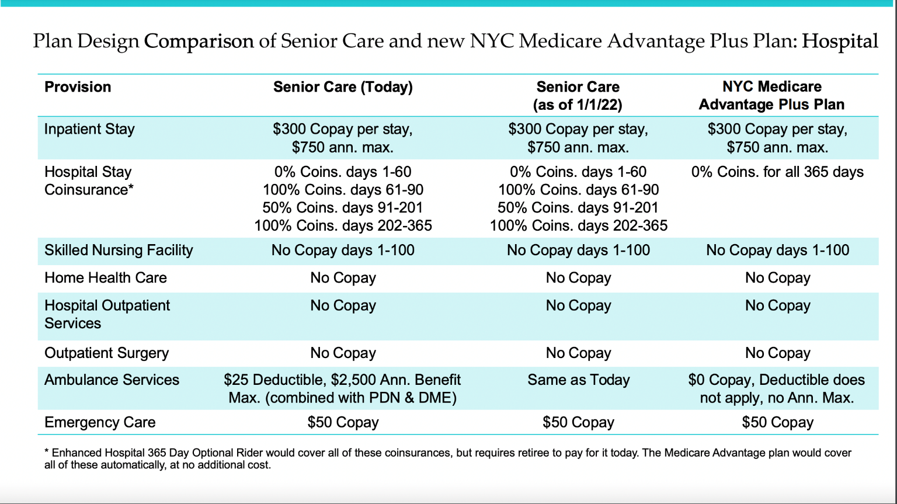New York City Office of Labor Relations, Plan Design Comparison of Senior Care and New NYC Medicare Advantage Plus Plan

Lastly, the new plan adds coverage for transportation costs for 24 one-way trips to doctors offices, home meal delivery for recently released hospital patients, fitness, and telemedicine programs.
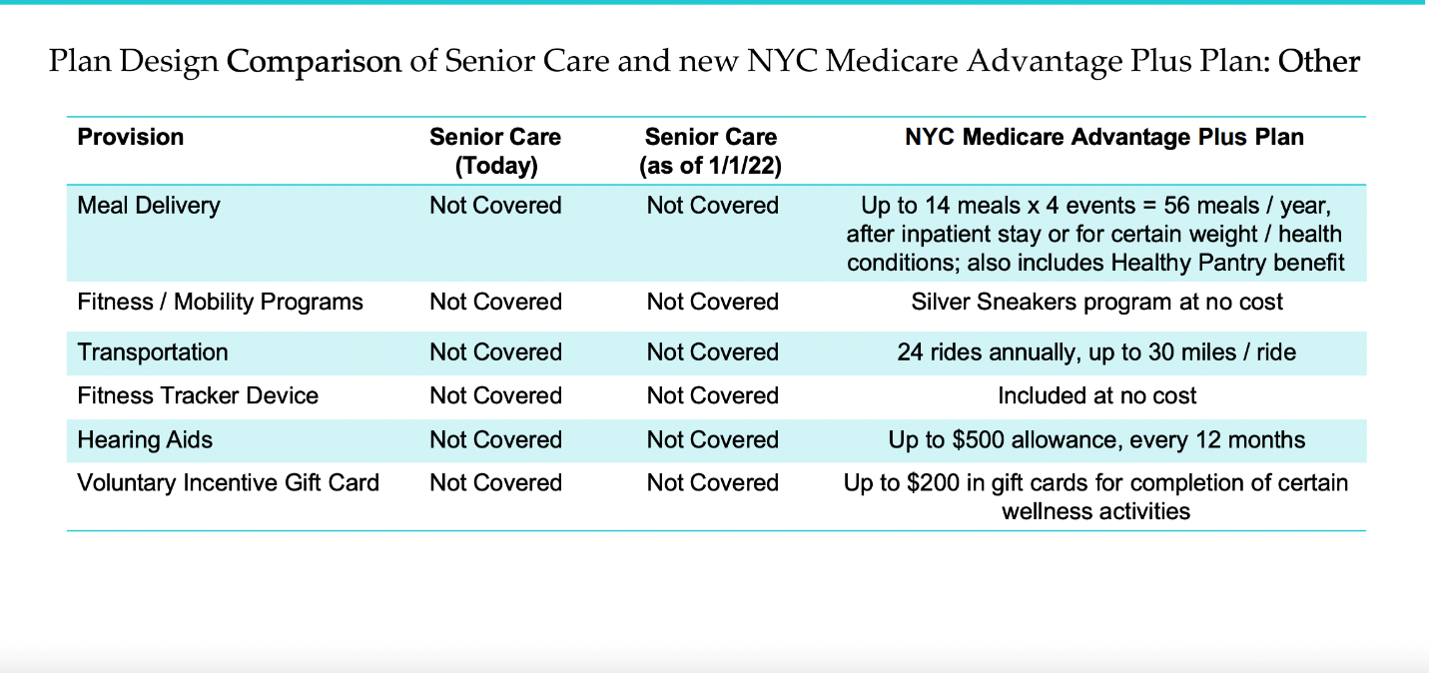New York City Office of Labor Relations, Plan Design Comparison of Senior Care and New NYC Medicare Advantage Plus Plan
Concerns of Municipal Retirees
Some retirees have expressed fears about the quality of care and out-of-pocket costs they will be subjected to under the Medicare Advantage Plus Plan. A major concern for retirees is whether they can keep their current doctors and hospitals on the NYC Medicare Advantage Plus Plan. According to the NYC Medicare Advantage Plus enrollment guide, enrollees can “see any doctor, provider, or specialist who participates in Medicare. Your copay or co-insurance remains the same – whether in or out of the plan’s provider network, your cost share doesn’t change. Your benefits won’t change locally, or nationwide.” Some have expressed skepticism about the City’s ability to keep this promise. Public health experts point out that even though NYC Medicare Advantage Plus is legally required to offer Medicare-equivalent reimbursements, out-of-network doctors aren’t bound to accept any private insurer’s offer as payment in full. They claim, this could result in enrollees facing unreimbursed bills and increasing out of pocket costs for their visits to providers outside of the NYC Medicare Advantage Plus Network.
By contrast, Medicare advantage advocacy coalitions stress the flexibility and value of large group employee plans such as NYC Medicare Advantage Plus, also known as Employer Group Waiver Plans (EGWPs). EGWPs are a public-private waiver utilized by state and local governments, and unions. The Better Medicare Alliance states that EGWPs often have broad provider networks to give coverage to retirees living across the country. Due to the wide geography EGWPs often cover, employer retiree Medicare Advantage plans may provide uniform costs in and out of network. EGWPs may vary cost-sharing by providing higher benefit levels, or modified premiums to beneficiaries in different areas, while delivering the same benefit design nationwide.
Another concern of city retirees is the plan’s requirement that enrollees obtain prior authorization from the insurer before having certain procedures. The NYC Medicare Advantage Plus enrollment guide states that prior authorization is required for the following procedures and services: inpatient hospital admissions, skilled nursing facility, rehabilitation, complex radiology, prosthetics, and transplants. Prior authorization requirements can create hurdles for enrollees and may limit access to care. In 2018, The HHS Office of the Inspector General (OIG) found that Medicare Advantage plans deny care at relatively high rates. The study found that when enrollees and providers appealed prior authorization and payment denials, Medicare Advantage programs overturned 75 percent of their own denials during 2014-16. The high number of overturned denials raised concerns that some Medicare Advantage beneficiaries and providers were initially denied services and payments that should have been provided. The OLR has said that, as is the case with plans for active city employees, some procedures will require preauthorization, which will be handled by the provider when in network.
City Retirees have also accused the OLR and MLC of selecting an insurance provider that supplies diminished benefits without the input of the 245,000 retirees directly affected by this change. The Council of Municipal Retiree Organizations (COMRO) has circulated a petition that has secured over 27,000 signatures claiming a lack of transparency in the decision-making process. OLR has since issued a letter to COMRO, claiming that the committee making the selection was comprised of municipal retirees and future retirees who appreciate the importance of this decision. OLR attempted to reassure the organization that the NYC Medicare Advantage Plus Plan will “provide equal or better coverage.”
- Conclusion
At today’s hearing, the Committee hopes to learn more about the changes to the municipal retirees’ healthcare plan, and what implications these changes will have on the health coverage of municipal retirees.

The Municipal Labor Committee (MLC), is an association of municipal labor organizations dedicated to collectively addressing concerns common to its membership
NYC Office of Labor Relations, Health Benefits Agreement Fiscal Years 2019-2021, available at https://www1.nyc.gov/assets/olr/downloads/pdf/collectivebargaining/health-benefits-agreement-fiscal-years-2019-2021.pdf (accessed Oct 20, 2021)
Health Benefits Agreement Fiscal Years 2019-2021, at para. 5 (June 28, 2018), available at https://www1.nyc.gov/assets/olr/downloads/pdf/collectivebargaining/health-benefits-agreement-fiscal-years-2019-2021.pdf (accessed Oct.15, 2021).
Office of the N.Y.C. Mayor, Mayor De Blasio and Commissioner Rene Campion Announce New and Improved Health Benefits Program, available at https://www1.nyc.gov/office-of-the-mayor/news/497-21/mayor-de-blasio-commissioner-campion-new-improved-health-benefits-program-city (accessed Oct. 15, 2021).
Id.
See NYC Organization of Public Service Retirees v. Campion, New York Supreme Court, Decision and Order of the Hon. Lyle E. Frank, Oct. 21, 2021, available at https://iapps.courts.state.ny.us/fbem/DocumentDisplayServlet?documentId=aHuq24WcFtJbmBTYE4Q50A==&system=prod.
Id. at 3-4.
Id.
Id. at 4.
Id.
Id. at 1
The City of New York Adopted Budget FY’22, Office of Management and Budget available at https://www1.nyc.gov/assets/omb/downloads/pdf/ss6-21.pdf (accessed Oct. 20, 2021)
Health Benefits Agreement Fiscal Years 2019-2021, (June 28, 2018), available at https://www1.nyc.gov/assets/olr/downloads/pdf/collectivebargaining/health-benefits-agreement-fiscal-years-2019-2021.pdf (accessed Oct.15, 2021).
Carol Kellerman and Charles Brecher, A Deal for Retirees and NYC: But The City Made Two Mistakes with its Medicare Advantage Plus Plan, N.Y. Daily News (Oct, 25 2021), available at https://www.nydailynews.com/opinion/ny-oped-fixing-the-nyc-retiree-health-mess-20211025-26d3lfchvbheljclsh4suhtey4-story.html (accessed Oct, 25, 2021).
Id.
Comments on New York’s Preliminary Budget for Fiscal Year 2022 and Financial Plan for Fiscal Years 2021-2025, Office of the New York City Comptroller (March 2021), available at https://comptroller.nyc.gov/reports/comments-on-new-york-citys-preliminary-budget-for-fiscal-year-2022-and-financial-plan-for-fiscal-years-2021-2025/ (accessed on Oct. 20, 2021).
An Infusion of Federal Funds Boosts City’s Bottom Line, as Vaccines Bring Optimism for Economic Recovery, NYC Independent Budget Office (May 2021), available at https://ibo.nyc.ny.us/iboreports/double-shot-an-infusion-of-federal-funds-boosts-citys-bottom-line-as-vaccines-bring-optimism-for-economic-recovery-executive-budget-report-may-2021.pdf (accessed Oct. 20, 2021).
Mayor De Blasio and Commissioner Rene Campion Announce New and Improved Health Benefits Program, Official Website of the City of New York, available at https://www1.nyc.gov/office-of-the-mayor/news/497-21/mayor-de-blasio-commissioner-campion-new-improved-health-benefits-program-city (accessed Oct. 15, 2021).
Id.
Id.
NYC Office of Labor Relations, Notice of Intent: The City of New York Office of Labor Relations Employee Benefits Program Negotiated Acquisition for Health Benefit Services in the Form of Medicare Advantage Plan Under Medicare Part C for City of New York Retirees and Their Dependents, available at https://www1.nyc.gov/assets/olr/downloads/pdf/rfp/medicare-advantage-notice-of-intent (accessed on Oct. 15. 2021).
Id.
NYC Office of Labor Relations, Frequently Asked Questions (FAQs) About the NYC Medicare Advantage Plus Plan, available at https://www1.nyc.gov/assets/olr/downloads/pdf/health/ma-faqs-09-29-21.pdf (accessed Oct. 15, 2021).
Id
Id.
Choosing Between Original Medicare and Medicare Advantage, Medicare Rights Center, available at https://www.medicareinteractive.org/get-answers/medicare-basics/medicare-coverage-overview/choosing-original-medicare-medicare-advantage (accessed Oct. 15, 2021).
NYC Office of Labor Relations, Plan Design Comparison of Senior Care and New NYC Medicare Advantage Plus Plan, available at https://www1.nyc.gov/assets/olr/downloads/pdf/health/plan-design-comparison-07-24-21.pdf (accessed Oct. 15, 2021).
Id.
Id.
Id.
Michael Gartland, NYC Retiree Health Care Plan has Former City Workers Fearing They Will Go Broke, N.Y. Daily News ( Oct. 10, 2021), available at https://www.nydailynews.com/news/politics/new-york-elections-government/ny-de-blasio-retiree-health-care-plan-nyc-workers-fear-going-broke-20211011-oqddte3vc5agrcc3wp3tjqpgpm-story.html (accessed Oct. 20, 2021).
NYC Office of Labor Relations, NYC Medicare Advantage Plus Enrollment Guide City of New York, available at https://www1.nyc.gov/assets/olr/downloads/pdf/health/5325101-511301MUSENMUB-001-CTYONY-GRS-PY-2021-City-of-New-York-Enrollment-Guide-HR-508.pdf (accessed Oct. 13 2021).
Barbara Caress, For City Retirees and Taxpayers, Four Questions About Future Healthcare, The New School New York City Center for Public Affairs (Oct. 13, 2021), available at http://www.centernyc.org/urban-matters-2/for-city-retirees-and-taxpayers-four-questions-about-future-healthcare?mc_cid=2ad4ca19e6&mc_eid=c2e573b597 (accessed Oct. 13 2021).
Id.
Id
Employer Group Waiver Plans: Current Issues, Evolution & Policy Recommendations, The Better Medicare Alliance (March 2018), available at https://bettermedicarealliance.org/wp-content/uploads/2020/03/BMA_EmployerGroupWaiverPlans_WhitePaper_2018_03_02_FINAL.pdf (accessed Oct. 20, 2021).
Id.
Id.
Id.
Id.
Leonard Rodberg, Stop the Medicare Bait and Switch: NYC is Poised to Harm it’s Retirees, N.Y. Daily News (Aug. 13, 2021), available at https://www.nydailynews.com/opinion/ny-oped-stop-the-medicare-bait-and-switch-nyc-retirees-20210813-tjvtnjf3vbaermqb4x32cbw63e-story.html (accessed Oct. 20, 2021).
NYC Office of Labor Relations, NYC Medicare Advantage Plus Enrollment Guide City of New York, available at https://www1.nyc.gov/assets/olr/downloads/pdf/health/5325101-511301MUSENMUB-001-CTYONY-GRS-PY-2021-City-of-New-York-Enrollment-Guide-HR-508.pdf (accessed Oct. 13 2021).
Gretchen Jacobson and Tricia Neuman, Prior Authorization in Medicare Advantage Plans: How Often Is It Used? (Oct. 28. 2018) available at https://www.kff.org/medicare/issue-brief/prior-authorization-in-medicare-advantage-plans-how-often-is-it-used/ (accessed Oct. 13, 2021).
U.S. Dep’t of Health and Human Services, Office of the Inspector General, Medicare Advantage Appeal Outcomes and Audit Findings Raise Concerns about Service Denials and Payments (Sept. 2018), available at https://oig.hhs.gov/oei/reports/oei-09-16-00410.asp (accessed Oct. 13, 2021).
Id.
Id
NYC of Labor Relations, Frequently Asked Questions (FAQs) About the NYC Medicare Advantage Plus Plan, available at https://www1.nyc.gov/assets/olr/downloads/pdf/health/ma-faqs-09-29-21.pdf (accessed Oct. 15, 2021).
Preserve Medicare Part B for Retirees, Change.org, available at https://www.change.org/p/mayor-de-blasio-preserve-medicare-part-b-for-nyc-retirees (accessed Oct. 20, 2021)
Id.
NYC Office of Labor Relations, Letter to Stu Eber, Council of Municipal Retiree Organizations (March 31, 2021), available at https://nycmea.org/wp-content/uploads/2021/04/OLR_LTRtoCOMRO.pdf (accessed Oct. 20, 2021).
Id.

