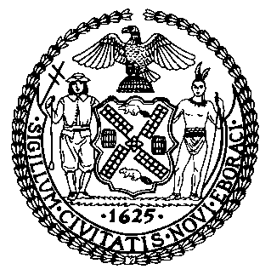 | The Council of the City of New York  Finance Division  Latonia Mckinney, Director  Fiscal Impact Statement  Proposed Int. No. 1440-A  Committee: Oversight and Investigations
Title: A Local Law to amend the administrative code of the city of New York, in relation to requiring the department of investigation and the special commissioner of investigation to create web applications to track agency cooperation and compliance with investigations and recommendations | Sponsors: Council Members Torres, Cumbo, Brannan, Holden, Ayala, Louis, and Kallos.
Summary of Legislation: Proposed Intro. No. 1440-A would require the Department of Investigation (DOI) and the Special Commissioner of Investigation for the New York City School District (SCI) to develop and maintain web applications providing information on City agencies’ compliance with DOI’s and SCI’s investigatory recommendations. Each web application would contain information on: each recommendation sent to a City agency resulting from an investigation; whether that recommendation was accepted or rejected by the City agency; and if accepted, whether the City agency implemented the recommendation. Both web applications would have to be made available online by July 1, 2020.

Effective Date: This local law would take effect immediately.
Fiscal Year In Which Full Fiscal Impact Anticipated: Fiscal 2021
Fiscal Impact Statement:

 | Effective FY20 | FY Succeeding  Effective FY21 | Full Fiscal  Impact FY21
Revenues (+) | $0 | $0 | $0
Expenditures (-) | $0 | $0 | $0
Net | $0 | $0 | $0

Impact on Revenues: It is anticipated that there would be no impact on revenues resulting from the enactment of this legislation.
Impact on Expenditures: It is anticipated that the legislation would not affect expenditures resulting from the enactment of Proposed Intro. No. 1440-A because the Department of Investigation and Special Commissioner of Investigation would utilize existing resources to fulfill the requirements of this legislation.
Source of Funds To Cover Estimated Costs: N/A
Source of Information: The Department of Investigation

Estimate Prepared by: Jack Kern, Financial Analyst

Estimate Reviewed by: Rebecca Chasan, Senior Counsel
Regina Poreda Ryan, Deputy Director
Eisha Wright, Unit Head

Legislative History: This legislation was introduced to the Council on February 13, 2019 as Intro. No. 1440 and was referred to the Committee on Oversight and Investigations (Committee). The Committee held a hearing on November 13, 2019 and the bill was laid over. The legislation was subsequently amended and the amended version, Proposed Intro. No. 1440-A, will be considered by the Committee at a hearing on February 27, 2020. Upon successful vote by the Committee, Proposed Intro. No. 1440-A will be submitted to the full Council for a vote on February 27, 2020.

Date Prepared: February 26, 2020

