Staff: Lance Polivy
Counsel, Committee State and Federal Legislation

Raymond Majewski
Deputy Director/Chief Economist, Finance Division

Andrew Wilber, Economist

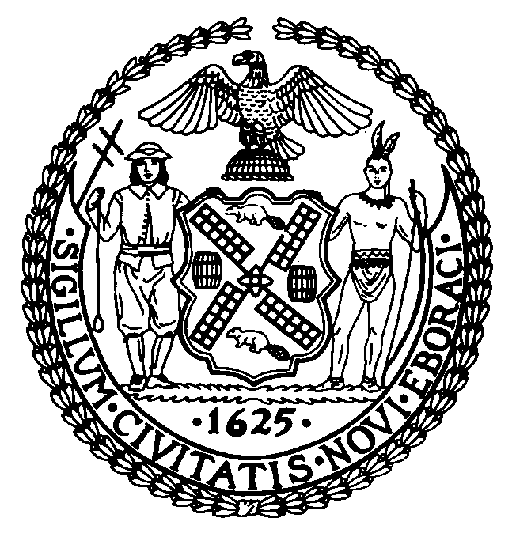

T H E C O U N C I L

REPORT OF THE GOVERNMENTAL AFFAIRS DIVISION
JEFF BAKER, LEGISLATIVE DIRECTOR
RACHEL CORDERO, DEPUTY DIRECTOR

COMMITTEE ON STATE AND FEDERAL LEGISLATION

Hon. Alan Maisel, Chair

May 27, 2021

By: Council Member Maisel

Preconsidered SLR 5: S.6229-A (Sanders)

A.7084-A (Anderson)

TITLE: AN ACT authorizing the city of New York to alienate and discontinue the use of certain portions of parkland.

BACKGROUND:
This legislation will allow for the Department of Environmental Protection to construct a storm sewer in Idlewild Park in Queens. The portion of the park below the surface will permanently be used as a storm sewer, and the portion above ground will temporarily be discontinued as a park during construction, and then will be restored as a park by the Department of Environmental Protection, in consultation with the City and the local Community Board.
PROPOSED LEGISLATION:
Section one of the legislation allows the City of New York to discontinue the permanent use of certain defined subsurface portions of parkland and transfer the lands to the Department of Environmental Protection for the purpose of constructing a storm sewer.
Section two sets a condition for section one that the City of New York must dedicate at least as much as the value of the parkland being discontinued for the acquisition of new parks or improvements to existing parks in Community Board 13 in Queens.
Section three states the metes and bounds of the parkland being discontinued.
Section four states the metes and bounds of the subsurface parkland being permanently discontinued.
Section five requires that if the City of New York receives any federal funding for the improvements described in this legislation, that the discontinuance of the parkland is not valid until all federal preconditions for the funding are met.
Section six states that after the completion of the construction, the Department of Environmental Protection will restore the surface portion of the land for use as a park, in consultation with the City of New York and the Community Board.
Section seven is the effective date.
FISCAL IMPLICATIONS:
See Council Finance Division fiscal impact statement.
EFFECTIVE DATE:
Immediately.

