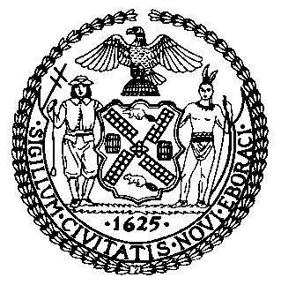 | The Council of the City of New York  Finance Division  Latonia McKinney, Director  Fiscal Impact Statement  Int. No: 1549  Committee: Parks and Recreation
Title: A Local Law in relation to renaming one thoroughfare and public place in the Borough of Queens, Seaver Way, and to amend the official map of the city of New York accordingly | Sponsor(s): By Council Member Moya

Summary of Legislation: This bill would amend the official map of the city of New York, in the Borough of Queens, through the posting of new signs and the renaming of a street:

New Name | Present Name | Limits
Seaver Way | 126th Street | Between Northern Boulevard and Roosevelt Avenue

Effective Date: This local law would take effect immediately.

Fiscal Year In Which Full Fiscal Impact Anticipated: Fiscal 2020

Fiscal Impact Statement:

 | Effective FY20 | FY Succeeding  Effective FY21 | Full Fiscal  Impact FY20
Revenues | $0 | $0 | $0
Expenditures | $1,175 | $0 | $1,175
Net | $1,175 | $0 | $1,175

Impact on Revenues: It is estimated that there would be no impact on revenues as a result of this legislation.

Impact on Expenditures: It is estimated that the enactment of this legislation would require the expenditure of $675 for 18 new signs at $37.50 each and of $500 for the labor necessary to install those 18 signs, for a total expenditure of $1,175.

Source of Funds To Cover Estimated Costs: General Fund

Source of Information: New York City Council Finance Division

Estimate Prepared By: Monika Bujak Legislative Financial Analyst

Estimate Reviewed By: Chima Obichere, Unit Head
Nathan Toth, Deputy Director
Noah Brick, Assistant Counsel

Legislative History: This legislation was introduced to the Council on May 8, 2019 as Intro. No. 1549 and referred to the Committee on Parks and Recreation (Committee). This bill will be considered by the Committee on June 26, 2019. Upon a successful vote by the Committee, the legislation will be submitted to the full Council for a vote on June 26, 2019.

Date Prepared: June 20, 2019.2019.

