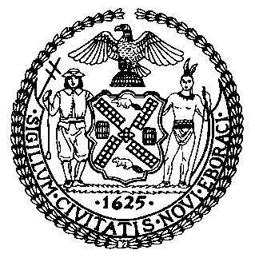 | The Council of the City of New York  Finance Division  Latonia McKinney, Director  Fiscal Impact Statement  Preconsidered - Proposed Int. No: 1954–A  Committee: Criminal Justice
title: A Local Law to amend the administrative code of the city of New York, in relation to requiring the department of correction and correctional health services to issue reports during public health emergencies. | Sponsor(S): Council Member Powers
Summary of Legislation:
Proposed Int. No. –A would require the Department of Correction (DOC) and Correctional Health Services to issue reports regarding any public health emergency and the outbreak of infectious diseases in city jails, which would include information on the incidence of infections among individuals in DOC custody, the number of tests administered to incarcerated individuals, and information on the number of staff who voluntarily self reported to be medically confirmed with the infection. The legislation would also require DOC and Correctional Health Services to publish a timeline of significant events related to the public health emergency, and to provide weekly updates to incarcerated individuals.
Effective Date: This local law would take effect immediately.
Fiscal Year In Which Full Fiscal Impact Anticipated: Fiscal 2021
Fiscal Impact Statement:

 | Effective FY20 | FY Succeeding  Effective FY21 | Full Fiscal  Impact FY21
Revenues | $0 | $0 | $0
Expenditures | $0 | $0 | $0
Net | $0 | $0 | $0

Impact on Revenues: It is estimated that there would be no impact on revenues resulting from the enactment of this legislation.

Impact on Expenditures: It is estimated that there would be no impact on expenditures resulting from the enactment of this legislation because the agency would utilize existing resources to fulfill the requirements of this legislation.
Source of Funds To Cover Estimated Costs: N/A

Source of Information: New York City Department of Correction
Mayor’s Office of City Legislative Affairs

Estimate Prepared By: Jack Storey, Legislative Financial Analyst

Estimated Reviewed By: Eisha Wright, Unit Head, New York City Council Finance Division
Regina Poreda Ryan, Deputy Director, New York City Council Finance Division
Stephanie Ruiz, Assistant Counsel, New York City Council Finance Division

Legislative History: This legislation was first considered by the Committee on Criminal Justice, at a hearing held jointly with the Committee on Justice System, as a Preconsidered Introduction on May 19, 2020 and the bill was laid over. The legislation was subsequently amended and the amended legislation, Proposed Int. No. –A, will be considered by the Committee on Criminal Justice at a hearing on May 28, 2020. Proposed Int. No. –A will be introduced to the full Council on May 28, 2020, and upon a successful vote by the Committee on Criminal Justice, it will be submitted to the full Council for a vote on May 28, 2020.
Date prepared: May 27, 2020

