THE COUNCIL OF THE CITY OF NEW YORK
RESOLUTION NO. 262

Resolution approving with modification the decision of the City Planning Commission on Application No. N 170241 ZRK, for an amendment of the Zoning Resolution of the City of New York, modifying Appendix F for the purpose of establishing a Mandatory Inclusionary Housing area, Community District 13, Borough of Brooklyn (L.U. No. 16).

By Council Members Salamanca and Moya

WHEREAS, the City Planning Commission filed with the Council on January 19, 2018 its decision dated January 17, 2018 (the "Decision"), pursuant to Section 201 of the New York City Charter, regarding an application submitted by SP North of North Limited Partnership, for an amendment of the text of the Zoning Resolution of the City of New York, modifying Appendix F for the purpose of establishing a Mandatory Inclusionary Housing area, which in conjunction with the related action would facilitate the construction of a new 100 percent affordable housing development containing two new eight-story buildings with 153 units in the Coney Island neighborhood of Brooklyn, (Application No. N 170241 ZRK), Community District 13, Borough of Brooklyn (the "Application");

WHEREAS, the Application is related to application C 170240 ZMK (L.U. No. 15), an amendment to the Zoning Map to change R5 and R5/C1-2 zoning districts to R5, R6, R6A, R7A/C2-4 zoning districts;

WHEREAS, the Decision is subject to review and action by the Council pursuant to Section 197-d(b)(1) of the City Charter;
WHEREAS, upon due notice, the Council held a public hearing on the Decision and Application on February 7, 2018;

WHEREAS, the Council has considered the land use implications and other policy issues relating to the Decision and Application; and

WHEREAS, the Council has considered the relevant environmental issues, including the negative declaration issued September 5, 2017 (CEQR No. 17DCP098K), which included (E) designations to avoid the potential for significant adverse impacts related to air quality, noise and hazardous materials (E-447) (the “Negative Declaration”).

RESOLVED:

The Council finds that the action described herein will have no significant impact on the environment as set forth in the Negative Declaration.

Pursuant to Sections 197-d and 200 of the City Charter and on the basis of the Decision and Application, and based on the environmental determination and consideration described in the report, N 170241 ZRK, incorporated by reference herein, the Council approves the Decision of the City Planning Commission with the following modifications:

Matter underlined is new, to be added;
Matter struck out is to be deleted;
Matter within # # is defined in Section 12-10;
Matter double struck-out is old, deleted by the City Council;
Matter double-underlined is new, added by the City Council;
* * * indicates where unchanged text appears in the Zoning Resolution

* * *

APPENDIX F

Inclusionary Housing Designated Areas and Mandatory Inclusionary Housing Areas

* * *

BROOKLYN

* * *

Brooklyn Community District 13

* * *

Map 2. [date of adoption]

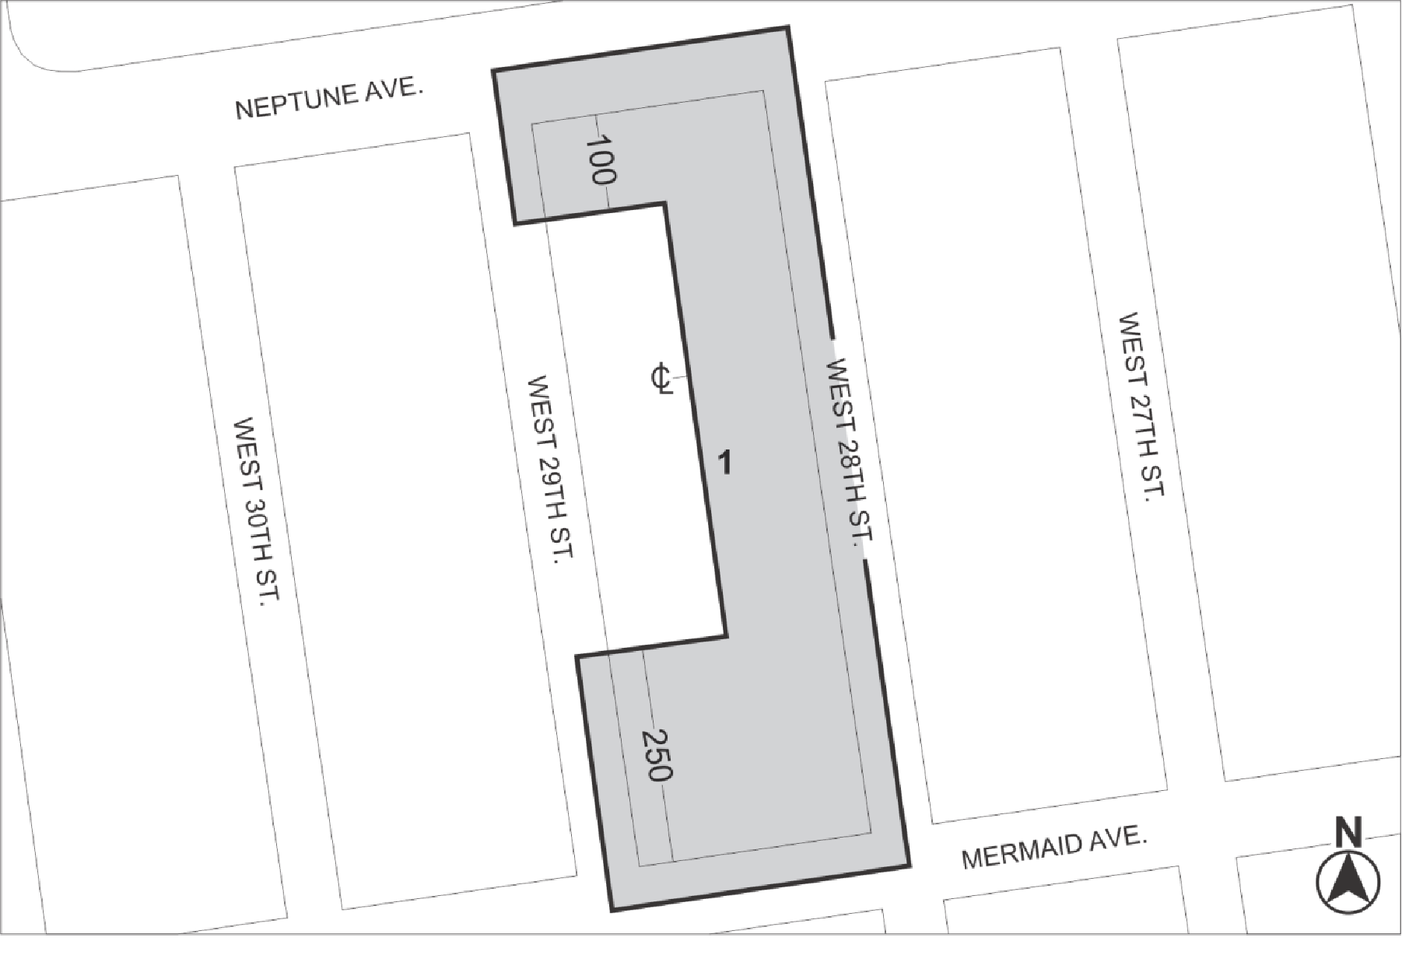

Mandatory Inclusionary Housing Area (see Section 23-154(d)(3))
Area 1 – [date of adoption] – MIH Program Option 1 and Option 2

Portion of Community District 13, Brooklyn

* * *

Adopted.

Office of the City Clerk, }
The City of New York, } ss.:

I hereby certify that the foregoing is a true copy of a Resolution passed by The Council of The City of New York on March 22, 2018, on file in this office.

.....…….........................................
City Clerk, Clerk of The Council

