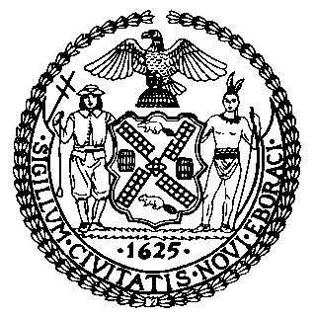 | The Council of the City of New York  Finance Division  Latonia Mckinney, Director  Fiscal Impact Statement  Proposed Intro. No: 242-B  Committee: Committee on Education
Title: A Local Law to amend the administrative code of the city of New York, in relation to requiring the department of education to report on funding for after school athletics | Sponsor(s): Council Members Reynoso, Brannan, Richards, Lander, Torres, Gibson, Holden, Treyger, Cumbo, Ampry-Samuel, Rose, Cohen, Levin, Cabrera, Menchaca, Rivera, Adams, Rosenthal, King, Cornegy, Eugene, Salamanca, Lancman, Powers, Ayala, Kallos, Moya and Ulrich
Summary of Legislation: This bill would require the Department of Education to provide a report on after school athletic funding to the Council and post the same report on their website. The report would include data with respect to funding for coaches, referees, athletic directors, equipment, uniforms, and transportation. The bill would also require reporting on student demographic information, athletic team requests, and athletic facilities used for after school athletics.

Effective Date: Immediately
Fiscal Year In Which Full Fiscal Impact Anticipated: Fiscal 2020
Fiscal Impact Statement:

 | Effective FY19 | FY Succeeding Effective FY20 | Full Fiscal Impact FY20
Revenues | $0 | $0 | $0
Expenditures | $0 | $0 | $0
Net | $0 | $0 | $0

Impact on Revenues: It is anticipated that there would be no impact on revenues resulting from the enactment of this legislation.
Impact on Expenditures: It is anticipated that there would be no impact on expenditures resulting from the enactment of this legislation, as DOE already has the resources in place to provide this data.
Source of Funds To Cover Estimated Costs: N/A
Source of Information: New York City Council Finance Division, New York City Department of
Education
Estimate Prepared by: Chelsea Baytemur, Legislative Financial Analyst
Estimate Reviewed by: Dohini Sompura, Unit Head
Regina Poreda Ryan, Deputy Director

Legislative History: This legislation was introduced to the Council as Intro. No. 242 on January 31, 2018 and referred to the Committee on Education. The legislation was subsequently amended and the amended legislation, Proposed Intro. No. 242-A, was introduced to the Council on December 3, 2018. A hearing was held by the Committee on Education on December 3, 2018 on the amended legislation after which, the legislation was laid over. The legislation was once again amended and the amended legislation Proposed Intro. No. 242-B will be considered by the Committee on Education on May 28, 2019. Upon a successful vote by the Committee, Proposed Intro. No. 242-B will be submitted to the full Council for a vote on May 29, 2019.

Date Prepared: May 23, 2019

