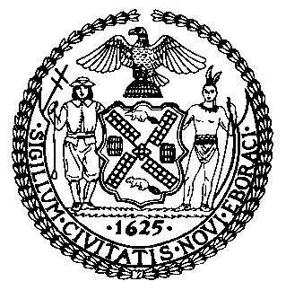 | The Council of the City of New York  Finance Division  Latonia McKinney, Director  Fiscal Impact Statement  Proposed Intro. No. 1180-A  Committee: Aging
Title: A Local Law to amend the administrative code of the city of New York, in relation to mental health training for senior center caseworkers | Sponsors: Council Members Ayala, Chin, Brannan, Ampry-Samuel, Kallos, Koo and Vallone
Summary of Legislation: Proposed Int. No. 1180-A would require caseworkers providing services at senior centers to complete the mental health first aid training course for older adults offered by the Department of Health and Mental Hygiene, or any successor agency, and to complete a refresher training course at least once every three years.
Effective Date: This local law would take effect 120 days after becoming law.
Fiscal Year in which Full Fiscal Impact Anticipated: Fiscal 2021
Fiscal Impact Statement:
 | Effective FY20 | FY Succeeding  Effective FY21 | Full Fiscal Impact FY21
Revenues (+) | $0 | $0 | $0
Expenditures (-) | $0 | $0 | $0
Net | $0 | $0 | $0

Impact on Revenues: It is estimated that there would be no impact on revenues resulting from the enactment of this legislation.
Impact on Expenditures: It is estimated that there would be no impact on expenditures resulting from the enactment of this legislation, because covered caseworkers would attend existing mental health first aid trainings provided by the Department of Health and Mental Hygiene.
Source of Funds to Cover Estimated Costs: N/A
Sources of Information: City Council Finance Division
Department of Health and Mental Hygiene
Mayor’s Office of City Legislative Affairs
Estimate Prepared by: Daniel Kroop, Financial Analyst
Estimate Reviewed by: Regina Poreda Ryan, Deputy Director
Dohini Sompura, Unit Head
Noah Brick, Assistant Counsel
Legislative History: This legislation was introduced to the Council as Intro. No. 1180 on October 31, 2018 and referred to the Committee on Aging. A joint hearing was held by the Committee on Aging and the Committee on Mental Health, Disabilities, and Addiction on November 19, 2018 and the legislation was laid over. The legislation was subsequently amended and the amended version, Proposed Intro. No. 1180-A, will be considered by the Committee on Aging on May 28, 2019. Upon a successful vote by the Committee, Proposed Intro. No. 1180-A will be submitted to the full Council for a vote on May 29, 2019.

Date Prepared: May 23, 2019

