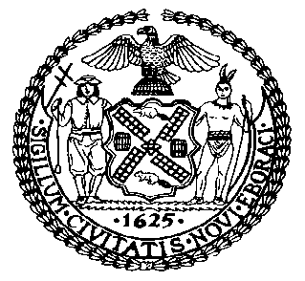 | The Council of the City of New York  Finance Division  Latonia McKinney, Director  Fiscal Impact Statement  Proposed Intro. No: 1269-A  Committee: Housing and Buildings
Title: A Local Law to amend the administrative code of the city of New York, in relation to the creation of regulatory agreements with community land trusts | Sponsors: Council Members Richards, Miller, Rodriguez, Chin, Salamanca, Maisel, Grodenchik, Levin, Menchaca, Lander, Rosenthal, Reynoso, Kallos, Williams, Johnson, Rose, Perkins, Espinal, Ferreras-Copeland, King, Levine, Gentile, Cumbo, Van Bramer and Koslowitz
Summary of Legislation: Proposed Intro. No. 1269-A would require the Department of Housing Preservation and Development (HPD) to enter into regulatory agreements with community land trusts (CLTs) which meet standard terms and conditions for regulatory agreements, and would allow HPD to enter into such agreements where the CLT is a recipient of city funding, property or a tax exemption.

Effective Date: This local law would take effect 120 days after it becomes law, except that the Commissioner of HPD may take such measures as are necessary for its implementation, including the promulgation of rules, before such effective date.
Fiscal Year In Which Full Fiscal Impact Anticipated: Fiscal 2019
Fiscal Impact Statement:

 | Effective FY18 | FY Succeeding Effective FY19 | Full Fiscal Impact FY19
Revenues | $0 | $0 | $0
Expenditures | $0 | $0 | $0
Net | $0 | $0 | $0

Impact on Revenues: It is estimated that there would be no impact on revenues resulting from the enactment of this legislation.
Impact on Expenditures: It is anticipated that there would be no impact on expenditures resulting from the enactment of this legislation because existing resources would be used by HPD to implement the provisions of this local law.
Source of Funds To Cover Estimated Costs: Not applicable.

Source of Information: New York City Council Finance Division
New York City Department of Housing Preservation and Development

Estimate Prepared by: Sarah Gastelum, Principal Financial Analyst

Estimated Reviewed by: Chima Obichere, Unit Head
Rebecca Chasan, Counsel

Legislative History: This legislation was introduced to the full Council on September 14, 2016 as Intro. No. 1269 and was referred to the Committee on Housing and Buildings (Committee). A joint hearing was held by the Committee with the Committee on Immigration on October 19, 2017, and the bill was laid over. The legislation was subsequently amended, and the amended version, Proposed Intro. 1269-A, will be considered by the Committee on December 18, 2017. Following a successful Committee vote, the bill will be submitted to the full Council for a vote on December 19, 2017.

Date Prepared: December 14, 2017

