THE COUNCIL OF THE CITY OF NEW YORK
RESOLUTION NO. 360

Resolution approving with modifications the decision of the City Planning Commission on Application No. N 220170 ZRQ, for an amendment of the text of the Zoning Resolution (Preconsidered L.U. No. 118).

By Council Members Salamanca and Riley

WHEREAS, Crescent Street Associates, LLC, filed an application pursuant to Section 201 of the New York City Charter, for an amendment of the text of the Zoning Resolution of the City of New York, modifying provisions of Article XI, Chapter 7 (Special Long Island City Mixed Use District) and modifying APPENDIX F for the purpose of establishing a Mandatory Inclusionary Housing area, which in conjunction with the related action would facilitate the development of a seven-story mixed-use building with residential, commercial, and light industrial uses at 40-25 Crescent Street in the Dutch Kills neighborhood of Queens, Community District 1 (ULURP No. N 220170 ZRQ) (the “Application”);

WHEREAS, the City Planning Commission filed with the Council on September 21, 2022, its decision dated September 21, 2022 (the “Decision”), on the Application;

WHEREAS, the Application is related to application C 220169 ZMQ (Pre. L.U. No. 117), a zoning map amendment from an M1-2/R5B and M1-2/R5D zoning districts to an M1-2/R6A zoning district;

WHEREAS, the Decision is subject to review and action by the Council pursuant to Section 197-d of the City Charter;

WHEREAS, upon due notice, the Council held a public hearing on the Decision and Application on September 22, 2022;

WHEREAS, the Council has considered the land use implications and other policy issues relating to the Decision and Application; and

WHEREAS, the Council has considered the relevant environmental issues, including the Negative Declaration issued May 6th, 2022 (CEQR No. 22DCP065Q), which includes an (E) designation to avoid the potential for significant adverse impacts related to hazardous materials, air quality, and noise (E-677) (the “Negative Declaration”).

RESOLVED:

The Council finds that the action described herein will have no significant impact on the environment as set forth in the (E) Designation (E-677) and Negative Declaration.

Pursuant to Sections 197-d and 200 of the City Charter and on the basis of the Decision and Application, and based on the environmental determination and consideration described in the report, N 220170 ZRQ, incorporated by reference herein, and the record before the Council, the Council approves the Decision of the City Planning Commission with the following modifications:

Matter underlined is new, to be added;
Matter struck out is to be deleted;
Matter within # # is defined in Section 12-10;
Matter double struck out is old, deleted by the City Council;
Matter double-underlined is new, added by the City Council
* * * indicates where unchanged text appears in the Zoning Resolution.

ARTICLE XI
SPECIAL PURPOSE DISTRICTS

Chapter 7
Special Long Island City Mixed Use District

117-00
GENERAL PURPOSES

* * *

117-06
Applicability of the Inclusionary Housing Program

For the purposes of applying the Inclusionary Housing Program provisions set forth in Sections 23-154 and 23-90, inclusive, #Inclusionary Housing designated areas# and #Mandatory Inclusionary Housing areas# within the #Special Long Island City Mixed Use District# are shown on the maps in APPENDIX F of this Resolution.

117-60
DUTCH KILLS SUBDISTRICT

* * *

APPENDIX F
Inclusionary Housing Designated Areas and Mandatory Inclusionary Housing Areas

QUEENS

Queens Community District 1

* * *

Map 10 - [date of adoption]

MAP
[modified by Council]
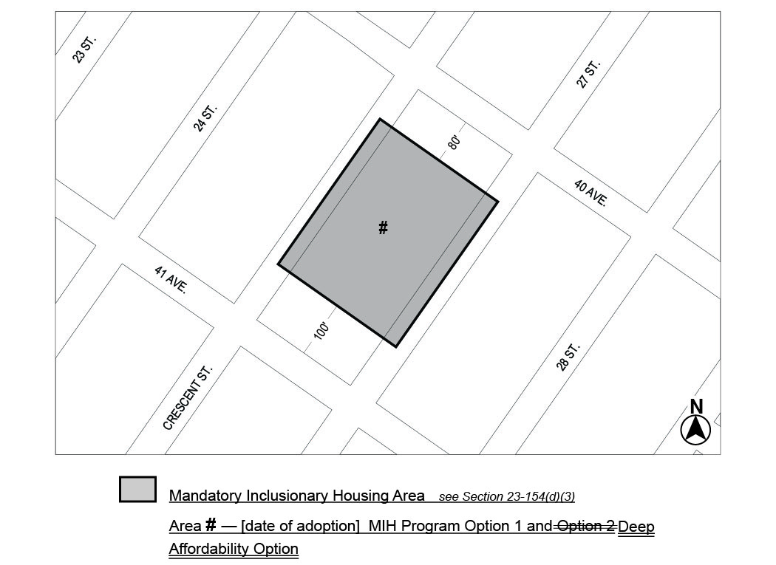

Portion of Community District 1, Queens

* * *

Adopted.

Office of the City Clerk, }
The City of New York, } ss.:

I hereby certify that the foregoing is a true copy of a Resolution passed by The Council of The City of New York on ___________, 2022, on file in this office.

.....................................................
City Clerk, Clerk of The Council

