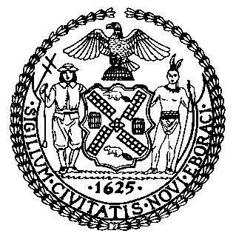 | The Council of the City of New York  Finance Division  Latonia McKinney, Director  Fiscal Impact Statement  Proposed Intro No. 1484-A  Committee: General Welfare
Title: A Local Law to amend the administrative code of the city of New York, in relation to providing information about pets whose owners enter homeless shelters | By Council Members Levin, Holden, Chin, Lander, Brannan, Ayala, Louis, Adams, Rivera, Salamanca and Gennaro
Summary of Legislation: Proposed Intro No. 1484-A would require the Department of Homeless Services (DHS) to post information on its website regarding the process for having a pet designated as an emotional support animal, and to report, every three months, information on how many individuals and families applied for shelter and reported they had a pet, as well as the placement or disposition of pets that belong to people who enter homeless shelters. The bill would also require the DHS to develop a questionnaire to obtain the information required to be reported.

Effective Date: This local law would take effect immediately.
Fiscal Year in which Full Fiscal Impact Anticipated: Fiscal 2023
Fiscal Impact Statement:
 | Effective FY22 | FY Succeeding  Effective FY23 | Full Fiscal Impact FY23
Revenues (+) | $0 | $0 | $0
Expenditures (-) | $0 | $0 | $0
Net | $0 | $0 | $0

Impact on Revenues: It is estimated that there would be no impact on revenues resulting from the enactment of this legislation.

Impact on Expenditures: It is estimated that there would be no impact on expenditures resulting from the enactment of this legislation. The Council expects that DHS will be able to use existing resources to comply with Proposed Intro No. 1484-A.

Source of Funds to Cover Estimated Costs: N/A

Sources of Information: New York City Council Finance Division
Mayor’s Office of Legislative Affairs
Office of Management and Budget

Estimate Prepared by: Frank Sarno, Financial Analyst

Estimate Reviewed by: Regina Poreda Ryan, Deputy Director
Dohini Sompura, Unit Head
Noah Brick, Assistant Counsel
Legislative History: This legislation was introduced to the full Council on March 28, 2019 and was subsequently referred to the Committee on General Welfare (Committee). The Committee heard the legislation on February 28, 2020 and the bill was laid over. The legislation was subsequently amended and the amended version, Proposed Intro. No. 1484-A, will be considered by the Committee at a hearing on August 26, 2021. Upon a successful vote by the Committee, Proposed Intro. No. 1484-A will be submitted to the full Council for a vote on August 26, 20121.
Date Prepared: August 24, 2021

