**THE COUNCIL OF THE CITY OF NEW YORK**

**RESOLUTION NO. 1759**

**..Title**

**Resolution approving the decision of the City Planning Commission on Application No. N 200307 ZRK, for an amendment of the text of the Zoning Resolution (L.U. No. 841).**

**..Body**

**By Council Members Salamanca and Moya**

WHEREAS, 307 Kent Associates, LLC, filed an application pursuant to Section 201 of the New York City Charter, for an amendment of the text of the Zoning Resolution of the City of New York, modifying APPENDIX F for the purpose of establishing a Mandatory Inclusionary Housing Area, which in conjunction with the related action would facilitate the development of a new nine-story, mixed-use building containing approximately 93,000-square-foot mixed-use building containing retail and commercial office uses at 307 Kent Avenue in Williamsburg neighborhood of Brooklyn, Community District 1 (ULURP No. N 200307 ZRK), (the “Application”);

WHEREAS, the City Planning Commission filed with the Council on September 3, 2021, its decision dated September 1, 2021 (the "Decision") on the Application;

WHEREAS, the Application is related to application C 200306 ZMK (L.U. No. 840), a zoning map amendment to change an M3-1 zoning district to an M1-5 and M1-4/R6A zoning districts within a Special Mixed Use District (MX-8) districts;

WHEREAS, the Decision is subject to review and action by the Council pursuant to Section 197-d of the City Charter;

WHEREAS, upon due notice, the Council held a public hearing on the Decision and Application on September 10, 2021;

WHEREAS, the Council has considered the land use implications and other policy issues relating to the Decision and Application; and

WHEREAS, the Council has considered the relevant environmental issues, including the Positive Declaration issued January 10th, 2020 (CEQR No. 20DCP100K) and a Final Environmental Impact Statement (FEIS) for which a Notice of Completion was issued on August 20, 2021, which identified significant adverse impacts related to hazardous materials, noise, and air quality would be avoided through the placement of (E) designations (E-592) on the project sites. The proposed project, as analyzed in the FEIS, also identified significant adverse impacts with respect to transportation (vehicular traffic, transit, pedestrian) and proposed mitigation measures are included in the Restrictive Declaration.

RESOLVED:

Having considered the FEIS with respect to the Decision and Application, the Council finds that:

1. The FEIS meets the requirements of 6 N.Y.C.R.R. Part 617;
2. Consistent with social, economic and other essential considerations, from among the reasonable alternatives thereto, the action is one which minimizes or avoids adverse environmental impacts to the maximum extent practicable; and
3. The adverse environmental impacts disclosed in the FEIS will be minimized or avoided to the maximum extent practicable by incorporating, as conditions to the approval, report for C 200306 ZMK, those project components related to environment and mitigation measures that were identified as practicable.

The Decision, together with the FEIS constitute the written statement of facts, and of social, economic and other factors and standards that form the basis of this determination, pursuant to 6 N.Y.C.R.R. §617.11(d).

Pursuant to Sections 197-d and 200 of the City Charter and on the basis of the Decision and Application, and based on the environmental determination and consideration described in the report, N 200307 ZRK, incorporated by reference herein, and the record before the Council, the Council approves the Decision of the City Planning Commission.

Matter underlined is new, to be added;

Matter ~~struck out~~ is to be deleted;

Matter within # # is defined in Section 12-10;

*** indicates where unchanged text appears in the Zoning Resolution.

* * *

**APPENDIX F**

**Inclusionary Housing Designated Areas and Mandatory Inclusionary Housing Areas**

* * *

**BROOKLYN**

* * *

**Brooklyn Community District 1**

* * *

Map 2 - [September 1, 2021]

[EXISTING MAP]

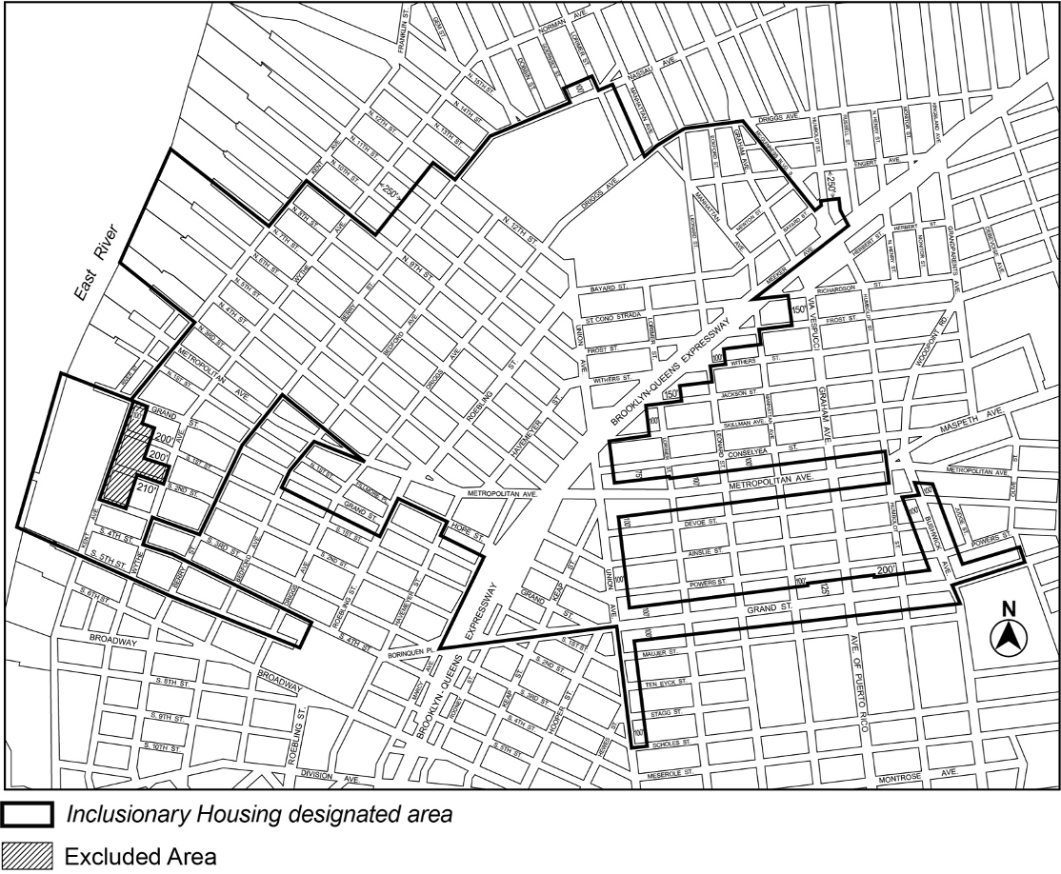

[PROPOSED MAP]



Portion of Community District 1, Brooklyn

Adopted.

Office of the City Clerk,}

The City of New York,} ss.:

I hereby certify that the foregoing is a true copy of a Resolution passed by The Council of The City of New York on October 7, 2021, on file in this office.

.....................................................

City Clerk, Clerk of The Council