Civil Service & Labor Committee Staff

Rie Ogasawara, *Legislative Policy Analyst*

Elizabeth Arzt, *Legislative Policy Analyst*

**THE COUNCIL OF THE CITY OF NEW YORK**

##### BRIEFING PAPER AND COMMITTEE REPORT OF THE HUMAN SERVICES DIVISION

Andrea Vazquez, *Legislative Director*

Smita Deshmukh*, Deputy Director, Human Services*

**COMMITTEE ON CIVIL SERVICE & LABOR**

Hon. Carmen De La Rosa, *Chair*

**May 31, 2023**

**Int. No. 877-A-2023** By Council Members Abreu, De La Rosa, Menin, Louis, Stevens, Hanif, Ung and Richardson Jordan

**Title:** A Local Law to amend the administrative code of the City of New York, in relation to requiring an exit interview for departing and retiring municipal employees

**Res. No. 27-2022:** By Public Advocate (Mr. Williams) and Council Members Hanif, Cabán and Louis

**Title:** Resolution calling on the New York State Legislature to pass, and the New York State Governor to sign, S. 1828 /A. 3103, which would eliminate the subminimum wage for employees based on their disability or age

**Res. No. 393-2022:** By Council Members De La Rosa, Hanif, Restler, Hudson, Farías and Brewer

**Title:** Resolution calling on the New York State Legislature to pass, and the Governor to sign, A.9398/S.8166, to establish the Nail Salon Minimum Standards Act

**Res. No. 0547-2023** By Council Members De La Rosa, Ung, Krishnan, Gennaro, Farías, Won, Brewer, Powers, Narcisse, Ossé, Bottcher, Abreu,

Holden, Schulman, Marte, Moya, Hudson, Brannan, Ayala, Riley,

Hanks, Menin and Hanif

**Title:** Resolution calling upon the New York City School Construction Authority (SCA) and the New York City Department of Design and Construction (DDC) to reconsider their decision to substitute precast concrete wall panels in place of traditional handset brick and block walls in public projects in New York City

1. **Introduction**

On May 31, 2023, the Committee on Civil Service and Labor, chaired by Council Member Carmen De La Rosa, will hear the following bill and resolutions: Introduction Number 877-A (Int. 877-A), in relation to exit surveys for resigning and retiring employees of New York City agencies; Resolution Number 27 (Res. 27), calling on the New York State Legislature to pass, and the New York State Governor to sign, S. 1828 /A. 3103, which would eliminate the subminimum wage for employees based on their disability or age; Res. 393 (Res.393), calling on the New York State Legislature to pass, and the Governor to sign, A.9398/S.8166, to establish the Nail Salon Minimum Standards Act; and Res. 547 (Res. 547), calling upon the New York City School Construction Authority (SCA) and the New York City Department of Design and Construction (DDC) to reconsider their decision to substitute precast concrete wall panels in place of traditional handset brick and block walls in public projects in New York City. Witnesses invited to testify include representatives from the New York City Department of Citywide Administrative Services (DCAS), municipal labor unions, and other interested stakeholders and members of the public.

1. **Background** 
   1. ***Department of Citywide Administrative Services***

DCAS provides agencies throughout New York City government (City) with various forms of administrative support.[1] The DCAS Human Capital team is responsible for providing City agencies with personnel-related services.[2] The primary functions of the Human Capital team include: (i) recruiting candidates for City employment;[3] (ii) helping City agencies meet their hiring needs in a manner consistent with local, state, and federal law;[4] (iii) overseeing background investigations of City employees;[5] (iv) administering civil service exams;[6] (v) developing and interpreting Citywide personnel policies;[7] (vi) conducting professional development and employee training programs;[8] and (vii) performing other personnel-related functions.[9]

* 1. ***Vacancies Across the Municipal Workforce***

The City faced numerous challenges after the COVID-19 pandemic outbreak in March 2020, including a decline in anticipated resources and a substantial change in the demand for certain municipal services.[10] In response to budgetary issues created by the pandemic, the City implemented a hiring freeze that was in effect between March 2020 and April 2021 on nonessential, nonrevenue-generating positions to help close its budget gaps, resulting in a net employment decline.[11] The pace of hiring has picked up since April 2021, but not fast enough to offset attrition.[12]

As of April 2023, the City had 22,964 vacant full-time positions, resulting in an overall vacancy rate of 7.9% based on actual staffing levels as of April 2023 and the FY 2023 authorized staffing levels.[13] This is more than five times higher than the 1.5% rate the City saw in March 2020 and March 2019.[14] While vacancy rates vary widely, most agencies had vacancy rates exceeding 5% as of April 2023.[15] Among agencies with over 100 full-time staff, the vacancy rate was highest at the Department of Small Business Services (26%%, with 83 vacant positions) and the Department of Buildings (18%, with 336 vacant positions).[16] Forty agencies had vacancy rates of more than 5%, and 26 agencies had rates above 10%.[17]

The following table shows the highest vacancy rates as of April 2023 among mayoral agencies with at least 100 authorized full-time positions.[18]

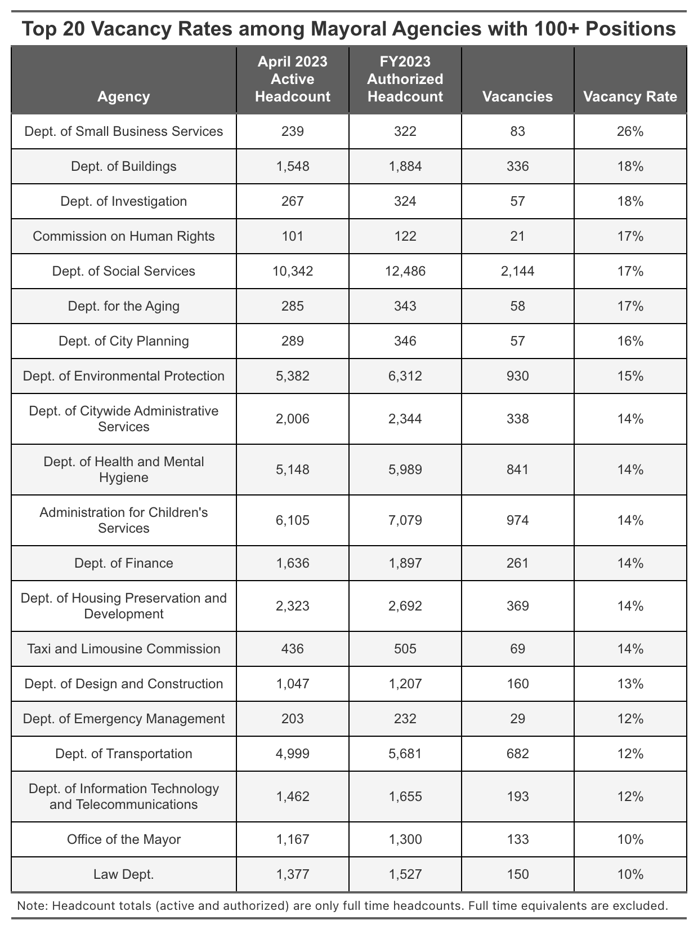

* 1. ***Impact on Service Delivery***

City agencies provide vital social safety net services, enforce administrative rules, and keep technological infrastructure running.[19] The Department of Buildings is responsible for reviewing plans, issuing permits and inspecting critical infrastructure for over a million structures, and currently has an 18% vacancy rate.[20] Similarly, the Department of Housing Preservation & Development (HPD), which provides financing for both affordable new construction and existing multifamily properties, has an overall vacancy rate of 14%.[21] The Department of Social Services, which has numerous mandated functions to support children and families, and to administer cash benefits and public assistance to New Yorkers, has a vacancy rate of 17%.[22] Rampant vacancies have hindered the City’s ability to deliver mission critical services to New York City (city) residents.[23] According to a March 2023 report by the City Comptroller’s office, of the 15 agencies with the highest employee vacancy rates, nine have failed to meet immediate, short-term, and long-term performance targets, leading to difficulty in delivering key services.[24]

While some agencies may have lost staff due to unique circumstances, others face a common set of challenges caused by systemic economic and policy factors that include salary competition from the private sector, the city’s high cost of living, headcount reduction efforts as part of the Mayor’s Program to Eliminate the Gap, and the Adams Administration’s resistance to hybrid work schedules.[25] City officials have stressed that the City must identify and address the various reasons municipal employees are leaving the public sector in order to remedy the vacancy crisis and ensure the timely delivery of services. [26]

1. **Legislative Analysis- Int. 877-A**

Int. 877-A would require the Commissioner of the Department of Citywide Administrative Services (DCAS) to create an exit survey for resigning and retiring employees designed to gather feedback from such employees on the quality of their work experience in the City’s civil service. Int. 877-A would require all City agencies to submit their then-current exit surveys or policies to DCAS by January 1, 2024, for the Commissioner’s consideration when creating an exit survey.

Int. 877-A would require agencies to administer the exit survey created by the Commissioner to resigning or retiring employees. The number of people employed by an agency would determine the number of resigning or retiring employees to whom the exit surveys would be administered: agencies with 100,000 employees or more would be required to administer the survey, at random, to 20% of resigning or retiring employees; agencies with 50,000 to 99,999 employees would be required to administer the survey, at random, to 40% of resigning or retiring employees; and agencies with fewer than 49,999 employees would be required to administer the survey to all resigning or retiring employees. Int. 877-A would require that all exit surveys be administered on or before the last day of employment.

Int. 877-A would require all agencies to provide DCAS with data from administered exit surveys by September 15, 2024, and annually on or before September 15 every following year.

Int. 877-A would require DCAS to submit a report on exit surveys completed by resigning and retiring employees to the New York City Commission on Human Rights and to the Speaker by March 30, 2025, and annually on or before March 30 every following year. Such report would include, but not be limited to, the following information: the number of resigning and retiring employees; the number of exit surveys administered; employee history with City agencies; reasons for resignation or retirement; reports of discrimination experienced in the workplace; and other indicated challenges in relation to working conditions.

Int. 877-A would take effect immediately.

1. **Conclusion**

The City’s vacancy crisis highlights the City’s challenges recruiting and retaining qualified employees. The municipal labor shortfall has led to concerns about agencies’ ability to efficiently deliver critical services during the City’s recovery from the COVID-19 pandemic. The Committee looks forward to hearing feedback from the Administration, municipal unions, and interested stakeholders on the effect that Int. 877-A could have in supporting the City’s recruitment and retention of civil servants.

Proposed Int. No. 877-A

By Council Members Abreu, De La Rosa, Menin, Louis, Stevens, Hanif, Ung and Richardson Jordan

A Local Law to amend the administrative code of the City of New York, in relation to exit surveys for resigning and retiring employees of City agencies

Be it enacted by the Council as follows:

Section 1. Chapter 2 of title 12 of the administrative code of the City of New York is amended by adding a new section 12-214 to read as follows:

§ 12-214 Exit surveys. a. Definitions. For purposes of this section, the following terms have the following meanings:

Commissioner. The term “commissioner” means the commissioner of Citywide administrative services.

Department. The term “department” means the department of Citywide administrative services.

Resigning employee. The term “resigning employee” means an agency employee who has provided notice of resignation from City civil service, but does not include a retiring employee.

Retiring employee. The term “retiring employee” means an agency employee who has provided notice of resignation from City civil service and will retire upon such resignation.

b. No later than January 1, 2024, each agency shall provide to the department any exit surveys or policies that such agency administers in relation to resigning or retiring employees.

c. The commissioner, in consultation with the New York City commission on human rights, and based on any exit surveys or policies received from agencies pursuant to subdivision b of this section, shall create a comprehensive exit survey for resigning and retiring employees. Such survey shall include, but not be limited to, questions designed to elicit the information required pursuant to subdivision f of this section, including details regarding the quality of the employee’s experience during their employment in the City civil service and the employee’s reasons for resigning or retiring from City civil service.

d. 1. Agencies shall make best efforts to administer the exit survey created pursuant to subdivision c to as many resigning and retiring employees as practicable, and in accordance with the following:

(a) Each agency with 100,000 employees or more shall administer such survey to no fewer than 20 percent of such employees;

(b) Each agency with no fewer than 50,000 employees and no more than 99,999 employees shall administer such survey to no fewer than 40 percent of such employees; and

(c) Each agency with fewer than 49,999 employees shall administer such survey to all such employees.

2. Agencies not required to administer exit surveys to all resigning and retiring employees shall administer exit surveys on an ongoing basis at random.

3. An exit survey shall be administered on or before the last day of employment of the subject employee.

e. No later than September 15, 2024, and on or before September 15 annually thereafter, each agency shall provide to the department data from the exit surveys administered pursuant to subdivision d of this section in a form and manner determined by the commissioner.

f. No later than March 30, 2025, and by March 30 annually thereafter, the department shall submit to the New York City commission on human rights and to the speaker of the council a report regarding employee resignations and retirements, and responses from exit surveys administered pursuant to this section. Such report shall include, but not necessarily be limited to:

1. The following information on resigning and retiring employees for the prior calendar year, disaggregated by agency, position, and status as resigning or retiring:

(a) The number of such employees;

(b) The number of such employees who were asked to complete an exit survey;

(c) The number of such employees who completed an exit survey;

(d) The number of such employees who were employed by multiple agencies during their City civil service career;

(e) The number of such employees who were promoted during their City civil service career;

(f) The number of such employees who applied for, but did not receive a promotion during their City civil service career;

(g) The number of such employees who were demoted, transferred, or experienced any other changes in personnel status other than a promotion during their City civil service career.

2. The following information obtained from exit surveys administered to agency employees in the prior calendar year, disaggregated by agency, position, and status as resigning or retiring:

(a) The reasons for resignation or retirement given by surveyed employees, and the number of such employees who reported each such reason;

(b) The number of such employees who indicated being the subject of discrimination, disaggregated by the type of discrimination indicated;

(c) The number of such employees who indicated being the subject of multiple types of discrimination, disaggregated by the number of such employees who indicated each combination of discrimination types;

(d) The number of such employees who indicated their resignation or retirement was due to circumstances outside their control;

(e) The number of such employees whose resignation or retirement was planned;

(f) The number of such employees whose resignation or retirement was unexpected;

(g) The number of such employees who transferred their job knowledge and experiences to other employees before their resignation or retirement; and

(h) A list of all indicated challenges in relation to working conditions other than discrimination, including, but not limited to, remote work policies; leave policies; caregiving responsibilities; wages and other compensation; conflict with management; unsafe working conditions; workload; loss of City residency; and commute time, and for each type of challenge identified, the number of such employees who indicated such challenge.

§ 2. This local law takes effect immediately.

Session 12

XC/NC

LS 8504

5/16/2022

Session 11

NJC

LS 14118

9/14/2020

1. *See* Who We Are – Department of Citywide Administrative Services, <https://www1.nyc.gov/site/dcas/about/who-we-are.page> (last visited August 31, 2022).
2. *See* Human Capital – Department of Citywide Administrative Services, <https://www1.nyc.gov/site/dcas/agencies/human-capital.page> (last visited August 31, 2022).
3. *See* Executive Team – Department of Citywide Administrative Services, <https://www1.nyc.gov/site/dcas/about/agency-executive-team.page> (last visited August 31, 2022).
4. *See id.*
5. *See* Who We Are – Department of Citywide Administrative Services (under “Human Capital” tab) <https://www1.nyc.gov/site/dcas/about/who-we-are.page> (last visited August 31, 2022).
6. *See id.*
7. *See* Executive Team – Department of Citywide Administrative Services, <https://www1.nyc.gov/site/dcas/about/agency-executive-team.page> (last visited August 31, 2022).
8. *See id.*
9. *See id.*
10. Office of the New York State Comptroller, *Impact of the Pandemic on New York City’s Municipal Workforce* (February 2022), *available at*  <https://www.osc.state.ny.us/files/reports/osdc/pdf/report-18-2022.pdf>.
11. *Id.*
12. *Id.*
13. Data provided by City Council Finance Division and Mayor’s Office of Management and Budget.
14. Dana Rubenstein and Emma Fitzsimmons, *Why City Workers in New York are Quitting in Droves*, New York Times (July 13, 2022), *available at*  <https://www.nytimes.com/2022/07/13/nyregion/labor-shortage-nyc-jobs.html>.
15. Data provided by City Council Finance Division and Mayor’s Office of Management and Budget.
16. *Id.*
17. *Id.*
18. *Id.*
19. *Id.*
20. Office of the NYC Comptroller, *Title Vacant: Addressing Critical Vacancies in NYC government Agencies* (Dec.6, 2022) <https://comptroller.nyc.gov/reports/title-vacant/>
21. *Id.*
22. *Id.*
23. Office of the NYC Comptroller, *Understaffed and Underserved* (March 2023) available at: <https://comptroller.nyc.gov/reports/understaffed-underserved/>
24. Mays, Jeff, New York Times, *New York’s Difficulty in Filling Job Vacancies has Hurt City Services* (March 6, 2023) available at: <https://www.nytimes.com/2023/03/06/nyregion/nyc-workers-hiring-vacancies.html>
25. Rubenstein, Fitzsimmons, *supra* note 5
26. Gonen, Yoav, The City, *One in Five Jobs Unfilled at Health and Buildings Departments, City Council Finds* (Sept 6, 2022) available at: [https://www.theCity.nyc/2022/9/6/23340069/health-housing-buildings-public-sector-unemployment-rate-high](https://www.thecity.nyc/2022/9/6/23340069/health-housing-buildings-public-sector-unemployment-rate-high)