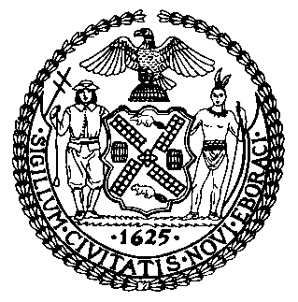 | The Council of the City of New York  Finance Division  Latonia McKinney, Director  Fiscal Impact Statement  Proposed Intro. No: 1811-A  Committee: Transportation
Title: A Local Law to amend the administrative code of the city of New York, in relation to the creation of a theatre district zone | Sponsors: Council Members Powers, the Speaker (Council Member Johnson), Vallone, and Yeger
Summary of Legislation: Proposed Intro. No. 1811-A would create a Theatre District zone on the streets surrounding Times Square in Manhattan. In the zone, the Department of Transportation (DOT) would be required to establish additional pedestrian flow zones where necessary to accommodate demand for pedestrian space. The department would also have the authority to add new designated activity zones for commercial activities. For the purpose of this bill, designated activities means commercial activities, which includes solicitation of any kind, distribution of anything, entertainment or performances by individuals or groups, posing for or taking photographs or videos, and vending expressive matter, where any form of compensation, donation, or gratuity is requested or accepted. Lastly, the bill would clarify that persons engaged in designated activities are deemed to be engaged in such activities for the entirety of their interactions with the public for the purpose of providing commercial activity.

Effective Date: This local law would take effect 60 days after it becomes law, except that the Commissioner of Transportation shall take such measures as are necessary for the implementation of this local law, including the promulgation of rules, before such date.

Fiscal Year In Which Full Fiscal Impact Anticipated: Fiscal 2023
Fiscal Impact Statement:
 | Effective FY22 | FY Succeeding Effective FY23 | Full Fiscal Impact FY23
Revenues | $0 | $0 | $0
Expenditures | $0 | $0 | $0
Net | $0 | $0 | $0
Impact on Revenues: It is estimated that there would be no impact on revenues resulting from the enactment of this legislation.

Impact on Expenditures: It is estimated that there would be no impact on expenditures because the agency responsible for implementing the requirements of the legislation would use existing resources to comply with the provisions of the local law. However, outside of the provisions of the local law, DOT has informed the Council that it plans to conduct a study in connection with the legislation to provide data to support their actions. The Mayor’s Office of Legislative Affairs estimates that this study would cost approximately $500,000.
Source of Funds to Cover Estimated Costs: N/A
Source of Information: New York City Council Finance Division
Mayor’s Office of Legislative Affairs
Department of Transportation
Estimate Prepared by: John Basile, Senior Financial Analyst
Estimate Reviewed by: Nathaniel Toth, Deputy Director
Chima Obichere, Unit Head
Stephanie Ruiz, Assistant Counsel
Legislative History: This legislation was first introduced to the Council as Intro. No. 1811 on November 26, 2019 and referred to the Committee on Transportation (the Committee). A hearing was held by the Committee on May 5, 2021 and the bill was laid over. The legislation was subsequently amended and the amended version, Proposed Intro. No. 1811-A, will be considered by the Committee on August 26, 2021. Upon successful vote by the Committee, Proposed Intro. No. 1811-A will be submitted to the full Council for a vote on August 26, 2021.
Date Prepared: August 25, 2021

