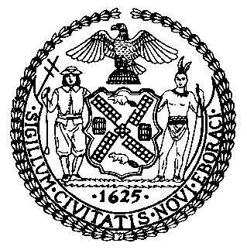 | The Council of the City of New York  Finance Division  Latonia Mckinney, Director  Fiscal Impact Statement  Proposed Intro. No: 1333-B  Committee: Public Safety
Title: A Local Law to amend the administrative code of the city of New York, in relation to amending the definition of public nuisances and establishing timeliness requirements under the nuisance abatement law, and to repeal certain provisions of the nuisance abatement law defining public nuisances and provisions relating thereto | Sponsors: Council Members Richards, The Speaker (Council Member Mark-Viverito) and Council Members Levine, Johnson. Salamanca, Gibson and Chin
Summary of Legislation: Proposed Intro. 1333-B would establish a four-month statute of limitations for all actions brought under the Nuisance Abatement Law. Additionally, this legislation would repeal nuisances related to obscenity, air pollution, and noise control, and eliminate references to those certain nuisances throughout the Nuisance Abatement Law. The bill would also update the definition of a “nuisance” in the Administrative Code of the City of New York, which currently refers to laws that no longer exist.

Effective Date: This local law would take effect 60 days after it becomes law.

Fiscal Year in Which Full Fiscal Impact Anticipated: Fiscal 2017
Fiscal Impact Statement:
 | Effective FY17 | FY Succeeding Effective FY18 | Full Fiscal Impact FY18
Revenues | $0 | $0 | $0
Expenditures | $0 | $0 | $0
Net | $0 | $0 | $0

Impact on Revenues: It is anticipated that there would be no impact on revenues as a result of this legislation.

Impact on Expenditures: It is anticipated that there would be no impact on expenditures as a result of this legislation.
Source of Funds To Cover Estimated Costs: N/A

Source of Information: New York City Council

Estimate Prepared by: Steve Riester, Senior Financial Analyst
Estimate Reviewed by: Regina Poreda Ryan, Deputy Director
Eric Bernstein, Counsel
Legislative History: This legislation was introduced to the Council on October 27, 2016 as Intro. No. 1333 and referred to the Committee on Public Safety. A hearing was held by the Committee on Public Safety on November 2, 2016 and the bill was laid over. The legislation was subsequently amended and the amended version, Proposed Intro. No. 1333-B, will be voted on by the Committee on Public Safety at a hearing on February 14, 2017. Upon successful vote by the Committee, Proposed Intro. No. 1333-B will be submitted to the full Council for a vote on February 15, 2017.
Date Prepared: February 8, 2017

