THE COUNCIL OF THE CITY OF NEW YORK
RESOLUTION NO. 1736

Resolution approving with modifications the decision of the City Planning Commission on Application No. N 200231 ZRQ, for an amendment of the text of the Zoning Resolution (Preconsidered L.U. No. 825).

By Council Members Salamanca and Moya

WHEREAS, Brisa Builders Development, LLC and God's Battalion of Prayer Properties, Inc., filed an application pursuant to Section 201 of the New York City Charter, for an amendment of the Text of the Zoning Resolution of the City of New York, modifying APPENDIX F for the purpose of establishing a Mandatory Inclusionary Housing area, which in conjunction with the related action would facilitate the development of a nine-story residential building with 83 Affordable Independent Residence for Seniors (AIRS) units and an 11-story charter school at 426-450 Beach 67th Street in the Arverne neighborhood of Queens, Community District 14 (ULURP No. N 200231 ZRQ), (the “Application”);

WHEREAS, the City Planning Commission filed with the Council on July 30, 2021, its decision dated July 14, 2021 (the "Decision") on the Application;

WHEREAS, the Application is related to application C 200230 ZMQ (Pre. L.U. No. 824), a zoning map amendment to change an R4A zoning district to an R6 zoning district;

WHEREAS, the Decision is subject to review and action by the Council pursuant to Section 197-d of the City Charter;

WHEREAS, upon due notice, the Council held a public hearing on the Decision and Application on August 3, 2021;

WHEREAS, the Council has considered the land use implications and other policy issues relating to the Decision and Application; and

WHEREAS, the Council has considered the relevant environmental issues, including the Conditional Negative Declaration issued March 1st, 2021, (CEQR No. 21DCP048Q) indicating significant adverse traffic and pedestrian impacts. Applicant will enter into a Restrictive Declaration to ensure the implementation of mitigation measures relating to transportation and, in addition, an (E) designation related to hazardous materials, air quality and noise is assigned to sites in the area affected by the proposal as described in the Conditional Negative Declaration (E-605) (the “Conditional Negative Declaration”).

RESOLVED:

The Council finds that the action described herein will have no significant impact on the environment as set forth in the (E) Designation (E-605) and Conditional Negative Declaration.
Pursuant to Sections 197-d and 200 of the City Charter and on the basis of the Decision and Application, and based on the environmental determination and consideration described in the report, N 200231 ZRQ, incorporated by reference herein, and the record before the Council, the Council approves the Decision of the City Planning Commission with the following modifications:

Matter underlined is new, to be added;
Matter struck out is to be deleted;
Matter double struck out is old, deleted by the City Council;
Matter double-underlined is new, added by the City Council
Matter within # # is defined in Section 12-10;
* * * indicates where unchanged text appears in the Zoning Resolution

* * *

APPENDIX F
Inclusionary Housing Designated Areas and Mandatory Inclusionary Housing Areas
* * *
Queens
* * *
Queens Community District 14
* * *
Map # – [date of adoption]

[CPC APPROVED MAP]

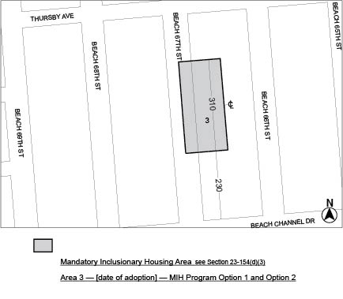

Portion of Community District 14, Queens

* * *
[CITY COUNCIL APPROVED MAP]

Adopted.

Office of the City Clerk,}
The City of New York,} ss.:

I hereby certify that the foregoing is a true copy of a Resolution passed by The Council of The City of New York on August 26, 2021, on file in this office.

.....................................................
City Clerk, Clerk of The Council

