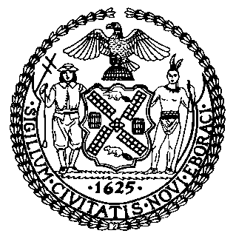 | The Council of the City of New York  Finance Division  Latonia Mckinney, Director  Fiscal Impact Statement  Proposed Int. No. 1673-A  Committee: Committee on Economic Development
Title: A Local Law to amend the administrative code of the city of New York, in relation to city agency food waste prevention plans | Sponsors: Council Members Rivera, Kallos, Ayala, Gibson, Lander, Van Bramer, Rosenthal, and Yeger
Summary of Legislation: Proposed Int. No. 1673-A would require each City agency with at least one food purchase contract within the previous 12 months to develop and implement a plan for reducing food waste. Each agency would be required to designate a coordinator to oversee the implementation of the plan and to include updates on the plan in the agency’s annual recycling report.
Effective Date: This local law would take effect 90 days after it becomes law.
Fiscal Year In Which Full Fiscal Impact Anticipated: Fiscal 2023
Fiscal Impact Statement:

 | Effective FY22 | FY Succeeding  Effective FY23 | Full Fiscal  Impact FY23
Revenues (+) | $0 | $0 | $0
Expenditures (-) | $0 | $0 | $0
Net | $0 | $0 | $0

Impact on Revenues: It is anticipated that there would be no impact on revenues resulting from the enactment of this legislation.
Impact on Expenditures: It is anticipated that there would be no impact on expenditures resulting from the enactment of this legislation as the impacted agencies would use existing resources to fulfill the requirements of this legislation.
Source of Funds To Cover Estimated Costs: N/A
Source of Information: Mayor’s Office of City Legislative Affairs
New York City Council Finance Division
Estimate Prepared by: Julia K. Haramis, Financial Analyst
Estimate Reviewed by: Regina Poreda Ryan, Deputy Director
Dohini Sompura, Unit Head
Stephanie Ruiz, Assistant Counsel
Legislative History: This legislation was introduced to the Council on August 14, 2019 as Int. No. 1673 and was referred to the Committee on Economic Development (the Committee). A hearing was held by the Committee jointly with the Committee on Education and the Committee on General Welfare on September 18, 2019, and the legislation was laid over. The legislation was subsequently amended and the amended version, Proposed Int. No. 1673-A, will be voted on by the Committee at a hearing on April 20, 2021. Upon a successful vote by the Committee, Proposed Int. No. 1673-A will be submitted to the full Council for a vote on April 22, 2021.
Date Prepared: April 15, 2021

