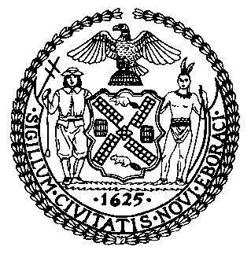 | The Council of the City of New York  Finance Division  Latonia Mckinney, Director  Fiscal Impact Statement  Proposed Intro. No: 1806-A  Committee: TECHNOLOGY
Title: Proposed Introduction No. 1806-A: A Local Law to amend the administrative code of the city of New York, in relation to reporting on automated decision systems used by city agencies | Sponsor(s): Council Members Koo, Lander, Ayala and Kallos
Summary of Legislation: Proposed Int. No. 1806-A would require city agencies to provide information regarding every automated decision system used by the agency during the prior calendar year to the Mayor’s Office of Operations. Such information would include what each automated decision system is intended to measure or reveal and a description of the decisions made or based on such system. The Mayor’s Office of Operations would be required to compile the information received by city agencies and report it to the Mayor and the Speaker of the Council every year.
Effective Date: This local law takes effect immediately.
Fiscal Year In Which Full Fiscal Impact Anticipated: Fiscal 2023
Fiscal Impact Statement:
 | Effective FY22 | FY Succeeding  Effective FY23 | Full Fiscal  Impact FY23
Revenues | $0 | $0 | $0
Expenditures | $0 | $0 | $0
Net | $0 | $0 | $0
Impact on Revenues: It is anticipated that the enactment of this legislation would not generate any revenue.

Impact on Expenditures: It is estimated that there would be no impact on expenditures resulting from the enactment of this legislation.

Source of Funds To Cover Estimated Costs: N/A

Source of Information: New York City Council Finance Division

Estimate Prepared by: Florentine Kabore, Financial Analyst

Estimate Reviewed by: John Russell, Unit Head
Nathan Toth, Deputy Director
Noah Brick, Assistant Counsel
Legislative History: This legislation was introduced to the Council on November 26, 2019 as Int. No. 1806 and was referred to the Committee on Technology (Committee). The Committee heard the legislation on January 22, 2020 and the legislation was laid over. The bill was subsequently amended, and the amended version, Proposed Int. No. 1806-A, will be heard by the Committee on December 14, 2021. Upon a successful vote by the Committee, the bill will be submitted to the full Council for a vote on December 15, 2021.
Date Prepared: December 13, 2021

