THE COUNCIL OF THE CITY OF NEW YORK
RESOLUTION NO. 1754

Resolution approving the decision of the City Planning Commission on Application No. N 200204 ZRK, for an amendment of the text of the Zoning Resolution (L.U. No. 833).

By Council Members Salamanca and Moya

WHEREAS, Lipkaw Realty, LLC, filed an application pursuant to Section 201 of the New York City Charter, for an amendment of the text of the Zoning Resolution of the City of New York, modifying APPENDIX F for the purpose of establishing a Mandatory Inclusionary Housing area, which in conjunction with the related action would facilitate the interior renovation and expansion of an existing long-term care facility located at 2840 Knapp Street (Block 8808, Lot 45) in the Sheepshead Bay neighborhood of Brooklyn, Community District 15 (ULURP No. N 200204 ZRK), (the “Application”);

WHEREAS, the City Planning Commission filed with the Council on August 23, 2021, its decision dated August 18, 2021 (the "Decision") on the Application;

WHEREAS, the Application is related to application C 200203 ZMK (L.U. No. 832), a zoning map amendment to change an R5 district to an R6 district;

WHEREAS, the Decision is subject to review and action by the Council pursuant to Section 197-d of the City Charter;

WHEREAS, upon due notice, the Council held a public hearing on the Decision and Application on September 10, 2021;

WHEREAS, the Council has considered the land use implications and other policy issues relating to the Decision and Application; and

WHEREAS, the Council has considered the relevant environmental issues, including the Negative Declaration issued April 19th, 2021, (CEQR No. 20DCP077K) which include an (E) designation related to air quality and noise has been assigned to the site in connection with the proposed action (E-611) (the “Negative Declaration”).

RESOLVED:

The Council finds that the action described herein will have no significant impact on the environment as set forth in the (E) Designation (E-611) and Negative Declaration.

Pursuant to Sections 197-d and 200 of the City Charter and on the basis of the Decision and Application, and based on the environmental determination and consideration described in the report, N 200204 ZRK, incorporated by reference herein, and the record before the Council, the Council approves the Decision of the City Planning Commission.

Matter underlined is new, to be added;
Matter struck out is to be deleted;
Matter within # # is defined in Section 12-10;
* * * indicates where unchanged text appears in the Zoning Resolution

* * *

APPENDIX F
Inclusionary Housing Designated Areas and Mandatory Inclusionary Housing Areas

* * *

BROOKLYN

* * *

Brooklyn Community District 15

* * *
Map 2 [date of adoption]

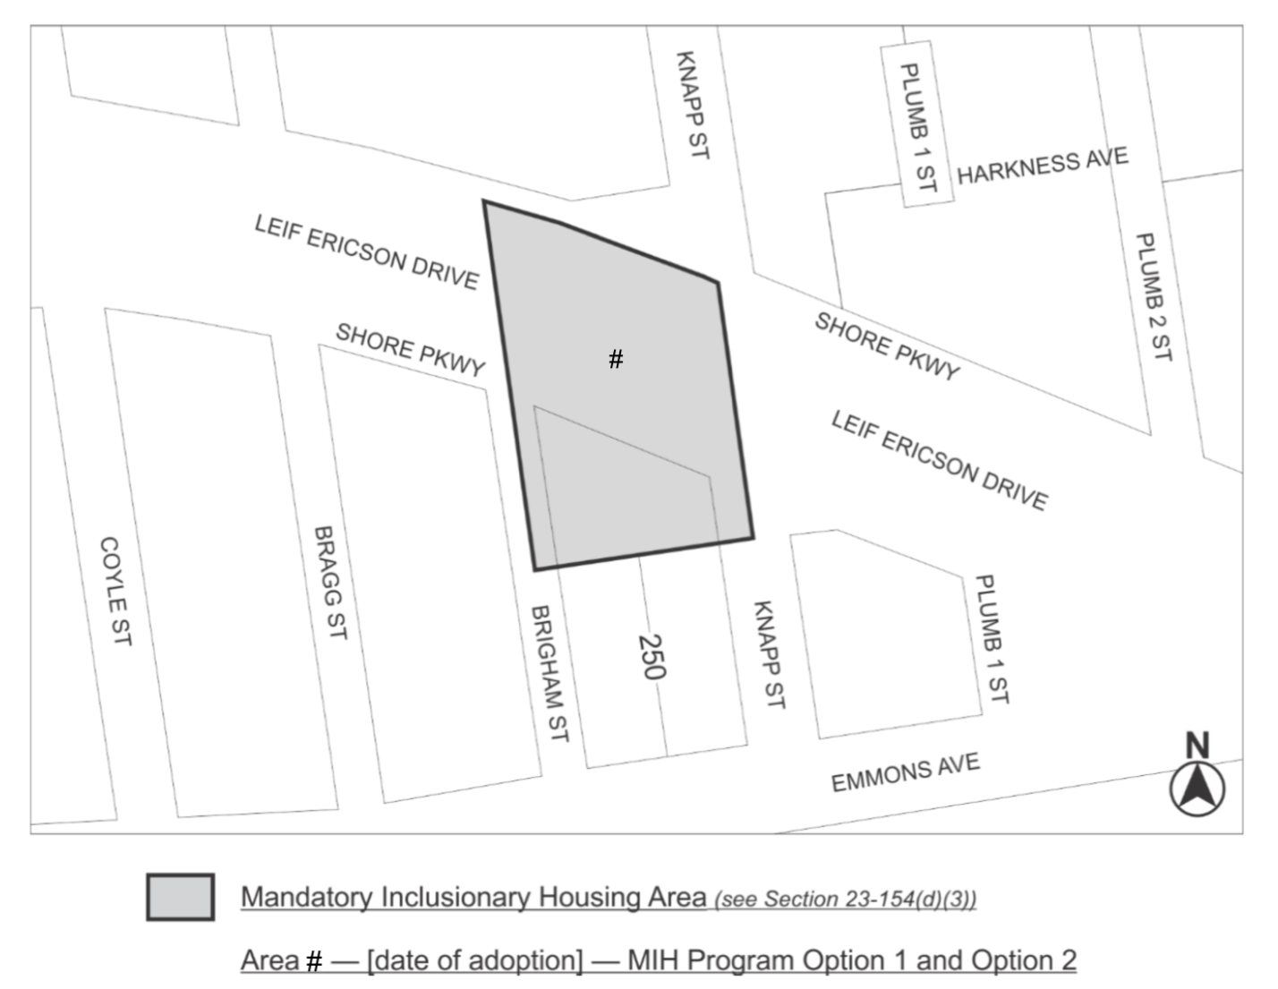

Portion of Community District 15, Brooklyn

* * *

Adopted.

Office of the City Clerk,}
The City of New York,} ss.:

I hereby certify that the foregoing is a true copy of a Resolution passed by The Council of The City of New York on October 7, 2021, on file in this office.

.....................................................
City Clerk, Clerk of The Council

