THE COUNCIL OF THE CITY OF NEW YORK
RESOLUTION NO. 253

Resolution approving the decision of the City Planning Commission on Application No. N 200336 ZRK, for an amendment of the text of the Zoning Resolution (L.U. No. 66).

By Council Members Salamanca and Riley

WHEREAS, 98 Third Avenue Realty, LLC, filed an application pursuant to Section 201 of the New York City Charter, for an amendment of the text of the Zoning Resolution of the City of New York, modifying Appendix F for the purpose of establishing a Mandatory Inclusionary Housing area, which in conjunction with the related action would facilitate the construction of a new mixed-use development containing approximately 24 dwelling units, approximately eight of which would be affordable under the Mandatory Inclusionary Housing (MIH) Program, as well as approximately 3,500 square feet of commercial floor area on the ground floor of the building, located at 98 Third Avenue (Block 388, Lot 31) in the Boerum Hill neighborhood of Brooklyn, Community District 2 (ULURP No. N 200336 ZRK) (the “Application”);

WHEREAS, the City Planning Commission filed with the Council on May 13, 2022, its decision dated May 11, 2022 (the “Decision”), on the Application;

WHEREAS, the Application is related to application C 200335 ZMK (L.U. No. 65), a zoning map amendment to change an M1-2 zoning district to an R7D/C2-4 zoning district and an R6B zoning district;

WHEREAS, the Decision is subject to review and action by the Council pursuant to Section 197-d of the City Charter;

WHEREAS, upon due notice, the Council held a public hearing on the Decision and Application on May 31, 2022;

WHEREAS, the Council has considered the land use implications and other policy issues relating to the Decision and Application; and

WHEREAS, the Council has considered the relevant environmental issues, including the Negative Declaration issued December 13th, 2021 (CEQR No. 21DCP096K) which includes an (E) designation on the development site to avoid the potential for significant adverse impacts related to hazardous materials, air quality, and noise impacts (E-647) (the “Negative Declaration”).

RESOLVED:

The Council finds that the action described herein will have no significant impact on the environment as set forth in the (E) Designation (E-647) and Negative Declaration.

Pursuant to Sections 197-d and 200 of the City Charter and on the basis of the Decision and Application, and based on the environmental determination and consideration described in the report, N 200336 ZRK, incorporated by reference herein, and the record before the Council, the Council approves the Decision of the City Planning Commission.

Matter underlined is new, to be added;
Matter struck out is to be deleted;
Matter within # # is defined in Section 12-10;
* * * indicates where unchanged text appears in the Zoning Resolution.

APPENDIX F
Inclusionary Housing Designated Areas and Mandatory Inclusionary Housing Areas

* * *

BROOKLYN

* * *

Brooklyn Community District 2

* * *

Map 10 – [date of adoption]

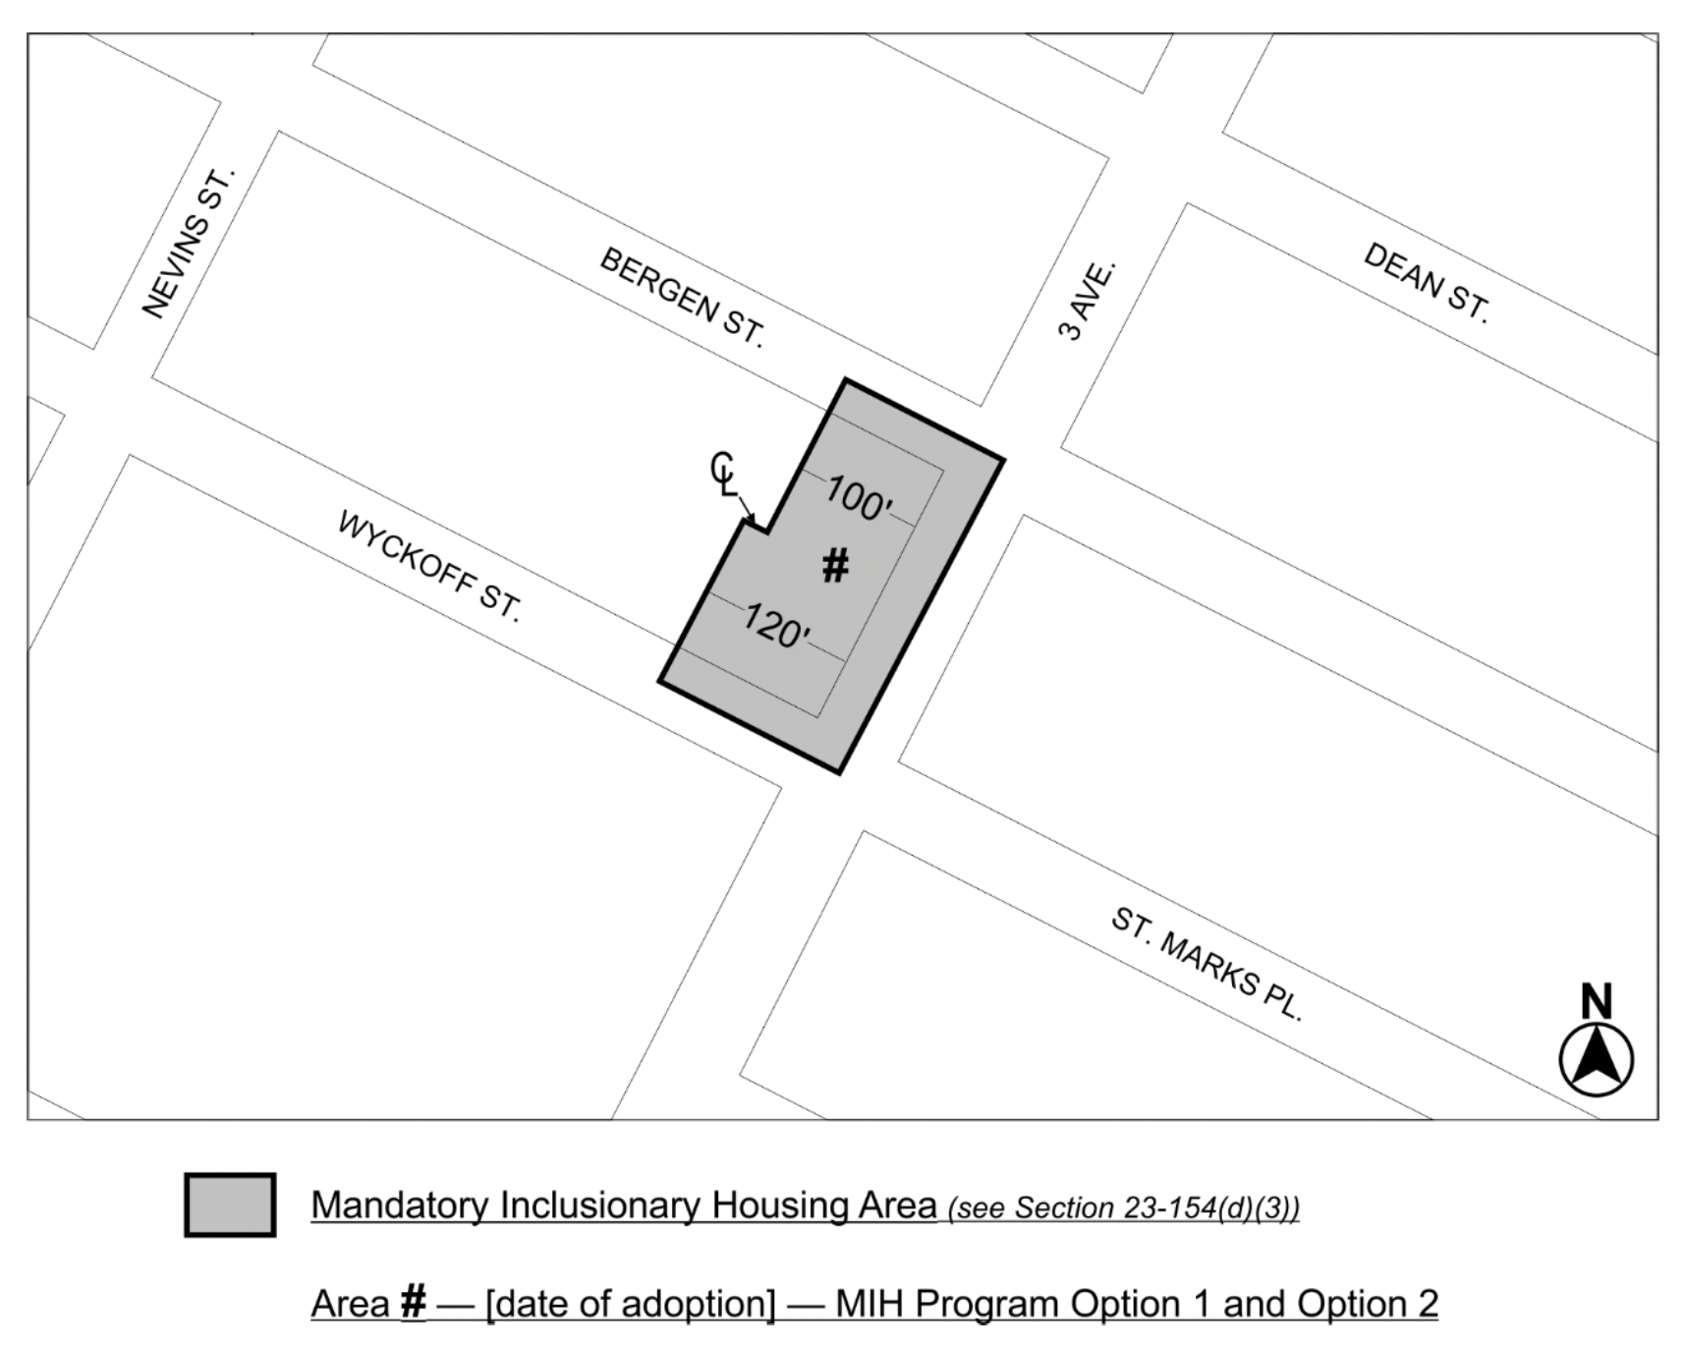

Portion of Community District 2, Brooklyn

* * *

Adopted.

Office of the City Clerk, }
The City of New York, } ss.:

I hereby certify that the foregoing is a true copy of a Resolution passed by The Council of The City of New York on __________, 2022, on file in this office.

.....................................................
City Clerk, Clerk of The Council

