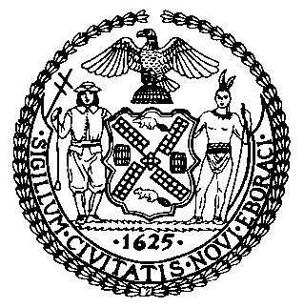 | The Council of the City of New York  Finance Division  Tanisha S. Edwards, Esq., Chief Financial Officer and Deputy Chief of Staff to the Speaker  Richard Lee, Finance Director  Fiscal Impact Statement  Proposed Intro. No: 431-A  Committee: General Welfare
Title: A Local Law to amend the administrative code of the city of New York, in relation to customer service training for shelter personnel of the department of homeless services and its contractors. | Sponsor(S): Salamanca, Hanif, Louis, Krishnan, Ayala, Lee, and Sanchez
Summary of Legislation: Proposed Int. No. 431-A would require the Department of Homeless Services (DHS) to develop and provide biannual training, unless otherwise provided by contract, to shelter personnel on best practices for improving interactions with shelter residents. The training would include techniques to improve professionalism, increase cultural sensitivity, implement a trauma-informed approach to interactions with shelter residents, and de-escalate conflict.

Effective Date: This local law would take effect 120 days after it becomes law.

Fiscal Year In Which Full Fiscal Impact Anticipated: Fiscal Year 2025
Fiscal Impact Statement:

 | Effective FY24 | FY Succeeding Effective FY25 | Full Fiscal Impact FY25
Revenues | $0 | $0 | $0
Expenditures | $0 | $0 | $0
Net | $0 | $0 | $0

Impact on Revenues: It is anticipated that there would be no impact on revenues resulting from the enactment of this legislation.

Impact on Expenditures: It is anticipated that there would be no impact on expenditures resulting from the enactment of this legislation as DHS will utilize existing resources to fulfill the requirements of this legislation.

Source of Funds To Cover Estimated Costs: N/A

Source of Information: New York City Council Finance Division
Estimate Prepared By: Julia K. Haramis, Principal Financial Analyst, NYC Council Finance Division

Estimate Reviewed By: Aliya Ali, Unit Head, NYC Council Finance Division
Kathleen Ahn, Counsel, NYC Council Finance Division
Chima Obichere, Deputy Director, NYC Council Finance Division
Jonathan Rosenberg, Managing Deputy Director, NYC Council Finance Division
Legislative History: This legislation was introduced to the Council on May 19, 2022, as Int. No. 431 and was referred to the Committee on General Welfare (the Committee). A hearing was held by the Committee on September 13, 2022, and the legislation was laid over. The legislation was subsequently amended and the amended version, Proposed Int. No. 431-A, will be voted on by the Committee at a hearing on March 16, 2023. Upon a successful vote by the Committee, Proposed Intro. No. 431-A will be submitted to the full Council for a vote on March 16, 2023.
Date Prepared: March 12, 2023

