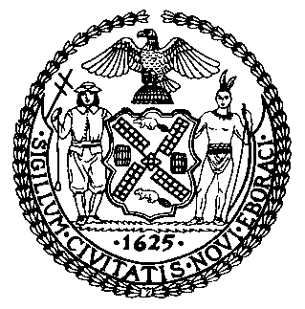 | The Council of the City of New York  Finance Division  Latonia McKinney, Director  Fiscal Impact Statement  Proposed Int. No: 2449-A  Committee: Housing and Buildings
Title: A Local Law to amend the administrative code of the city of New York, in relation to penalties for failing to certify correction of immediately hazardous conditions and the reinspection of immediately hazardous conditions at construction sites, and penalties for one to four family homes | Sponsors: Council Members Gibson, Van Bramer, Gjonaj, Cornegy, and Brannan
Summary of Legislation: Proposed Int. No. 2446-A would clarify Department of Buildings (“DOB”) enforcement requirements with respect to one- to four-family homes. This bill would allow DOB to issue a request for corrective action in lieu of a notice of violation to one- and two-family homes, with some exceptions. This bill clarifies that the penalty issued for failure to submit a certification of correction of an immediately hazardous violation and the re-inspection requirement for such violation apply only at construction sites, and do not apply to one- to four-family homes.

Effective Date: This local law would take effect 120 days after becoming law

Fiscal Year In Which Full Fiscal Impact Anticipated: Fiscal 2023
Fiscal Impact Statement:
 | Effective FY22 | FY Succeeding Effective FY23 | Full Fiscal Impact FY23
Revenues | $0 | $0 | $0
Expenditures | $0 | $0 | $0
Net | $0 | $0 | $0
Impact on Revenues: It is estimated that there would be no impact on revenues resulting from the enactment of this legislation.

Impact on Expenditures: It is estimated that there would be no impact on expenditures resulting from the enactment of this legislation because the relevant agencies would utilize existing resources.
Source of Funds to Cover Estimated Costs: N/A
Source of Information: New York City Council Finance Division
Mayor’s Office of Legislative Affairs
Estimate Prepared by: John Basile, Senior Financial Analyst

Estimate Reviewed by: Chima Obichere, Unit Head
Stephanie Ruiz, Assistant Counsel
Legislative History: This legislation was first considered by the Committee on Housing and Buildings (the “Committee”) on November 9, 2021 as a Pre-considered Introduction and the bill was laid over. Following the Committee hearing, the legislation was introduced to the full Council on November 10, 2021 as Int. No. 2449 and was referred to the Committee. The legislation was subsequently amended and the amended version, Proposed Int. No. 2449-A, will be considered by the Committee on December 14, 2021. Upon a successful vote by the Committee, Proposed Int. No. 2449-A will be submitted to the full Council for a vote on December 15, 2021
Date Prepared: December 13, 2021

