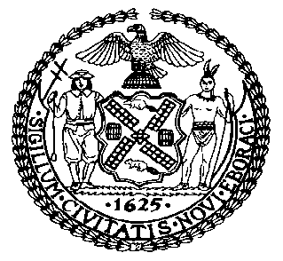 | The Council of the City of New York  Finance Division  Latonia McKinney, Director  Fiscal Impact Statement  Intro. No: 979  Committee: Housing and Buildings
Title: A Local Law to amend the administrative code of the city of New York, in relation to community land trusts | Sponsors: Council Members Richards, Levin and Rosenthal
Summary of Legislation: Intro. No. 979 is a technical amendment that would provide discretion to the Department of Housing Preservation and Development (HPD) whether to enter into a regulatory agreement with a community land trust, as set forth in Local Law 67 of 2018.

Effective Date: This local law would take effect immediately and would be retroactive to and deemed to have been in full force and effect as of May 19, 2018.
Fiscal Year In Which Full Fiscal Impact Anticipated: Fiscal 2019
Fiscal Impact Statement:

 | Effective FY19 | FY Succeeding Effective FY20 | Full Fiscal Impact FY19
Revenues | $0 | $0 | $0
Expenditures | $0 | $0 | $0
Net | $0 | $0 | $0

Impact on Revenues: It is estimated that there would be no impact on revenues resulting from the enactment of this legislation.

Impact on expenditures: It is estimated that there would be no impact on expenditures resulting from the enactment of this legislation because existing resources would be used by HPD to implement the provisions of this legislation.
Source of Funds To Cover Estimated Costs: N/A.

Source of Information: New York City Council Finance Division

Estimate Prepared by: Sarah Gastelum, Principal Financial Analyst

Estimated Reviewed by: Noah Brick, Assistant Counsel
Chima Obichere, Unit Head

Legislative History: This legislation was introduced to the full council on June 7, 2018 as Intro. No. 979 and was referred to the Committee on Housing and Buildings (Committee). A hearing was held by the Committee on October 16, 2018 and the legislation was laid over. The Housing and Buildings Committee will vote on Intro. No. 979 on February 26, 2019. Following a successful vote by the Committee, the bill would be submitted to the full Council for a vote on February 28, 2019.
Date Prepared: February 21, 2019

