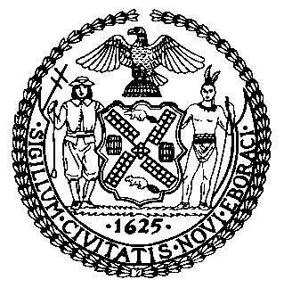 | The Council of the City of New York  Finance Division  Latonia McKinney, Director  Fiscal Impact Statement  Proposed Intro. No. 1318-A  Committee: Environmental Protection
Title: A Local Law to amend the administrative code of the city of New York, in relation to an assessment of the replacement of gas-fired power plants and to amend local law number 248 for the year 2017, in relation to the completion date of the long-term energy plan | Sponsors: Council Members Constantinides, Cabrera, Rosenthal, Cohen, Rodriguez, Menchaca, Dromm, Powers, Maisel, Vallone, Adams, Espinal, Richards, Kallos and Lander
Summary of Legislation: Proposed Int. No. 1318-A would require the Administration to conduct an assessment of the feasibility of utilizing renewable energy sources combined with battery storage to replace in-city gas fired power plants. The results of such assessment must be included in the City’s long-term energy plan, which this local law would require to be completed by December 31, 2021, and updated every four years thereafter.
Effective Date: This local law would take immediately.
Fiscal Year in which Full Fiscal Impact Anticipated: Fiscal 2020
Fiscal Impact Statement:
 | Effective FY19 | FY Succeeding  Effective FY20 | Full Fiscal Impact FY20
Revenues (+) | $0 | $0 | $0
Expenditures (-) | $0 | $0 | $0
Net | $0 | $0 | $0

Impact on Revenues: It is anticipated that there would be no impact on revenues resulting from the enactment of this legislation.
Impact on Expenditures: It is anticipated that there would be no impact on expenditures resulting from the enactment of this legislation.
Source of Funds to Cover Estimated Costs: N/A
Sources of Information: City Council Finance Division
Mayor’s Office of City Legislative Affairs
Estimate Prepared by: Jonathan Seltzer, Senior Financial Analyst
Estimate Reviewed by: Nathan Toth, Deputy Director
Crilhien R. Francisco, Unit Head
Noah Brick, Assistant Counsel
Legislative History: This legislation was introduced to the Council as Intro. No. 1318 on January 9, 2019 and referred to the Committee on Environmental Protection (Committee). The Committee heard the legislation on February 11, 2019 and the legislation was laid over. The legislation was subsequently amended and the amended version, Proposed Intro. No. 1318-A, will be considered by the Committee on April 18, 2019. Upon a successful vote by the Committee, Proposed Intro. No. 1318-A will be submitted to the full Council for a vote on April 18, 2019.

Date Prepared: April 10, 2019

