Environmental Protection Committee
Samara Swanston, Legislative Counsel
Nadia Johnson, Senior Policy Analyst
Ricky Chawla, Policy Analyst
Jonathan Seltzer, Senior Finance Analyst

Resiliency & Waterfronts Committee
Jessica Steinberg Albin, Legislative Counsel
Patrick Mulvihill, Senior Policy Analyst
Jonathan Seltzer, Senior Finance Analyst

Land Use Division
James Cottone, Resiliency Planner

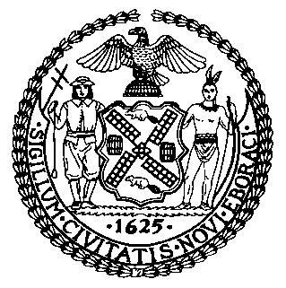

The New York City Council
Jeffrey Baker, Legislative Director

COMMITTEE REPORT OF THE INFRASTRUCTURE DIVISION
Terzah Nasser, Deputy Director

Committee on Environmental Protection
Hon. Costa Constantinides, Chair

Committee on Resiliency & waterfronts
Hon. Justin Brannan, Chair

October 29, 2019

Oversight: 7th Anniversary of Superstorm Sandy

Int. No. 382: By Council Member Ulrich

Title: A Local Law to amend the administrative code of the city of New York, in relation to a special flood hazard area notification

Administrative Code: Adds a new section 30-116

Int. No. 1480: By Council Members Constantinides, Ulrich, Brannan, Gjonaj, Chin and Gibson

Title: A Local Law to amend the New York city charter, in relation to creating a marine debris disposal office

City Charter: Adds a new section 20-f

Int. No. 1620: By Council Members Constantinides, Brannan, Koo, Levin and Gibson

Title: A Local Law to amend the administrative code of the city of New York, in relation to the creation of a comprehensive five borough plan to protect the entire shoreline from climate change, sea level rise and sunny day flooding

Administrative Code: Adds a new section 24-808

- Introduction
On October 29, 2019, the Committee on Environmental Protection, chaired by Council Member Costa Constantinides, and the Committee on Resiliency and Waterfronts, chaired by Council Member Justin Brannan, will hold a joint oversight hearing entitled “7th Anniversary of Superstorm Sandy.” The Committees will also consider three bills. Int. No. 382, sponsored by Council Member Ulrich, would require a special flood hazard area notification. Int. No. 1480, sponsored by Council Member Constantinides, would require the creation of a marine debris disposal office. Int. No. 1620, sponsored by Council Member Constantinides, would require the creation of a five borough resiliency plan. The Committees expect to hear testimony from the Mayor’s Office of Resiliency, the Office of Emergency Management, climate experts, environmental and housing advocates, and interested members of the public.

- Background
On October 29, 2012, Superstorm Sandy approached New York City from the southeast, causing high winds and a 14-foot storm surge. Sections of Lower Manhattan, Staten Island, Brooklyn and Queens were inundated with seawater. The Superstorm flooded approximately 17% of New York City’s total land mass, or 51 square miles. By the end of 2012, the Department of Buildings (DOB) identified approximately 800 buildings as damaged or destroyed and thousands of housing units were found to have suffered some amount of damage.
Superstorm Sandy caused an estimated $19 billion in losses in New York City. Along with damage to residential and commercial property, the storm damaged critical city infrastructure and services. Close to 2 million people lost power at some point during the storm. Con Edison’s steam system was unable to service one-third of its customers for nearly two weeks. Flood damage at critical facilities in Southern Manhattan, Red Hook, and the Rockaways disrupted landline and Internet service for up to 11 days. Six hospitals and 500 buildings with doctors’ offices, clinics, and other outpatient facilities were forced to close due to flooding.
On October 8, 2018, the Intergovernmental Panel on Climate Change (“IPCC”) released a special report on the impacts of global warming of 1.5°C above preindustrial levels. According to the report, peak temperature increase beyond 2°C will lead to long-lasting and irreversible changes, such as ecosystem loss. Climate change is expected to continue exacerbating extreme weather events, leading to stronger and more frequent storms like Hurricane Sandy.At a City Council hearing in April 2018, the Director of the Mayor’s Office for Recovery and Resiliency testified that by 2050, New York City’s annual precipitation is “projected to increase between 4 and 11 percent” and that sea levels are “projected to rise between 11 inches and 21 inches, on top of a foot of sea level rise that we have already witnessed since 1900.” For New York City’s waterfront communities, this is a life- and property- threatening reality. Further, extreme weather events could cost $90 billion in damages in 2050, compared to the $19 billion caused by Superstorm Sandy.

A. Flooding
A recent report by the National Oceanic and Atmospheric Administration (NOAA) finds that by 2100, "high tide flooding will occur 'every other day' (182 days/year) or more often under the Intermediate Low Scenario within the Northeast and Southeast Atlantic. . ." The report also projects that the low and high end estimates of high tide flood frequency along the coast of the Northeast Atlantic “will reach on average about 235 and 365 days/year (with 95 and 100% from tides)” respectively. New York City’s waterfront communities face significant threats from extreme weather events and high tides, and projections show that these communities will experience greater and more frequent damage because of climate-related weather events and sea level rise. Neighborhoods such as Broad Channel, Howard Beach, Hamilton Beach, Rosedale, Far Rockaway, Coney Island, Stapleton, Arrochar, and Midland Beach, where eight New Yorkers drowned in Sandy’s floodwaters, regularly experience tidal inundation, a trend that will only be exacerbated by continued sea level rise. (See Figure 1)

Figure 1: Potential progression of monthly tidal flooding from present through 2100
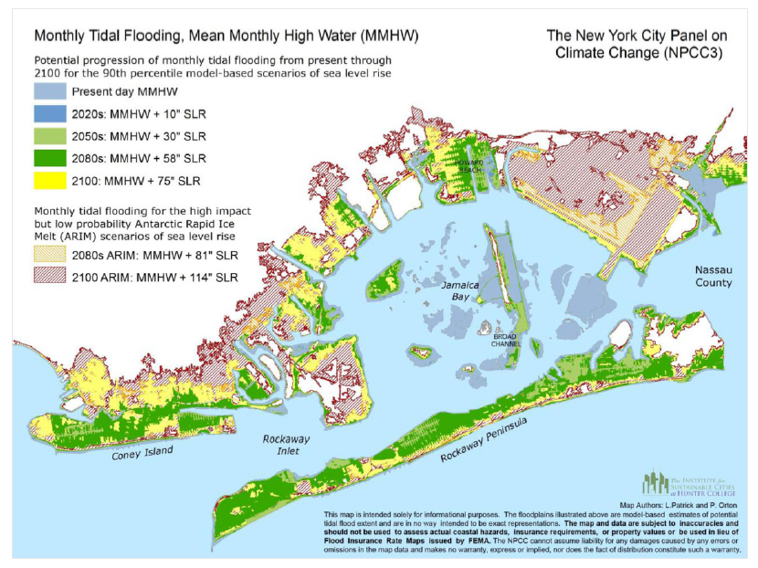-

B. Sea Level Rise
With 520 miles of coastline bordering the ocean, rivers, bays and inlets, New York City is particularly vulnerable to the impacts of sea-level rise, storm surge, and high-tide or sunny-day flooding. According to a Union of Concerned Scientists study published in 2018, New York State ranks third in the nation for most homes at risk of coastal inundation by the end of the century. The East and Gulf Coasts of the United States are undergoing some of the fastest rates of sea level rise, with coastal flooding rates in 2012 averaging once every three months, up from once every 5 years in the 1950’s. Nationally, more than 300,000 homes with a collective value of $117.5 billion dollars, and 14,000 commercial properties valued at $18.5 billion dollars are at risk of chronic flooding within the next 30 years. In the state of New York, 15,500 homes representing a population of approximate 42,000 people and valued at approximately 8.5 billion dollars, mostly clustered in Long Island (Hempstead, Babylon), and Queens, risk chronic inundation by 2045. By 2100, 143,000 properties housing approximately 366,000 people, and valued at approximately 98 billion dollars, risk the same fate. The homes at risk by 2045 contributed about 170 million dollars in tax revenue by 2018 figures, and those at risk by 2100 represent 2 billion dollars of tax revenue. The 2,700 homes at risk in Queens by 2045 are largely concentrated in environmental justice communities.

Figure 2: 100 Year Flood Plain in 2050
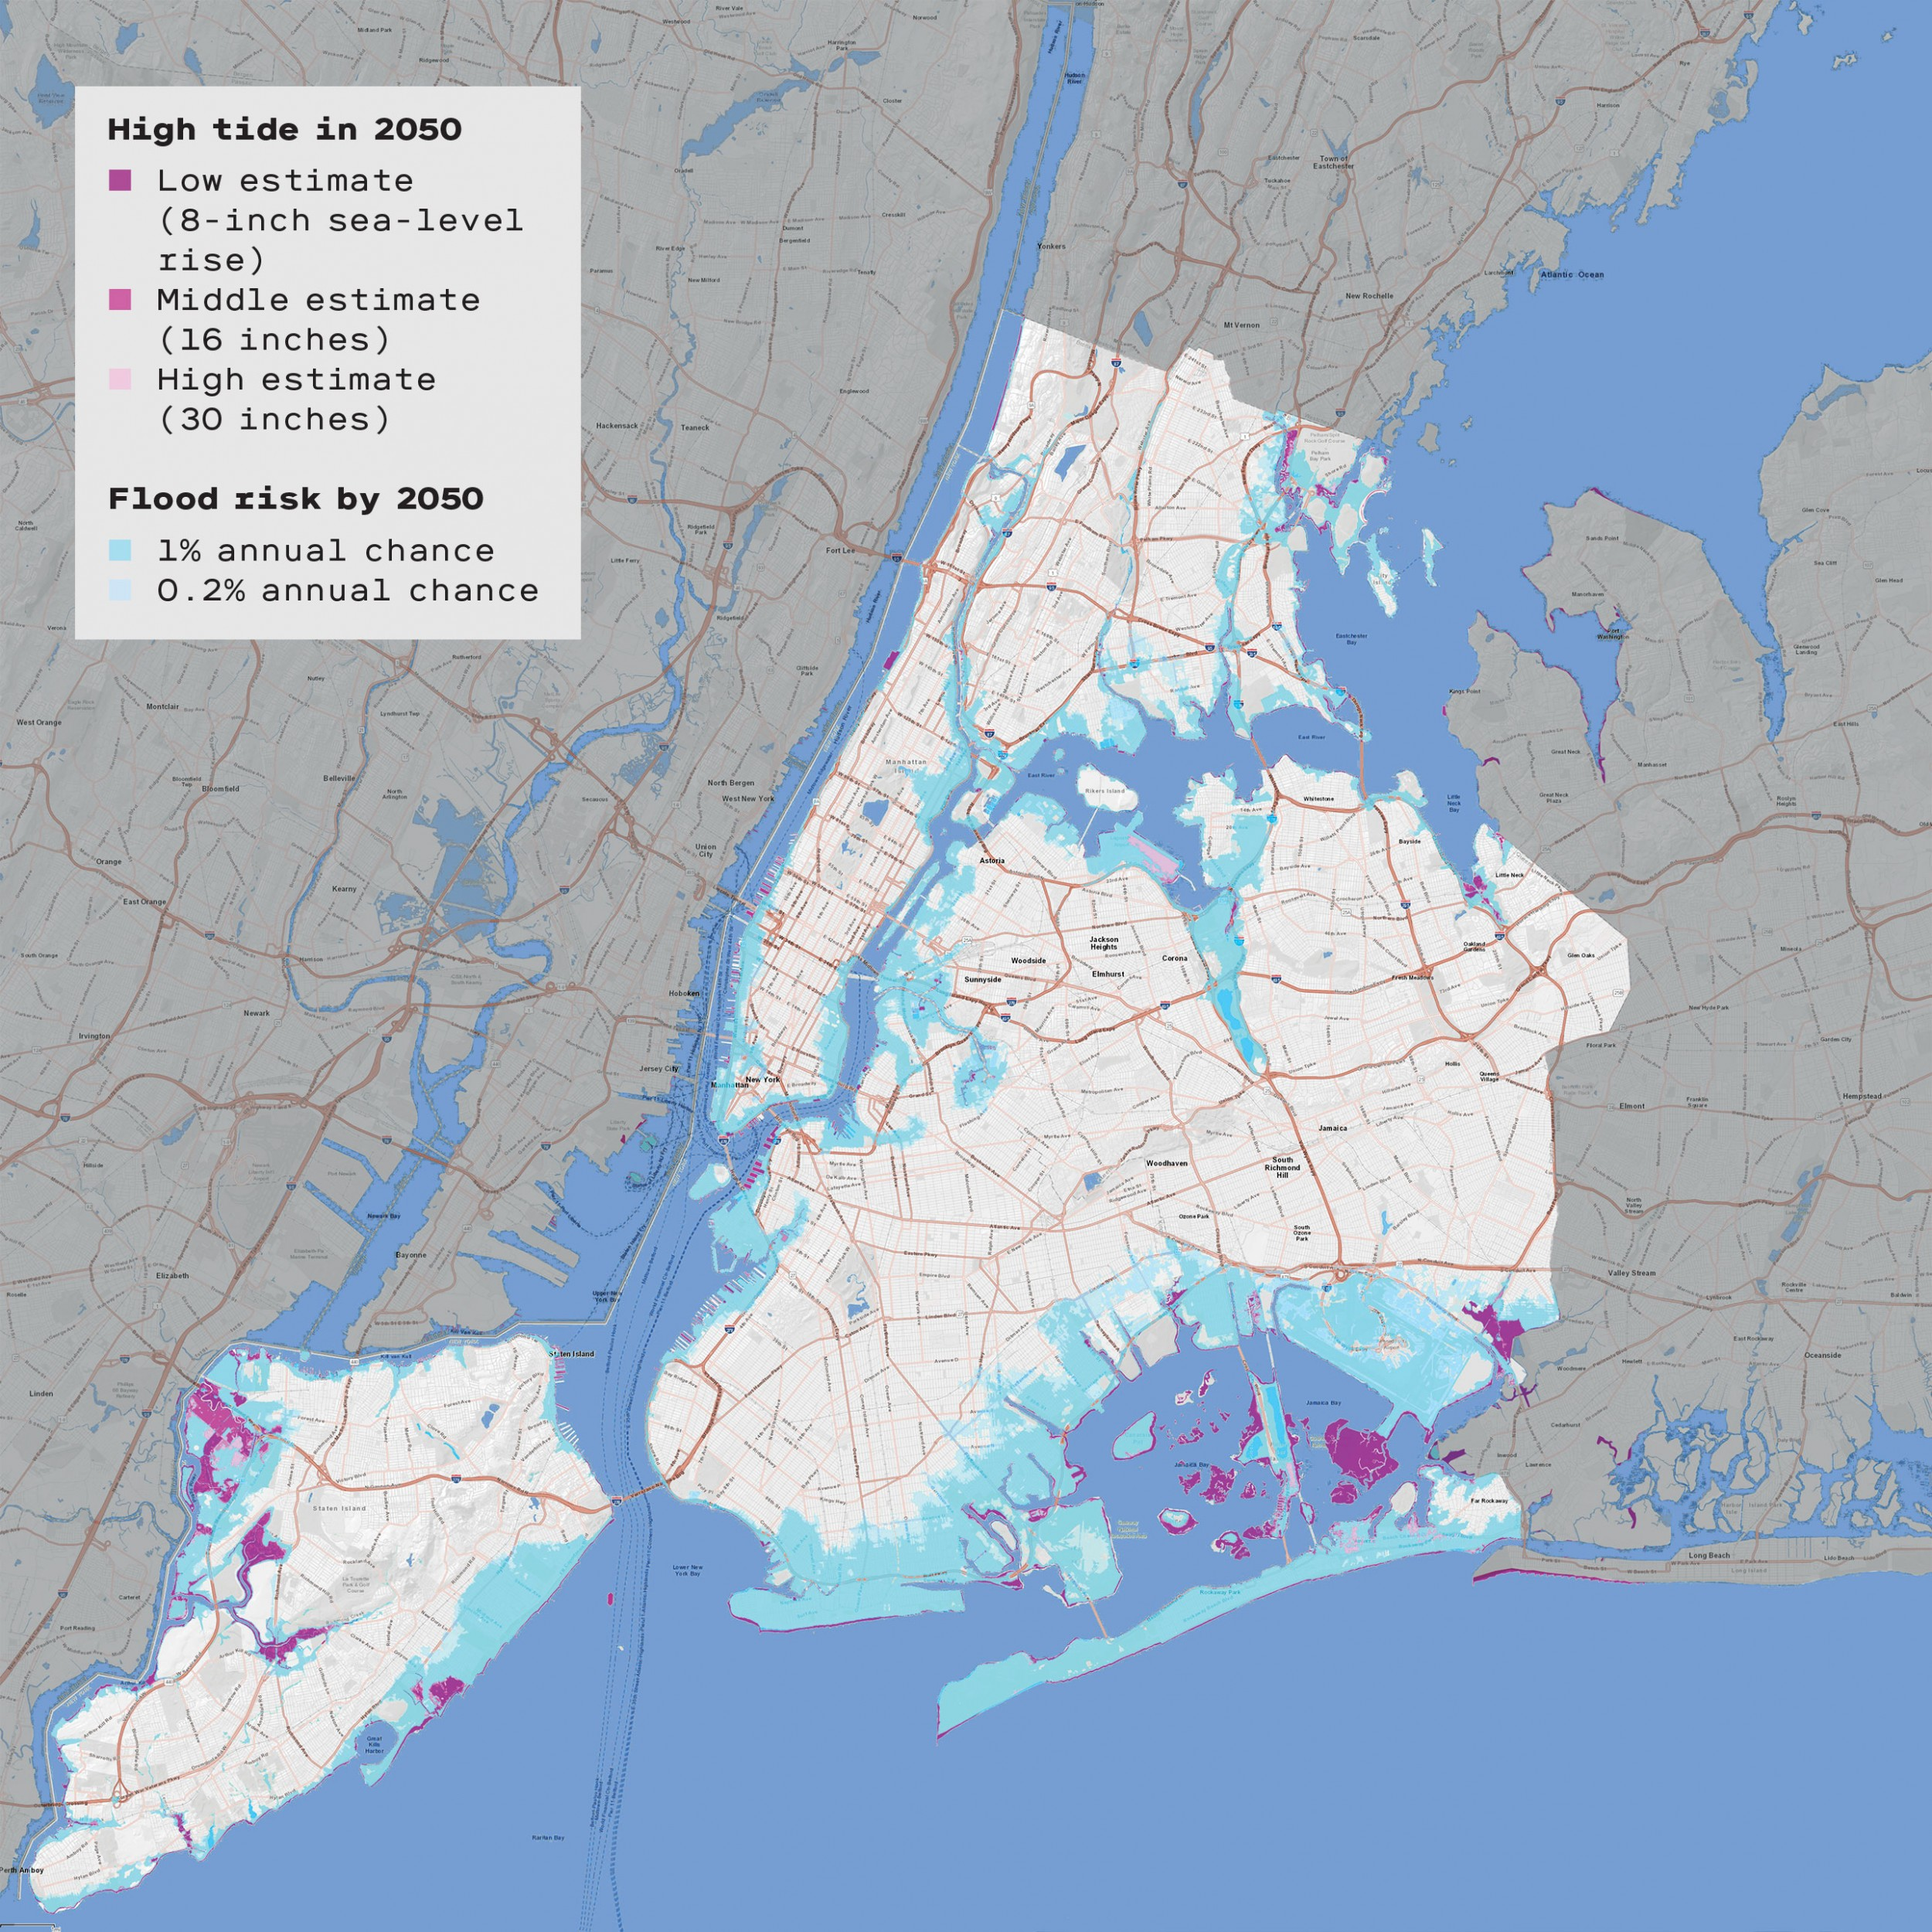

Figure 3: 500 Year Flood Plain in 2050
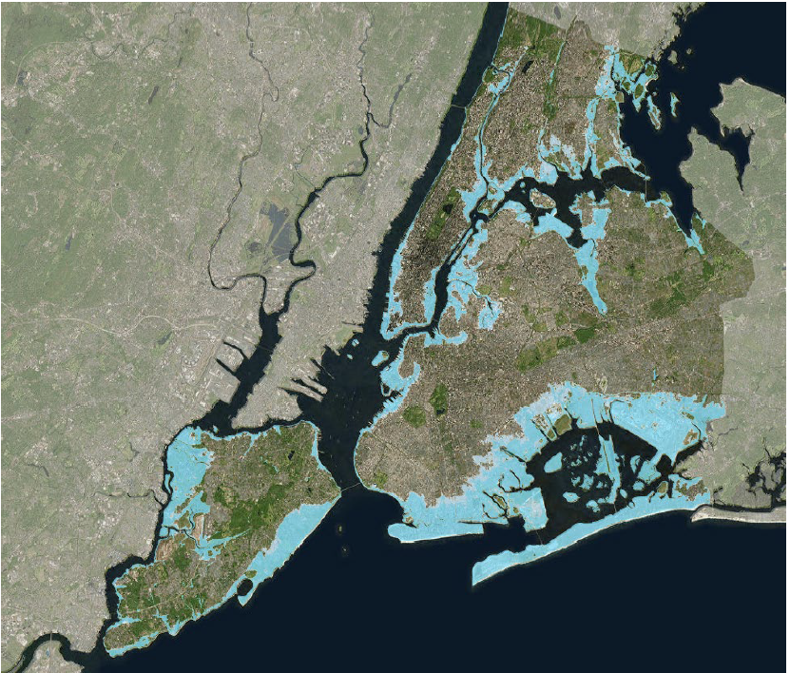

C. Storm Surge
New York suffered unprecedented levels of storm surge during Superstorm Sandy. At the Battery, where tidal records go back to 1920, the storm tide reached 14.06 ft. above Mean Lower Low Water (MLLW), 4.36 ft. higher than the previous record set in December 1992. Parts of Staten Island and Manhattan experienced above ground inundation levels of 4-9 feet due to storm surge, Brooklyn and Queens saw inundation levels ranging from 3-6 feet, and the Bronx saw inundation levels of 2-4 feet. Storm surge related flooding was reported as far up the Hudson River as Albany, with many cities along the banks experiencing 4-5 feet of inundation above ground level. Across the affected area, storm surge was responsible for 57% of the reported fatalities linked to Superstorm Sandy.

- Build It Back

On November 9, 2012, then-Mayor Michael Bloomberg announced the start of the Rapid Repairs Program to assist homeowners by using FEMA grants to fund basic repairs so that residents could shelter in their homes while awaiting more extensive repairs or rebuilding.
To achieve permanent home repairs and rebuilding, the City announced the Build It Back (“BIB”) program on June 13, 2013. BIB is designed to help multi-family and single family homes by using funds from the United States Department of Housing and Urban Development’s (HUD) Community Development Block Grant Disaster Recovery (CDBG-DR) program. The New York City Housing Recovery Office (HRO) administers the BIB program.
BIB offers multiple pathways to homeowners impacted by the storm: repairing, repairing and elevating, or rebuilding damaged homes; reimbursement for repair work; and offers of acquisition for severely damaged homes. The vast majority of applicants to the BIB program are single family homeowners.
Although BIB was created to swiftly and efficiently assist New Yorkers whose homes were destroyed by Superstorm Sandy, there were issues with the program from its inception. The City encouraged everyone to register for BIB by calling 311 or registering on-line. 20,275 homeowners registered for the program. However, since 2014 that number dropped significantly to approximately 8,300 applicants; some applicants were deemed ineligible, did not properly complete paperwork or dropped out because of frustrating delays. At a September 2017 hearing, Amy Peterson, Director of HRO, testified that 4,900 applicants did not take the next step to complete an application, 5,000 applicants started an application at the center but dropped out before selecting a program option and 1,100 applicants were deemed ineligible for such reasons as the property was not a primary residence or lack of compliance with flood insurance requirements.
When BIB was created, it did not have dedicated customer service staff. BIB lost paperwork and applications and failed to properly communicate with applicants. In addition, managing federal funds and their accompanying rules made the development and implementation of BIB more complex. However, BIB’s customer service improved over several months, and proper standards and procedures were implemented. BIB acquired more City staff at its centers, including additional foreign language speaking staff, and were better able to assist applicants through the process,. The program’s policies were also posted online so they were accessible to applicants.
As of May 2019, BIB has served over 96 percent of the approximately 8,300 homeowners who remained in the program through either reimbursement check, construction start or acquisition. Approximately 5,100 projects have been completed across Sandy-impacted areas in Brooklyn, the Bronx, Queens and Staten Island.

- City Resiliency Projects

The New York City Mayor's Office of Recovery and Resiliency (“ORR”) was announced in May 2014 by Mayor Bill de Blasio to lead City efforts “to build a stronger, more resilient New York,” though it is at least in part a renamed continuation of the Office of Long Term Planning and Sustainability, as codified by Local Law 17 of 2008. ORR describes themselves as being guided by scientific data, and the analysis of the New York City Panel on Climate Change (“NPCC”), to ensure that NYC’s communities, economy and public services can withstand and combat the impacts of 21st century threats such as climate change. This work includes spearheading a resiliency program with a $20 billion budget (5.5 billion from city capital, the rest from various federal agencies). Residents can visit the OneNYC Recovery & Resiliency Map (see Figure 4) to see how this budget is being spent on recovery and resiliency projects in their communities.
ORR, along with the Mayor’s Office of Sustainability (MOS), is guided by and oversees several city initiatives, including OneNYC: The Plan for a Strong and Just City (“OneNYC”), which was previously known as “PlaNYC” and is required pursuant to local law, and its related greenhouse gas reduction and climate resiliency goals, along with efforts to recover and rebuild from Superstorm Sandy. OneNYC’s “Vision 4: Our Resilient City” is in part an update of the Bloomberg administration’s 2013 report, A Stronger, More Resilient New York, in which an initial plan for the City’s post-Sandy recovery was laid out.
Additionally, ORR prepared Climate Resiliency Design Guidelines to provide step-by-step instructions for climate change-adaptive construction, incorporating historical weather data with NPCC climate change projections in order to ensure that building code and design standards are updated to address future conditions. These guidelines are supplemented by Department of City Planning Resilient Neighborhood studies, which identify neighborhood-specific strategies, including zoning and land use changes, to support the vitality and resiliency of communities in the floodplain and prepare them for future storms. It was launched in 2013 to work directly with floodplain communities to look at questions of land use, zoning and development in light of coastal flood risks. DCP published summary reports for the neighborhoods studied in 2016 and 2017. The City has also secured a commitment from FEMA to redraw the City’s flood maps so that they better account for flood risk. Progress on projects that are part of the $20 billion resiliency program continue to advance, including the completion of the Rockaway Boardwalk, interim flood protection measures and hundreds of home elevations. A $106 million heat mitigation and adaptation program was also launched, to help keep residents safe during extreme heat.
Figure 4: OneNYC Recovery and Resiliency Map
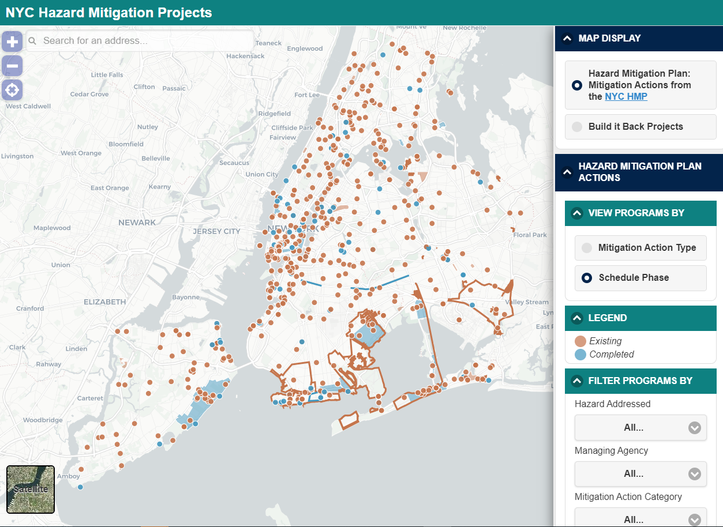

Since Superstorm Sandy, the following resiliency projects have been completed, many with or by state or federal agencies.
Brooklyn
The U.S. Army Corps of Engineers (USACE) announced the completion of the Sea Gate Reach portion of the Coney Island Coastal Storm Risk Reduction Project in June 2016. The $28 million project started over twenty years ago with the widening and elevating of Coney Island beach between Corbin Place and West 37th Street and more recently included beach replenishment, groin work and as a result of Superstorm Sandy, 70,000 cubic yards of sand was placed at Sea Gate Beach. In addition, the project includes four new T-groin structures and Norton Point Dike and the West 37th Street Terminal Groin were reinforced with bedding stone to minimize sand erosion. 30,000 cubic yards of sand will be placed every ten years in future phases of this project to minimize sand erosion and reduce damages to households and businesses during future storms.
Queens
The new resilient Rockaway boardwalk opened in May 2017 after it was destroyed by Superstorm Sandy. The project cost $341 million and was constructed with a steel-reinforced concrete deck which is adhered to steel pipes that elevate it above the 100-year flood plain. Six miles of planted dunes were also integrated into the boardwalk design for protection from future storms.
In Breezy Point, a $56 million double dune system project was approved in August 2014, along with other bayside flooding and erosion protection measures to protect the area from future extreme weather conditions. The dune system continues the existing dune line on the Atlantic side of Breezy Point and provides flood and erosion protection by using the Cooperative’s natural features.
Staten Island

Shoreline protection and reinforced dunes were installed between South Beach and Conference House Park. In addition, Phase I of the New Creek Bluebelt was completed in 2018. Located in Midland Beach, the $25 million first phase of the project includes the first two of 19 Bluebelt wetlands that will receive and filter stormwater that falls in the area. The project includes a new 4.7-acre freshwater wetland between Nugent Avenue and Freeborn Street and a 0.7-acre freshwater wetland from Freeborn Street to Olympia Boulevard. Phase II of the project is ongoing.

- Planning Ahead

Across the five boroughs, there are approximately 680 mitigation actions being undertaken as part of the post-Sandy hazard mitigation plan. These actions are categorized as emergency service actions (approximately 226 listed actions, 13 completed), coastal and natural resource protections (approximately 53 listed actions, 7 completed), infrastructure projects (approximately 94 listed actions, 9 completed), prevention and policy actions (approximately 111 listed actions, 32 completed), property protections (approximately 200+ actions, 41 completed), and public education and awareness initiatives (none currently listed).
Coastal/natural resource protection projects are largely related to the capture and treatment of stormwater runoff, and encompass upgrades to wastewater treatment facilities, bluebelt initiatives in Staten Island, and green infrastructure projects such as bioswales and attempts at reducing impervious surfaces. FEMA has funded short term dune replenishment projects in the Rockaways, and 3,200 feet of living breakwaters, constructed of rubble and mound as well as ecological concrete armor, designed to be colonized and reinforced by marine organisms, are planned for the waters off Staten Island.
Manhattan
Some of the most extensive resiliency projects currently being considered are those aimed at protecting lower Manhattan. The City has committed to employing a variety of resilience strategies along the southern tip of the island, broken into five distinct project areas, starting with the Battery Park City Resilience projects on the west side, the Battery Coastal Resilience project on the southern tip, the financial district and seaport climate resilience master plan, and the Brooklyn Bridge Montgomery Coastal Resilience Plan (also known as the Two Bridges Plan) and East Side Coastal Resiliency Project to the east. Emphasis on this area has been justified by the high concentration of economic interests and critical infrastructure in the area, coupled with its low lying topography. The Two Bridges Plan is reliant on permanent deployable flood walls that would be hidden underground most of the time, and flipped up in the event of a storm. The Battery Coastal Resilience project would raise the height of the waterfront esplanade in the neighborhood. The Battery Park City resilience effort is split into 3 projects, the South Battery Park City Resiliency Project, which would create a continuous flood barrier from the Museum of Jewish Heritage to a higher elevation point at State Street, The North Battery Park City Resiliency Project which relies on deployable barriers, and The Battery Park City Western Perimeter Resiliency project, which relies on garden/park walls to create a new line of flood protection along the water's edge. The financial district and seaport plan that is being proposed is still in the development stage, but is expected to consist of a significant buildout, extending the shoreline approximately 500 feet (or two City blocks) into the East River at a projected cost of $10 billion. The City also plans to deploy interim flood protection measures throughout the lower Manhattan area, consisting of “just in time” water-filled dams to be deployed in event of a storm (Tiger Dams), and pre-deployed sand-filled barriers (HESCO Barriers) to remain in place.
Brooklyn
The planned Red Hook Integrated Flood Protection System is comprised of permanent flood protection barriers around Atlantic Basin. Currently, only temporary measures such as HESCO barriers and Tiger dams have been employed. Department of City Planning led resiliency studies have been initiated for Canarsie, Sheepshead Bay and Gerritsen Beach. These studies examine damage caused by Sandy, potential for damage from future storms, and review zoning regulations to identify changes to land use and zoning necessary to ensure the continued vitality of the neighborhoods. The resiliency study for the Coney Island Creek identifies flood proof measures, measures to improve storm water drainage, and flood mitigation measures for the area. Additionally, sand has been replenished along Coney Island beach to address Sandy-related coastal erosion.

The Bronx
Department of City Planning (DCP) Resilient Neighborhoods studies of Harding Park and Edgewater Park identified strategies to retrofit existing homes and rebuild structures for maximum resiliency while maintaining compliance with local zoning regulations and without unduly affecting existing neighborhood aesthetics. Recommendations include elevating structures and utilities above the base flood elevation, with permeable structures that allow for the pass through of floodwaters. The studies also identified a number of green infrastructure solutions to address stormwater runoff and chronic ponding issues, and call for the fortification of breakwaters along the waterfront. A Rebuild by Design project for Hunts Point has obtained 45 million dollars in HUD CDBG-DR funding. The proposed project will develop a resilient working waterfront, and install resilient and sustainable power to critical facilities at the Food Distribution Center and two local public schools. Also in the study phase, this project is assessing the feasibility of various flood control measures to protect critical food distribution resources in the neighborhood.

Queens
The Rockaway Beach dune project is set to begin in late 2019, and will involve dune reinforcement, and a new tapered groin field combined with a system of berms, floodwalls, and nature based features. A DCP resilient neighborhoods study of Old Howard Beach/Hamilton Beach/Broad Channel, Rockaway Beach/Rockaway Park has created new zoning regulations based on the neighborhood’s high flood risk and established development patterns, that aim to limit further development in the most flood prone areas without unduly limiting homeowners’ ability to invest in their properties or safeguard existing structures. Fourteen million dollars in HUD funding has been committed to a double dune system in Breezy Point, which is expected to help mitigate strong tides during storms.
Staten Island
A DCP resilient neighborhoods study of Staten Island’s East Shore will use damage caused by Sandy to examine potential for damage from future storms. This initiative has borne numerous zoning changes to the affected area, and density limiting initiatives in the state buyout areas, Oakwood Beach, Graham Beach, and Ocean Breeze. Additionally, the Staten Island Levee Project is a $615 million proposed levee for the East Shore (a federal/City project); it will integrate the USACE’s seawall project, and create a 5.3 mile long barrier from Fort Wadsworth to Oakwood Beach. Further, $60 million in CDBG-DR funds have been allocated to create an ecologically enhanced breakwater system along the Tottenville shoreline, in conjunction w/ the Tottenville Shoreline Protection Project, which uses living breakwaters, dunes, and dune plantings to protect the Conference House Park shoreline from Carteret St. to Page Ave.
Citywide
The city is in the process of implementing interim flood protection measures at 52 sites across the city, and creating 9,000 curbside rain gardens to address combined sewage overflow issues, with 5,000 to be completed by the end of 2019. Further, beach nourishment projects are planned across all five boroughs.
In addition to these City efforts, the USACE is investigating measures to address future flood risk in the New York-New Jersey Harbor Region. The goal is to manage the risk of coastal storm damage in the New York/New Jersey Harbor and Tributaries (NYNJHAT) study area, while contributing to the resilience of communities, critical infrastructure, and the environment.
The NYNJHAT study covers 2,150+ square miles and 900+ miles of affected shoreline, and includes 25 counties in New York and New Jersey with an affected population of roughly 16 million people.
Numerous environmental advocacy groups have voiced concern that four of the six proposed plans (Alternatives 2, 3A, 3B and 4) include in-water storm surge barriers at bottlenecks throughout the New York Harbor. The in-water barriers are intended to protect against storm surge, the temporary sea level rise created by a coastal storm. Advocates argue that building storm surge gates across almost every body of water in the City, from Jamaica Bay to Throgs Neck, would severely restrict tidal flow, contaminant and sediment transport and migration of fish. They note that restricted tidal flow would prevent sewage and other contaminants from flushing to the ocean, creating more frequent algae blooms and also lower dissolved oxygen that is essential for aquatic life.

- Legislation

Int. No. 382
Int. No. 382 would require the Office of Emergency Management to conduct a mailing after the final adoption of a federal flood insurance rate map, informing members of the public whose properties are in the special flood hazard area of flood insurance requirements and other relevant information. This local law would take effect immediately.

Int. No. 1480
Int. No. 1480 would require that the Mayor or such agency as the Mayor may designate create a program designed to dispose of, or if appropriate, reuse marine debris left on public beaches. The program would require a plan to recycle, where possible, marine debris. This local law would take effect immediately.

Int. No. 1620

Int. No. 1620 would require that the Office of Recovery and Resiliency or such office or agency as the Mayor shall designate shall develop a comprehensive five borough plan to protect the entire shoreline of New York City. This local law would take effect immediately.

Int. No. 382

By Council Member Ulrich
A Local Law to amend the administrative code of the city of New York, in relation to a special flood hazard area notification

Be it enacted by the Council as follows:
Section 1. Chapter one of title 30 of the administrative code of the city of New York is amended by adding a new section 30-116 to read as follows:
§ 30-116 Special flood hazard area notification. a. Not more than eight months after the federal emergency management agency makes a final determination to adopt a flood insurance rate map, as described in subsection (e) of section 4104 of the United States code, the office of emergency management, in consultation with the office of recovery and resiliency, shall mail a notification to all property owners in the special flood hazard area of such flood insurance rate map.
b. Such notification shall include the following:
1. a statement that the recipient’s property is in the special flood hazard area and a plain language explanation of what that means;
2. a description of flood insurance purchase requirements, how to obtain flood insurance and any measures that may increase flood insurance affordability;
3. a copy of the localized emergency preparedness material for that address, as developed under section 30-114, or the equivalent information in another form; and
4. at the discretion of the director of emergency management and the director of recovery and resiliency, any other information deemed useful.
§ 2. This local law takes effect immediately.

BJR

LS 661

LS 4720 / Int.864-2015
12/27/17 5:03PM
Int. No. 1480

By Council Members Constantinides, Ulrich, Brannan, Gjonaj, Chin and Gibson

A Local Law to amend the New York city charter, in relation to creating a marine debris disposal office

Be it enacted by the Council as follows:

Section 1. Chapter 1 of the New York city charter is amended by adding a new section 20-f to read as follows:
20-f. Office of marine debris disposal. The mayor or such agency as the mayor shall designate shall establish a marine debris disposal office to monitor, recycle or dispose of marine debris left on public beaches. The duties of such office shall include, but not be limited to:
1. Develop a plan to recycle plastics, wood or metal and dispose of other nonrecyclable marine debris.
2. Seek to coordinate cleanups dates with the New York state beach cleanup volunteers and nongovernmental organizations currently involved in beach cleanup.
3. Take steps to coordinate with other entities to address and remove marine debris that is dumped or abandoned in the water or along the shoreline.
4. Take appropriate steps to determine when such debris is traceable to any group or individual and if traceable such office shall seek to issue a notice of violation for a civil penalty based upon structure to be determined by rule.
§ 2. This local law takes effect immediately.

SS
LS #6915
11/21/18

Int. No. 1620

By Council Members Constantinides, Brannan, Koo, Levin, Gibson, and Grodenchik

A Local Law to amend the administrative code of the city of New York, in relation to the creation of a comprehensive five borough plan to protect the entire shoreline from climate change, sea level rise and sunny day flooding

Be it enacted by the Council as follows:

Section 1. Chapter 24 of the New York city administrative code is amended by adding a new section 24-808 to read as follows:
§ 24-808 Comprehensive plan for the entire shoreline. a. Definitions. For the purposes of this section, the following terms have the following meanings:
Hard and soft stabilization methods. The term “hard and soft stabilization methods” means rip rap, groins, breakwaters, levees, floodwalls, marshes, erosion control, beach nourishment and restoration, non-structural living shoreline options, and any similar stabilization methods.
Structural and non-structural risk reduction approaches. The term “structural and non-structural risk reduction approaches” means strategic relocation programs removing structures from floodplains, wetlands preservation and restoration, densification on high ground, and any similar concepts.
b. No later than January 1, 2021, and every ten years thereafter, the office of long-term planning and sustainability, or such other agency or office as the mayor shall designate, shall develop a comprehensive five borough plan to protect the entire shoreline of New York city, consisting of all areas of the city within the special flood hazard area of the flood insurance rate map as described in subsection (e) of section 4101 of the United States code. Such plan shall consider both hard and soft stabilizations methods and structural and non-structural risk reduction approaches. Such plan shall not conflict with any proposals developed by the United States army corps of engineers as part of the New York and New Jersey Harbor and Tributaries Focus Area Feasibility Study.
b. Each shoreline community district, in which a portion of such community district is located within a special flood hazard area of the flood insurance rate map as described in subsection (e) of section 4101 of the United States code, shall be evaluated for climate change resiliency and adaptation measures. For each such community district, hard and soft stabilization methods shall be evaluated for their effectiveness in protecting residential buildings not more than three stories in height located within the special flood hazard area within such community district, and implemented where appropriate. For each such community district, structural and non-structural risk reduction approaches shall be evaluated, and implemented where appropriate.
c. Such comprehensive plan shall include long-term strategies to address climate change, sea level rise and sunny day flooding.
§ 2. This local law shall take effect immediately.

SS LS #10364
5/31/19 11:36 a.m.

Brian Kahn, "Sandy’s Surge Was Extreme. It Could Become Normal" Climate Central (October 10, 2016), http://www.climatecentral.org/news/sandys-surge-climate-change-20776
James Barron, "New York’s Next Nickname: The Big Sponge?" The New York Times (September 27, 2018), https://www.nytimes.com/2018/09/27/nyregion/new-york-flooding.html
NYC Special Initiative for Rebuilding and Resiliency Report, A Stronger, More Resilient New York, Foreword from Michael Bloomberg, https://www1.nyc.gov/office-of-the-mayor/news/201-13/mayor-bloomberg-outlines-ambitious-proposal-protect-city-against-effects-climate-change (last accessed 10/22/19)
Id.
PlaNYC, “Sandy and Its Impacts,” available at http://www.nyc.gov/html/sirr/downloads/pdf/final_report/Ch_1_SandyImpacts_FINAL_singles.pdf
Id.
Id.
Id.
Intergovernmental Panel on Climate Change, “Global Warming of 1.5°C: Summary for Policymakers” at 3 (October 2018), http://ipcc.ch/report/sr15/
Id.
Union of Concerned Scientists. The Science Connecting Extreme Weather to Climate Change. https://www.ucsusa.org/sites/default/files/attach/2018/06/The-Science-Connecting-Extreme-Weather-to-Climate-Change.pdf (last accessed 10?21/19)
Testimony of Jainey Bavishi, “New York City Council Hearing of the Environmental Protection Committee,” (April 12, 2018), http://legistar.council.nyc.gov/LegislationDetail.aspx?ID=3427962&GUID=850E9004-2D8A-41C6-A453-873D06F8D594&Options=&Search=
Id.
National Oceanic and Atmospheric Administration (NOAA), Patterns and Projections of High Tide Flooding Along the U.S. Coastline Using a Common Impact Threshold," (February 2018) at ix, https://tidesandcurrents.noaa.gov/publications/techrpt86_PaP_of_HTFlooding.pdf
Id. at 25
Nathan Kensinger. In Queens, chronic flooding and sea-level rise go hand in hand. October 12, 2017. Curbed NY. https://ny.curbed.com/2017/10/12/16462790/queens-climate-change-jamaica-bay-flooding-photos (last accessed 10/23/19)
Amy Plitt. These NYC Neighborhoods Experience Chronic Street Flooding. December 3, 2018. Curbed NY. https://ny.curbed.com/2018/12/3/18015910/new-york-weather-street-flooding-rainfall (last accessed 10/23/2019)
Orton et al. New York City Panel on Climate Change 2019 Report Chapter 4: Coastal Flooding. New York Academy of Sciences. https://nyaspubs.onlinelibrary.wiley.com/doi/10.1111/nyas.14011 (last accessed 10/23/190
Sunny day flooding, also known as tidal flooding, is the temporary inundation of low lying areas due to exceptionally high tide events.
New Study Finds 143,00 New York Homes Worth $98 Billion will be at Risk from Tidal Flooding. https://www.ucsusa.org/press/2018/new-study-finds-143000-new-york-homes-at-risk-from-tidal-flooding (last accessed 10/21/2019)
Dahl, K.A. et al.. Effective inundation of continental United States communities with 21st century sea level rise. Elem Sci Anth, 5, p.37. 2017 DOI: http://doi.org/10.1525/elementa.234 (last accessed 10/21/2019)
New Study Finds 143,00 New York Homes Worth $98 Billion will be at Risk from Tidal Flooding. https://www.ucsusa.org/press/2018/new-study-finds-143000-new-york-homes-at-risk-from-tidal-flooding (last accessed 10/21/2019)
Id.
Id.
Id.
Id.
MIT Technology Review. The Mind Boggling Task of Protecting NYC from Rising Seas. https://www.technologyreview.com/s/613329/the-mind-boggling-task-of-protecting-new-york-city-from-rising-seas/ (last accessed 10/22/190
New York City Office of the Comptroller, Scott Stringer. Safeguarding Our Shores Protecting New York City's Coastal Communities from Climate Change. https://comptroller.nyc.gov/reports/safeguarding-our-shores-protecting-new-york-citys-coastal-communities-from-climate-change/ (last accessed 10/22/19)
National Oceanic and Atmospheric Administration. Tropical Cyclone Report Hurricane Sandy https://www.nhc.noaa.gov/data/tcr/AL182012_Sandy.pdf (last accessed 10/22/19)
Id.
Id.
Id.
Id.
NYC Recovery: Rapid Repairs, found at: http://www.nyc.gov/html/recovery/html/resources/rapid.shtml.
NYC Housing Recovery webpage, “Welcome to NYC Housing Recovery” available at: http://www.nyc.gov/html/recovery/html/home/home.shtml
Id.
Id.
Testimony by Amy Peterson, Director of the Mayor’s Office of Housing Recovery Operations, Oversight – Build It Back, September 26, 2017, available at: https://legistar.council.nyc.gov/LegislationDetail.aspx?ID=3136570&GUID=2BC725C2-C054-4CD3-B68B-1B35C9A71CCB&Options=&Search=
Id.
Id.
Testimony by Amy Peterson, Director of the Mayor’s Office of Housing Recovery Operations, Oversight – Housing Recovery Post-Sandy: The Status of the Build-It-Back Program, March 31, 2014, available at: https://legistar.council.nyc.gov/LegislationDetail.aspx?ID=1683909&GUID=1924370E-147A-4A32-B115-625FB1221A8E&Options=&Search=
Id.
Id.
Id.
Id.
NYC Recovery. Sandy Funding Tracker. https://www1.nyc.gov/content/sandytracker/pages/build-it-back (last accessed 10/25/19)
Id.
NYC Mayor's Office of Recovery & Resiliency, "Director's Message" http://www1.nyc.gov/site/orr/about/directors-message.page (last visited October 21, 2019)
NYC Mayor's Office of Recovery & Resiliency, "About" http://www1.nyc.gov/site/orr/about/about.page (last visited October 21, 2019)
NYC Special Initiative for Rebuilding and Resiliency. A Stronger, More Resilient New York. https://www1.nyc.gov/assets/sirr/downloads/pdf/Ch19_Funding_FINAL_singles.pdf (last accessed 10/23/19)
Id.
NYC Economic Development Corporation, "A Stronger, More Resilient New York" (2013), https://www.nycedc.com/resource/stronger-more-resilient-new-york
NYC Mayor's Office of Recovery and Resiliency, "Climate Resiliency Design Guidelines," (March 2019), https://www1.nyc.gov/assets/orr/pdf/NYC_Climate_Resiliency_Design_Guidelines_v3-0.pdf
Id.
NYC Department of City Planning. Resilient Neighborhoods. https://www1.nyc.gov/site/planning/plans/resilient-neighborhoods.page (last accessed 10/25/190
Id
NYC Office of the Mayor, "OneNYC Progress Report 2018" (May 2018), https://onenyc.cityofnewyork.us/wp-content/uploads/2018/05/OneNYC_Progress_2018.pdf
Id.
Id.
A link to the interactive map can be found at: https://www1.nyc.gov/site/orr/projects/projects.page
News Releases, Army Corps announces the completion of Sea Gate Reach portion of the Coney Island Coastal Storm Risk Reduction Project, US Army Corps of Engineers, June 13, 2016, available at: https://www.nan.usace.army.mil/Media/News-Releases/Article/797718/army-corps-announces-the-completion-of-sea-gate-reach-portion-of-the-coney-isla/
Id.
Id.
Id.
Bill Barry, Resilient Rockaway boardwalk completed in time for Memorial Day weekend, Times Ledger News, May 26, 2017, available at: https://qns.com/story/2017/05/26/resilient-rockaway-boardwalk-completed-in-time-for-memorial-day-weekend/
Id.
Press Release, Governor Cuomo, Mayor de Blasio and Congressman Meeks Announce Federal Approval of Comprehensive Coastal Protection System for Breezy Point, Queens, August 4, 2014, available at: https://www1.nyc.gov/office-of-the-mayor/news/836-14/governor-cuomo-mayor-de-blasio-congressman-meeks-federal-approval-comprehensive
Id.
See, NYC Hazard Mitigation Projects, available at: https://maps.nyc.gov/resiliency/
Press Release, City Announces Construction Underway on $39 million Mid-Island Bluebelt Phase II, April 11, 2019, available at: https://www1.nyc.gov/site/ddc/about/press-releases/2019/pr-041119-bluebelt.page
Press Release, City and Staten Island Leaders Tour the First Mid-Island Bluebelt, November 6, 2017, available at: https://www1.nyc.gov/site/ddc/about/press-releases/2017/pr-110617-bluebelt.page
Id.
NYC Hazard Mitigation Projects Map. https://maps.nyc.gov/resiliency/ (last accessed 10/17/19)
Id.
Id.
Id.
Governor’s Office of Storm Recovery. Learn More About the Living Breakwaters Project. https://stormrecovery.ny.gov/learn-more-about-living-breakwaters-project (last accessed 10/21/19)
New York City Economic Development Corp. Lower Manhattan Climate Resilience Study, March 2019. https://edc.nyc/sites/default/files/filemanager/Projects/LMCR/Final_Image/Lower_Manhattan_Climate_Resilience_March_2019.pdf (last accessed 10/21/19)
Id.
Id.
Id.
New York City Lower Manhattan Coastal Resiliency. Battery Park City Resilience Projects. https://www1.nyc.gov/site/lmcr/progress/battery-park-city-resilience-projects.page (last accessed 10?21?19)
New York City Economic Development Corp. Lower Manhattan Climate Resilience Study, March 2019. https://edc.nyc/sites/default/files/filemanager/Projects/LMCR/Final_Image/Lower_Manhattan_Climate_Resilience_March_2019.pdf (last accessed 10/21/19)
Id.
https://www.nan.usace.army.mil/Missions/Civil-Works/Projects-in-New-York/Rockaway-Inlet-to-Norton-Point-Coney-Island/Sea-Gate-More-Info/
NYC Department of City Planning. Resilient Neighborhoods. Brooklyn. https://www1.nyc.gov/site/planning/plans/brooklyn.page (last accessed 10/25/19)
Id.
New York Economic Development Corporation. Coney Island Creek Resiliency Study. https://edc.nyc/sites/default/files/filemanager/2016.07.08_CICBWFS_PFR_FINAL_Reduced.pdf (last accessed 10/25/19)
Id.
NYC Department of City Planning. Resilient Neighborhoods. Harding Park. https://www1.nyc.gov/assets/planning/download/pdf/plans-studies/resilient-neighborhoods/harding-park/summary-report-harding-park.pdf (last accessed 10/25/190
NYC Department of City Planning. Resilient Neighborhoods. Edgewater Park. https://www1.nyc.gov/assets/planning/download/pdf/plans-studies/resilient-neighborhoods/edgewater-park/summary-report-edgewater-park.pdf?r=1 (last accessed 10/25/19)
NYC Department of City Planning. Resilient Neighborhoods. Queens. https://www1.nyc.gov/site/planning/plans/bronx.page (last accessed 10/25/19)
Id
Rebuild by Design was a HUD-launched design competition for areas affected by Superstorm Sandy to propose, and if selected receive federal funding, to implement projects to be more resilient against future storms.
Rebuild by Design.; Hunts Point Resiliency Project. http://www.rebuildbydesign.org/our-work/all-proposals/winning-projects/hunts-point-lifelines (last accessed 10/22/19)
https://www.nan.usace.army.mil/Missions/Civil-Works/Projects-in-New-York/Rockaway-Inlet-to-Norton-Point-Coney-Island/Sea-Gate-More-Info/
NYC Department of City Planning. Resilient Neighborhoods. Old Howard Beach, Hamilton Beach, and broad Channel. https://www1.nyc.gov/site/planning/plans/resilient-neighborhoods/old-howard-beach-hamilton-beach-broad-channel.page (last accessed 10/23/19)
NYC Rising Communities Reconstruction Program: Breezy Point. https://stormrecovery.ny.gov/sites/default/files/crp/community/documents/breezypoint_nyrcr_plan_20mb.pdf (last accessed 10/24/19)
Id at 85
NYC Department of City Planning. Resilient Neighborhoods. East Shore Neighborhoods. https://www1.nyc.gov/site/planning/plans/resilient-neighborhoods/east-shore.page (last accessed 10/23/19)
https://www.nan.usace.army.mil/Missions/Civil-Works/Projects-in-New-York/Rockaway-Inlet-to-Norton-Point-Coney-Island/Sea-Gate-More-Info/
Id.
Id.
Id.
Id at 75
U.S. Army Corps of Engineers, "PowerPoint: New York-New Jersey Harbor and Tributaries Coastal Storm Risk Management Feasibility Study--National Environmental Policy Act (NEPA) SCOPING MEETING" (October 12, 2018), https://www.nan.usace.army.mil/Portals/37/docs/civilworks/projects/ny/coast/NYNJHAT/NYNJHAT%20NEPA%20Scoping%20Presentation%203%20Oct%2018.pdf?ver=2018-10-12-151150-907
Riverkeeper, "Storm surge barriers for NY Harbor: Army Corps alternatives threaten the very life of the Hudson River" (July 5, 2018), https://www.riverkeeper.org/blogs/ecology/storm-surge-barriers-for-ny-harbor-threaten-life-of-the-hudson-river/
Nathan Kensiger, Surveying the Existential threat posed by New York’s massive storm surge barrier. https://ny.curbed.com/2019/6/13/18677063/new-york-usace-barrier-climate-change-photos (last accessed 10/22/19)
Riverkeeper, "Storm surge barriers for NY Harbor: Army Corps alternatives threaten the very life of the Hudson River" (July 5, 2018), https://www.riverkeeper.org/blogs/ecology/storm-surge-barriers-for-ny-harbor-threaten-life-of-the-hudson-river/
Id.

