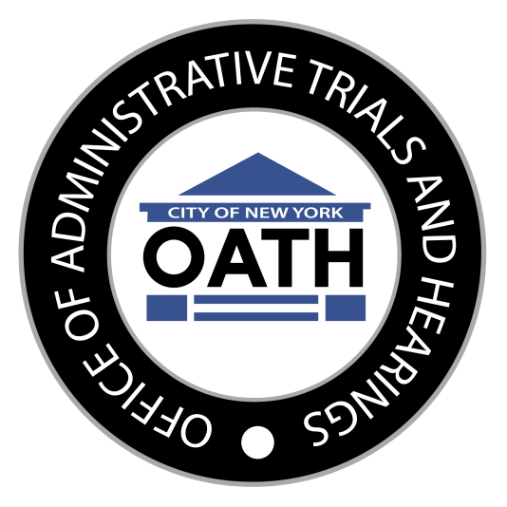

Office of Administrative Trials and Hearings
100 Church Street, 12th Floor, New York, New York 10007

Criminal Justice Reform Act
Quarterly Report
Vol. 1, No. 2
Quarter Ending September 30, 2017

Fidel F. Del Valle
Commissioner
Chief Administrative Law Judge

Introduction
The Criminal Justice Reform Act (CJRA) of 2016 created a civil preference for certain low level offenses previously prosecuted in criminal court, with the dual goal of preserving public safety while reducing arrests and incarceration. The law provides that, for certain specified violations and pursuant to Department Guidance, police officers have the discretion to write summonses for civil adjudication rather than criminal prosecution. Thus, the civil preference means an increase in the number of civil adjudications of these offenses, which will be conducted at OATH. Effective June 13, 2017, the NYPD began issuing civil summonses returnable to OATH for violations of certain sections of the New York City Administrative Code, and Title 56 of the Rules of the City of New York (New York City Park Rules), as specified in the CJRA. Many of the Administrative Code violations, such as littering, public urination, and unreasonable noise, had previously been adjudicated at OATH. However, the CJRA created new civil violations for consumption of alcohol on streets (open container) and for spitting, and it reduced civil penalties for some violations already adjudicated at OATH. Importantly, the CJRA also created a community service option in lieu of the monetary civil penalty and created a category of dismissal in the interest of justice, which will be an option under specified circumstances.
As mandated by the CJRA, the Chief Administrative Law Judge is required to submit to the Mayor and City Council, no later than 20 days after the end of each quarter, and post to the Office of Administrative Trials and Hearings’ website a report regarding adjudications for the specified violations set forth in the law. See Charter § 1049(6) (setting forth reporting requirement). In accordance with that requirement, this report contains the number and percentage of adjudications, in total and disaggregated by violation, in which:
(a) the respondent appeared, in total and disaggregated by whether such appearance was made in person or by another method;

(b) the respondent accepted the option to perform community service pursuant to subdivision 4 of this section, in total and disaggregated by whether such service was performed;

(c) a pre-adjudication withdrawal was made by the agency;

(d) a decision was rendered after a hearing;

(e) a civil penalty was ordered, disaggregated by numerical ranges of penalty amounts;

(f) the violation was dismissed;

(g) the violation was dismissed in the interest of justice pursuant to subdivision 5 of this section;

(h) the respondent paid the civil penalties imposed, in whole or in part; and

(i) a default judgment was ordered due to the respondent’s failure to appear for a hearing.

The following Tables 1 – 8 present the data mandated by the CJRA. It should be noted that reporting requirements for subdivisions “f” (violations dismissed) and “g” (violations dismissed in the interest of justice) have been combined into one table (Table 6) as the number and percentage of violations dismissed in the interest of justice is presented as a subset of all dismissed violations.

OATH is uniquely qualified to conduct these adjudications and has worked diligently to implement the innovations set forth in the law, by promulgating a new community service rule, by contracting a vendor -- the Center for Court Innovation -- to devise our community service program, by enlisting an independent neutral evaluator of the program, and by training over 270 Hearing Officers in the provisions of the CJRA and the new OATH procedures resulting therefrom.

