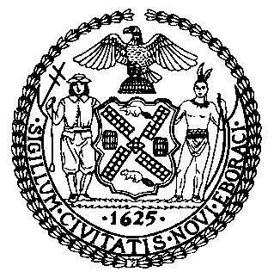 | The Council of the City of New York  Finance Division  Tanisha Edwards, Chief Financial Officer and Deputy Chief of Staff to the Speaker  Richard Lee, Finance Director  Fiscal Impact Statement  Proposed Intro No. 700-A  Committee: Committee on Governmental Operations
Title: A Local Law to amend the administrative code of the city of New York, in relation to translation services for compliance materials | Sponsors: Council Members Won, Restler, Hanif, Hudson, Sanchez, Louis, Gutiérrez, Velázquez, Narcisse, Menin, Brannan, Avilés and Cabán
Summary of Legislation: This bill would amend the Language Access Law to require agencies that provide direct public services to produce translations of written materials that the agency distributes when enforcing New York City laws and carrying out compliance actions.

Effective Date: This bill would take effect 120 days after becoming law.
Fiscal Year in which Full Fiscal Impact Anticipated: Fiscal 2024
Fiscal Impact Statement:
 | Effective FY23 | FY Succeeding  Effective FY24 | Full Fiscal Impact FY24
Revenues (-) | $0 | $0 | $0
Expenditures (+) | $0 | $0 | $0
Net | $0 | $0 | $0

Impact on Revenues: It is estimated that there would be no impact on revenues resulting from the enactment of this legislation assuming full compliance.

Source of Funds to Cover Estimated Costs: It is anticipated that there would be no impact on expenditures resulting from the enactment of this legislation because the relevant City agency would utilize existing resources to fulfill its requirements.

Sources of Information: Mayor’s Office of Legislative Affairs

Estimate Prepared by: Masis Sarkissian, Unit Head

Estimate Reviewed by: Masis Sarkissian, Unit Head
Jonathan Rosenberg, Managing Deputy Director

Legislative History: This legislation was introduced to the Council on September 14, 2022, as Int. No. 700 and referred to the Committee on Governmental Operations. The legislation was considered by the Committee on Governmental Operations at a hearing held on November 2, 2022, and was Laid Over by Committee. It was subsequently amended, and the amended version, Proposed Intro. No. 700-A, will be considered by the Committee on Governmental Operations on December 21, 2022. Upon a successful vote by the Committee, Proposed Int. No. 700-A will be submitted to the full Council for a vote on December 21, 2022.

Date Prepared: December 20, 2022

