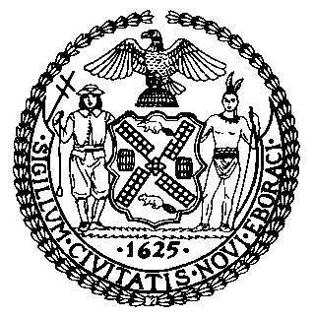 | The Council of the City of New York  Finance Division  Latonia Mckinney, Director  Fiscal Impact Statement  Proposed Intro. No: 1554-B  Committee: Committee on Education
Title: A Local Law to amend the administrative code of the city of New York, in relation to reporting on the demographics of school staff in New York city public schools | Sponsors: Council Members Treyger, Kallos, Eugene and Lander
Summary of Legislation: This bill would amend local law number 59 of 2015, and would require the Department of Education (DOE) to report on the demographics of school staff, including leadership, teaching staff and other professional and paraprofessional staff. The required reporting would be due to the Council no later than December 1, 2020 and would include gender, race or ethnicity, length of employment at the school of employment and years of experience in that position.
Effective Date: This local law would take effect immediately.

Fiscal Year In Which Full Fiscal Impact Anticipated: Fiscal 2021
Fiscal Impact Statement:
 | Effective FY20 | FY Succeeding Effective FY21 | Full Fiscal Impact FY21
Revenues | $0 | $0 | $0
Expenditures | $0 | $0 | $0
Net | $0 | $0 | $0
Impact on Revenues: It is anticipated that there would be no impact on revenues resulting from the enactment of this legislation.
Impact on Expenditures: It is anticipated that there would be no impact on expenditures resulting from the enactment of this legislation as DOE already has the resources necessary to comply with the requirements of this legislation.
Source of Funds To Cover Estimated Costs: N/A
Source of Information: New York City Council Finance Division
New York City Department of Education
Estimate Prepared by: Chelsea Baytemur, Legislative Financial Analyst
Estimate Reviewed by: Noah Brick, Assistant Counsel
Dohini Sompura, Unit Head
Regina Poreda Ryan, Deputy Director
Legislative History: This legislation was first considered by the Committee on Education jointly with the Committee on Civil and Human Rights as a preconsidered Introduction on May 1, 2019 and was laid over. The legislation was subsequently introduced by the full Council on May 8, 2019 and referred to the Committee on Education. The legislation was subsequently amended twice and the amended version, Proposed Intro. No. 1554-B, will be considered by the Committee on Education on October XX, 2019. Upon a successful Committee vote, Proposed Intro. No. 1554-B will be submitted to the full Council for a vote on October XX, 2019.
Date Prepared: October 11, 2019

