Committee on Public Safety:
Joshua Kingsley, Senior Legislative Counsel
Chad Benjamin, Legislative Policy Analyst
Jack Storey, Senior Finance Analyst
Owen Kotowski, Finance Analyst

THE COUNCIL OF THE CITY OF NEW YORK
BRIEFING PAPER AND COMMITTEEE REPORT OF THE
GOVERNMENTAL AFFAIRS DIVISION
Andrea Vazquez, Legislative Director
Rachel Cordero, Deputy Director, Governmental Affairs

COMMITTEE ON PUBLIC SAFETY
Hon. Kamillah Hanks, Chair

November 4, 2022

Oversight: Supporting Providers Serving the City’s Crisis Management System (CMS)

INT. NO. 439: By Council Members Williams, Narcisse, Kagan, Hanks, Riley, Stevens, Hudson, Abreu, Restler, Sanchez, Louis and Ayala

TITLE: A Local Law to amend the New York city charter, in relation to requiring the mayor’s office of criminal justice to evaluate the effectiveness of criminal justice programs that receive funding from the city

CHARTER: Amends §13

INT. NO. 756: By Council Members Hanks, Louis, Ayala and Restler

TITLE: A Local Law to amend the administrative code of the city of New York, in relation to requiring the mayor’s office of criminal justice to provide training and operational support to not-for-profit service providers participating in the city’s crisis management system

ADMINISTRATIVE CODE: Adds §9-130

- INTRODUCTION
On November 4, 2022, the Committee on Public Safety, chaired by Council Member Kamillah Hanks, will hold an oversight hearing on “Supporting Providers Serving the City’s Crisis Management System (“CMS”). The Committee will also hear two pieces of related legislation: Introduction Number 439 (“Int. No. 439”), sponsored by Council Member Nantasha Williams, in relation to requiring the Mayor's Office of Criminal Justice (“MOCJ”) to evaluate the effectiveness of criminal justice programs that receive funding from the City; and Introduction Number 756 (“Int. No. 756”), sponsored by Council Member Kamillah Hanks, in relation to requiring MOCJ to provide training and operational support to not-for-profit service providers participating in the City’s CMS. Those expected to testify include representatives from MOCJ, organizations that are part of the City’s CMS, legal service providers, advocates, and other interested parties.
- BACKGROUND
Cure Violence is an anti-violence model that seeks to utilize a public health approach to stopping the spread of violence. Approaching violence reduction in a manner similar to combatting a communicable disease, Cure Violence seeks a targeted effort to detect and interrupt conflicts, identify and treat individuals at the highest risk of committing violent acts, and changing social norms.
Cure Violence programs are formed by community stakeholders and employ culturally competent outreach workers who are trained to make contact with persons most exposed to violence in order to facilitate positive behavioral changes and shift cultural norms. As credible messengers, many of whom are formerly incarcerated or identify themselves as previously belonging to a gang, violence interrupters use their personal relationships, social networks, and knowledge of their communities to dissuade individuals from engaging in violence and instead manage conflict in healthier ways. Staff members mediate disputes, prevent escalating violence that often follows shootings, connect youth to supportive services and opportunities, and help young people develop the skills and resilience necessary to avoid violence in the future.
- NEW YORK CITY’S CRISIS MANAGEMENT SYSTEM
In New York City, CMS is a violence reduction program, based in part on the Cure Violence model, which aims to prevent gun violence by using a holistic public health approach. Established in 2012, the system receives over $100 million is operating funding from the City, and serves communities in 21 precincts across all five boroughs.
Task Force to Combat Gun Violence
Despite having one of the lowest murder rates among major U.S. cities, gun violence continues to plague New York City, where cycles of violence have brought about generational trauma in many underserved communities. In response to concerns regarding the persistence of gun violence, the New York City Council created the Task Force to Combat Gun Violence (“the Task Force”) in 2011. The Task Force was comprised of criminal justice stakeholders and community leaders, and was tasked with studying trends of gun violence in New York City and formulating policy recommendations for reducing such violence.
The Task Force used data on shooting incidents obtained from the New York Police Department (‘NYPD’), finding that of 76 police precincts in the City, 44% of all shooting incidents occurred in just 15 precincts, and 82% of all incidents were confined to 40 precincts, with violent conduct largely concentrated among young men between the ages of 14 to 24 years old. This data led the Task Force to conclude that the City’s gun violence reduction efforts should focus on selected neighborhoods and demographics rather than involving a generalized citywide effort.
From this work, the Task Force recommended the creation of CMS, as a multi-agency and multi-disciplinary, program that employs a cure violence model and provides holistic, community-based, responses to gun violence. The Task Force also recommended that additional support services and interventions being made available in target neighborhoods, such as mental health services for youth at-risk for violence, therapeutic services available to victims and community members impacted by gun violence, and increased investment in educational placement, job readiness and training and other wrap around services.
NYC CMS
CMS, is managed through MOCJ and the Mayor’s Office to Prevent Gun Violence (OPGV), is a network of community-based organizations that aim to reduce gun violence by providing an immediate, coordinated response following acts of violence. This approach acknowledges that violence is a learned behavior and seeks to support communities with social services intended to restore damage done to communities by violence, and prevent further violence. Beginning in 2012, CMS was piloted in one neighborhood in each of New York City’s five boroughs: East New York, Brooklyn; South Bronx; South Jamaica, Queens; North Harlem, Manhattan; and North Staten Island.
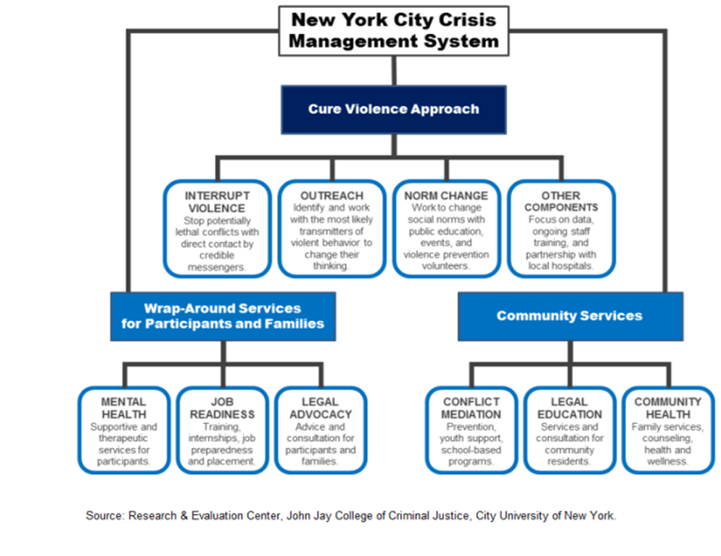
Currently, CMS consists of a network of more than 50 community-based organizations, operating in 22 NYC communities experiencing high rates of gun violence. The City significantly increased its investment in CMS from FY-21 to FY-22—expanding funding from $35 million to an estimated total of more than $100 million. However, the FY23 budget included no such increases in funding for CMS despite calls from providers and advocates seeking increased funding to deliver necessary services.

The following are a few examples of CMS providers that deliver services in each of the City’s five boroughs.
Manhattan
Getting Out Staying Out (GOSO), operates Stand Against Violence East Harlem (SAVE), which serves the East Harlem community as part of CMS. SAVE employs violence interrupters to respond to shootings in an attempt to prevent retaliation and mediate conflicts; reduce high-risk activities through providing access to job training, employment opportunities, and mental health services that aim to provide long-term violence reduction in the community.
Brooklyn
Man Up! Inc. is the host organization for the CMS programs operating in Brooklyn neighborhoods of East New York and Bedford Stuyvesant; engaging in anti-violence work and providing services including school and summer camp programs, mentoring and leadership development, community watch programs, services for the formerly incarcerated, and assistance with parenting and housing.
Queens
LIFE Camp Inc. (Love Ignites Freedom through Education), operates CMS programming in South Jamaica, Queens. Using a model of violence interruption, LIFE Camp, teaches violence prevention in schools, and creates programs to provide educational, employment and social opportunities that are often unavailable to at-risk youth and their families.
Bronx
The Center for Court Innovation, a well-known criminal justice research and community development organization, implemented Save Our Streets (S.O.S.) which serves as the host organization for CMS programming in the South Bronx, and works closely with neighborhood leaders and businesses to reduce gun violence. S.O.S. also operates CMS programs in the Crown Heights and Bedford Stuyvesant neighborhoods in Brooklyn.
Staten Island
The Central Family Life Center operates the True 2 Life program as part of CMS. True 2 Life provides services in the North Shore of Staten Island, including conflict resolution, hospital-based violence interruption, mentoring, and job training.
- EVALUATIONS OF CURE VIOLENCE PROGRAMMING
Cure Violence programs have shown positive effects in communities that historically experienced high levels of violent crime, including gun violence. Between 2015 and 2017, the Research and Evaluation Center at John Jay College of Criminal Justice (JohnJayREC) published a series of evaluations of Cure Violence programs that served as part of the City’s Crisis Management System. JohnJayREC’s analysis focused on the change in the presence of gun violence, homicides, and the attitudes of program participants. Results from JohnJayREC’s research suggests that when compared to neighborhoods with similar characteristics not served by Cure Violence programming, areas of NYC with established CMS programs tended to experience greater declines in homicides and gun injuries. JohnJayREC’s analysis of shooting victimizations and gun injuries between 2014 and 2016 found that CMS programming contributed to significant declines in gun violence that may not have occurred otherwise. For example, East New York experienced a 50% reduction in gun injuries after the implementation of CMS, compared to Flatbush, a neighborhood not served by CMS, which saw a 5% deduction during the same time period.
Surveys of Cure Violence participants suggests positive changes in attitudes towards violence. Between 2014 and 2016, JohnJayREC surveyed CMS participants, majority of whom were Black and Hispanic men ages 18 to 30 and found that young men living in neighborhoods with Cure Violence programs: expressed fewer violence-endorsing norms overtime in hypothetical disputes, both petty and serious; reported significant reductions in their willingness to use violence compared to men in similar areas without programs; and reported increased confidence in police and increased willingness to contact police.
- LEGISLATIVE ANALYSIS
Int. No. 439:
This bill would require MOCJ to evaluate the effectiveness of services offered by organizations that receive funding from the City for criminal justice-related services. A summary of such evaluations must be submitted to the Mayor and the Council annually. This bill would take effect immediately after enactment.
Int. No. 756:
This bill would require MOCJ to provide training and operational support to not-for-profit organizations participating in CMS. This effort would include: (i) training relevant to the delivery of services and non-profit administration; (ii) technical support ranging from business services to human resource assistance; (iii) facilitating collaboration between CMS stakeholders; and (iv) offering voluntary certifications for service provider employees. This bill would take effect immediately after enactment
- CONCLUSION
The City has placed increased emphasis on the role of violence prevention and CMS in bringing about needed reductions in gun violence. As operations expand, effective functioning of this approach requires organizations receive adequate funding and operational support to meet the needs of their communities. The Committee is eager to examine the City’s efforts to support the work of service providers that make up CMS, and highlighting ways that the City can better support providers –ranging from contracting issues and prompt payment; administrative and technical support for operational expansion; and improved collaboration between CMS providers, City agencies, and other community resources.

Int. No. 439

By Council Members Williams, Narcisse, Kagan, Hanks, Riley, Stevens, Hudson, Abreu, Restler, Sanchez, Louis and Ayala

A Local Law to amend the New York city charter, in relation to requiring the mayor’s office of criminal justice to evaluate the effectiveness of criminal justice programs that receive funding from the city

Be it enacted by the Council as follows:
Section 1. Section 13 of chapter 1 of the New York city charter is amended by adding a new subsection (4) to read as follows:

(4) evaluate the performance of the vendor of any contract with the coordinator’s office for the provision of criminal justice related services. For purposes of this subsection, “criminal justice related services” include but are not limited to: (i) providing alternatives to incarceration; (ii) re-entry or diversion programs; and (iii) pretrial supervised release services. Beginning on January 1, 2023 and annually thereafter, the coordinator shall submit a summary of each evaluation to the Mayor and the Council. This summary shall include criteria determined by the coordinator, which shall include, but not be limited to, information related to the following for each such organization: (i) the amount of funding received; (ii) the number of individuals served; (iii) a brief description of the services provided; and (iv) recidivism and compliance rates, if applicable.
§ 2. This local law takes effect immediately.

Int. No. 756

By Council Members Hanks, Louis, Ayala, Restler, Williams and Hudson

A Local Law to amend the administrative code of the city of New York, in relation to requiring the mayor’s office of criminal justice to provide training and operational support to not-for-profit service providers participating in the city’s crisis management system

Be it enacted by the Council as follows:
Section 1. Chapter 3 of Title 9 of the administrative code of the city of New York is amended by adding a new section 9-310 to read as follows:
§ 9-310. Training and operational support for the crisis management system. a. Definitions. For the purpose of this section, “service providers” means a not-for-profit organization that contracts with the city to deliver services as part of the city’s crisis management system.
b. The office shall offer training and operational support for service providers to promote the functioning of the city’s crisis management system. Such efforts shall include, but not be limited to: (i) providing training on skills relevant to the delivery of services within the crisis management system and not-for-profit administration; (ii) providing technical support tailored to service provider organizational needs, including but not limited to, businesses services, legal assistance, grant writing assistance, and human resource assistance; (iii) facilitating collaboration and information sharing between service providers, city agencies, legal service providers and other relevant stakeholders; and (iv) offering voluntary certifications for service provider staff to obtain following completion of designating trainings.
c. No later than January 30, 2023, and within 30 days after the beginning each subsequent calendar year, the office shall submit to the council and post publicly on its website a report detailing efforts undertaken pursuant to this section, and a summary of the office’s ongoing efforts to support the operation of the city’s crisis management system.
§ 2. This local law takes effect immediately.

Delgado, S., Negredo, L., Begum, P., Cubellis, M., Henninger, A., Evans, D., Tomberg, K., & Butts, J. (August 1, 2013) NYC-Cure First Year Assessment Report 2013 A project funded by the New York City Council. Retrieved 2022, from https://johnjayrec.nyc/nyc1_intro/
Sheyla A. Delgado, Laila Alsabahi, Kevin Wolff, Nicole Alexander, Patricia Cobar, and Jeffrey A. Butts “Denormalizing Violence: A Series of Reports From the John Jay College of Evaluation of Cure Violence Programs in New York City” available at https://johnjayrec.nyc/2017/10/02/cvinsobronxeastny/
Ibid.
Ibid.
Delgado, S., Negredo, L., Begum, P., Cubellis, M., Henninger, A., Evans, D., Tomberg, K., & Butts, J. (August 1, 2013) NYC-Cure First Year Assessment Report 2013 A project funded by the New York City Council. Retrieved 2022, from https://johnjayrec.nyc/nyc1_intro/
See “Program: The Office to Prevent Gun Violence” Mayor’s Office of Criminal Justice available at https://criminaljustice.cityofnewyork.us/programs/office-to-prevent-gun-violence/
Report of New York City Council’s Task Force to Combat Gun Violence, December 21, 2012; available at: http://council.nyc.gov/press/wp-content/uploads/sites/56/2016/12/gvtfreport.pdf.
Ibid.
Ibid.
Ibid.
See “Program: The Office to Prevent Gun Violence” Mayor’s Office of Criminal Justice available at https://criminaljustice.cityofnewyork.us/programs/office-to-prevent-gun-violence/
Task Force to Combat Gun Violence Presents Proposals For Reducing Gun Violence to City Council, available at: https://council.nyc.gov/press/2012/12/21/617/
Ibid.
See “Program: The Office to Prevent Gun Violence” Mayor’s Office of Criminal Justice available at https://criminaljustice.cityofnewyork.us/programs/office-to-prevent-gun-violence/
Id.
Offenhartz, Jake, No New Funding for Violence Interrupter Program Despite Adams’ promised Expansion, Gothamist, June 15, 2022; available at: https://gothamist.com/news/no-new-funding-for-violence-interrupter-program-despite-adams-promised-expansion
Delgado, S., Negredo, L., Begum, P., Cubellis, M., Henninger, A., Evans, D., Tomberg, K., & Butts, J. (August 1, 2013) NYC-Cure First Year Assessment Report 2013 A project funded by the New York City Council; available at: https://johnjayrec.nyc/nyc1_intro/.
SAVE East Harlem – GOSO. (n.d.). Retrieved 2022, from https://www.gosonyc.org/save-east-harlem/.
Man Up! Inc, Anti-Violence Programs; available at: https://manupinc.org/anti-violence-program.html.
LIFE Camp Inc; available at: https://www.peaceisalifestyle.com/about-us/lifecamp.
Save Our Streets (S.O.S.). Center for Court Innovation; available at https://www.courtinnovation.org/programs/save-our-streets-sos/more-info.
Central Family Life Center, True 2 Life; available at: https://www.centralfamilylifecenter.org/true2life.
See Evaluating Cure Violence in New York City John Jay College of Criminal Justice available at http://cureviolence.org/results/scientific-evaluations/nyc-evaluation-johnjay/
Ibid.
Ibid.
Effective of the Cure Violence Model in New York City: Homicide Rates in NYC: 2010-201 John Jay College of Criminal Justice January 2015 available at https://johnjayrec.nyc/2015/01/16/researchbrief201501/
The Effects of Cure Violence in the South Bronx and East new York, Brooklyn John Jay College of Criminal Justice October 2017 available at https://johnjayrec.nyc/2017/10/02/cvinsobronxeastny/
Ibid.
The Effects of Cure Violence in the South Bronx and East New York, Brooklyn John Jay College of Criminal Justice October 2017 available at https://johnjayrec.nyc/2017/10/02/cvinsobronxeastny/
Young Men in Neighborhoods with Cure Violence Programs Adopt Attitudes Less Supportive of Violence John Jay College of Criminal Justice March 2017 available at https://johnjayrec.nyc/2017/03/16/databit201701/
See Evaluating Cure Violence in New York City John Jay College of Criminal Justice available at http://cureviolence.org/results/scientific-evaluations/nyc-evaluation-johnjay/

