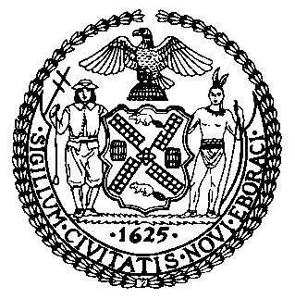 | The Council of the City of New York  Finance Division  Latonia Mckinney, Director  Fiscal Impact Statement  Proposed Intro. No: 1261-A  Committee: Fire and Criminal Justice Services
Title: A Local Law to amend the New York city charter, in relation to authorizing the waiver of fees in the collection of cash bail | Sponsors: The Speaker (Council Member Mark-Viverito) and Council Members Richards, Chin and Dromm
Summary of Legislation: Proposed Intro. 1261-A would authorize the Commissioner of the Department of Finance (DOF) to waive the three percent fee that the Department currently retains from cash bail posted on behalf of defendants subsequently convicted of a crime, after consideration of the budgetary impact on the city of such a waiver.

Effective Date: This local would take effect immediately.

Fiscal Year in Which Full Fiscal Impact Anticipated: Fiscal 2017
Fiscal Impact Statement:
 | Effective FY17 | FY Succeeding Effective FY18 | Full Fiscal Impact FY18
Revenues | ($650,000) | ($650,000) | ($650,000)
Expenditures | $0 | $0 | $0
Net | ($650,000) | ($650,000) | ($650,000)

Impact on Revenues: It is anticipated that the Commissioner would waive the three percent fee. As a result, there would be a decrease of $650,000 in revenue collected by DOF per fiscal year as a result of this legislation.

Impact on Expenditures: It is anticipated that there would no impact on expenditures as a result of this legislation.
Source of Funds To Cover Estimated Costs: General Fund

Source of Information: New York City Council
Mayor’s Office of Criminal Justice

Estimate Prepared by: Jin Lee, Legislative Financial Analyst
Estimate Reviewed by: Regina Poreda Ryan, Deputy Director
Eisha Wright, Head Unit
Legislative History: This legislation was introduced to the Council on September 14, 2016 as Intro. No. 1261 and referred to the Committee on Fire and Criminal Justice Services. A hearing was held by the Committee on Fire and Criminal Justice Services on September 26, 2016 and the bill was laid over. The legislation was subsequently amended and the amended version, Proposed Intro. No. 1261-A, will be voted on by the Committee on Fire and Criminal Justice Services at a hearing on December 5, 2016. Upon successful vote by the Committee, Proposed Intro. No. 1261-A will be submitted to the full Council for a vote on December 6, 2016.
Date Prepared: December 2, 2016

