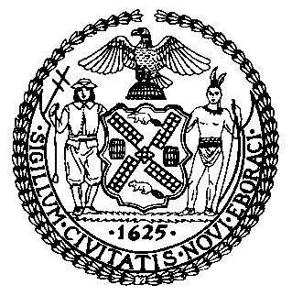 | The Council of the City of New York  Finance Division  Tanisha S. Edwards, Esq., Chief Financial Officer, and Deputy Chief of Staff to the Speaker  Richard Lee, Director  Fiscal Impact Statement  Proposed Intro. No: 875-B  Committee: Housing and Buildings
Title: A Local Law to amend the administrative code of the city of New York, the New York city plumbing code, the New York city building code, the New York city mechanical code and the New York city fuel gas code, in relation to technical corrections, clarifications and modifications to provisions of the New York city construction codes | Sponsor(S): Council Members Sanchez and Louis (by request of the Mayor)
Summary of Legislation: This bill would make technical corrections, updates, modifications, and corrections to Local Law 126 of 2021, which enacted the latest revision to the New York City Construction Codes.
Effective Date: This local law would take effect immediately after it becomes law.

Fiscal Year In Which Full Fiscal Impact Anticipated: Fiscal 2024
Fiscal Impact Statement:

 | Effective FY23 | FY Succeeding Effective FY24 | Full Fiscal Impact FY24
Revenues | $0 | $0 | $0
Expenditures | $0 | $0 | $0
Net | $0 | $0 | $0

Impact on Revenues: It is anticipated that this legislation would not affect revenues.

Impact on Expenditures: It is anticipated that there would be no impact on expenditures resulting from the enactment of this legislation.

Source of Funds To Cover Estimated Costs: N/A

Source of Information: New York City Council Finance Division
Estimate Prepared By: Daniel Kroop, Principal Financial Analyst, NYC Council Finance Division
Estimate Reviewed By: Chima Obichere, Deputy Director, NYC Council Finance Division
Jonathan Rosenberg, Managing Deputy Director, NYC Council Finance Division
Kathleen Ahn, Counsel, NYC Council Finance Division

Legislative History: The legislation was introduced to the full Council on January 4, 2023 as Proposed Intro. No. 875 and referred to the Committee on Housing and Buildings (Committee). The Committee heard the legislation on January 24, 2023 and it was laid over. The legislation was subsequently amended twice, and the amended version, Proposed Intro. 875-B, will be considered by the Committee on May 10, 2023. Upon a successful vote by the Committee, Proposed Intro. No. 875-B will be submitted to the full Council for a vote on May 11, 2023.
Date Prepared: May 9, 2023

