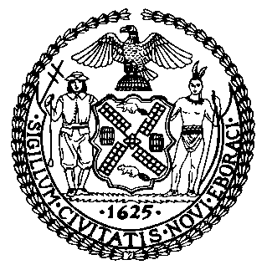 | The Council of the City of New York  Finance Division  Tanisha Edwards, Chief Financial Officer and Deputy Chief of Staff to the Speaker  Fiscal Impact Statement  Proposed Int. No. 655-A  Committee: Finance
Title: A Local Law to amend the administrative code of the city of New York, in relation to authorizing an increase in the amount to be expended annually in three business improvement districts. | Sponsors: Council Members Brannan and Restler (by request of the Mayor)
Summary of Legislation: The proposed local law amends the Administrative Code of the city of New York to increase the budget amounts of three business improvement districts (“BIDs”) throughout the City. The budgets are funded by special assessments on properties within the BID and pay for additional services beyond those which the City provides. The special assessments are collected with the City’s property tax collection system and passed through to the BIDs.

Effective Date: This local law would take effect immediately and is retroactive to and deemed to have been in full effect as of July 1, 2022.

Fiscal Year (FY) In Which Full Fiscal Impact Anticipated: Fiscal Year 2023
Fiscal Impact Statement:

 | Effective  FY 23 | Succeeding  FY 24 | Full Fiscal  Impact FY 23
Revenues (+) | $0 | $0 | $0
Expenditures (-) | $0 | $0 | $0
Net | $0 | $0 | $0

Impact on Revenues: It is estimated that there would be no impact on revenues resulting from the enactment of this legislation.

Impact on Expenditures: It is anticipated that there would be no impact on expenditures resulting from the enactment of this legislation.

Source of Funds To Cover Estimated Costs: BIDs special assessments
Source of Information: New York City Department of Small Business Services
New York City Council Finance Division

ESTIMATE PREPARED BY: Kathleen Ahn, Counsel

ESTIMATE REVIEWED BY: Jonathan Rosenberg, Managing Deputy Director

Legislative History: On September 29, 2022, the Finance Committee adopted Resolution 306-A that set October 12, 2022 as the date to consider a local law that would increase the annual expenditures of three Business Improvement Districts as of July 1, 2022. Proposed Int. No. 655-A will be heard by the Finance Committee on October 12, 2022, and upon a successful vote by the Finance Committee on October 12, 2022, the bill will be submitted to the full Council for a vote on October 12, 2022.

Date Prepared: October 11, 2022

