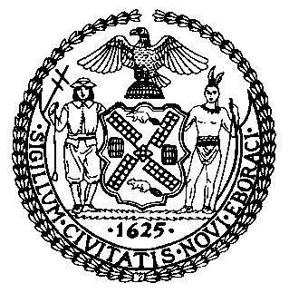 | The Council of the City of New York  Finance Division  Latonia Mckinney, Director  Fiscal Impact Statement  Proposed Intro. No: 1580-A  Committee: Health
Title: A Local Law in relation to a public hearing on public burial and related issues | Sponsors: Council Members Rose, Kallos, Louis, Ampry-Samuel, Ayala and Holden
Summary of Legislation: This bill would require a public hearing on public burial to allow the public the opportunity to discuss the laws, rules, regulations, policies and procedures related to public burial, to recommend changes to these programs and to consider the feasibility of alternative programs. Following the hearing, the Department of Social Services would be required to submit a report with recommendations to the Mayor and the Council.

Effective Date: This local law would take effect immediately after it becomes law and is deemed repealed on January 15, 2020 or the day after submission of the report required by section one of this local law, whichever is later.

Fiscal Year In Which Full Fiscal Impact Anticipated: Fiscal 2021
Fiscal Impact Statement:

 | Effective FY20 | FY Succeeding Effective FY21 | Full Fiscal Impact FY21
Revenues | $0 | $0 | $0
Expenditures | $0 | $0 | $0
Net | $0 | $0 | $0

Impact on Revenues: It is anticipated that the proposed legislation would not affect revenues.

Impact on Expenditures: It is anticipated that the proposed legislation would not affect expenditures resulting from the enactment of Proposed Intro. No. 1580-A because the relevant City agencies would utilize existing resources to fulfill the requirements of this legislation.

Source of Funds To Cover Estimated Costs: N/A
Source of Information: New York City Council Finance Division
Department of Health and Mental Hygiene
Estimate Prepared By: Lauren Hunt, Financial Analyst

Estimate Reviewed By: Nathan Toth, Deputy Director, NYC Council Finance Division
Crilhien R. Francisco, Unit Head, NYC Council Finance Division
Stephanie Ruiz, Assistant Counsel, NYC Council Finance Division
Legislative History: This legislation was introduced to the full Council as Int. No. 1580 on May 29, 2019 and was referred to the Committee on Health, Committee on Transportation, and Committee on Parks and Recreation. A hearing was held by Committee on Health, Committee on Transportation, and Committee on Parks and Recreation on May 30, 2019 and the bill was laid over. The legislation was subsequently amended and the amended legislation, Proposed Intro. 1580-A, will be voted on by the Committee on Health at a hearing on November 12, 2019. Upon a successful vote by the Committee on Health, Proposed Intro. No. 1580-A will be submitted to the full Council for a vote on November 14, 2019.
Date Prepared: November 8, 2019

