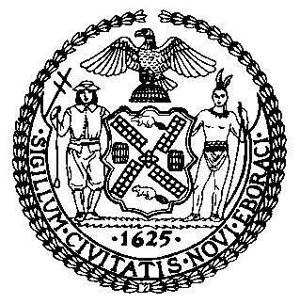 | The Council of the City of New York  Finance Division  Latonia Mckinney, Director  Fiscal Impact Statement  Proposed Intro. No: 750-A  Committee: Environmental Protection
Title: A Local Law to amend the administrative code of the city of New York, in relation to creation of a New York City Jamaica Bay task force, which would provide advice and recommendations to the city with respect to the Jamaica Bay clean up and resiliency project. | Sponsors: Constantinides, Richards, Adams, Miller, Maisel and Grodenchik
Summary of Legislation: Proposed Int. No. 750-A would create a Jamaica Bay Task Force to provide recommendations to the Commissioner of Environmental Protection and the Speaker of the Council on the cleanup of Jamaica Bay, the process by which combined sewer overflows are managed for the bay, including the long-term control plan and the effects of climate change on the bay. The Task Force would consist of eleven members, including five appointed by the Speaker and six appointed by the Mayor, all of whom would serve without compensation.

Effective Date: This local law would take effect immediately.

Fiscal Year in Which Full Fiscal Impact Anticipated: Fiscal 2020
Fiscal Impact Statement:
 | Effective FY19 | FY Succeeding Effective FY20 | Full Fiscal Impact FY20
Revenues | $0 | $0 | $0
Expenditures | $0 | $0 | $0
Net | $0 | $0 | $0

Impact on Revenues: It is anticipated that there would be no impact on revenues as a result of this legislation.

Impact on Expenditures: It is anticipated that there would be no impact on expenditures resulting from the creation of the Task Force.
Source of Funds To Cover Estimated Costs: N/A

Source of Information: New York City Council Finance Division
Mayor’s Office of Legislative Affairs

Estimate Prepared by: Jonathan Seltzer, Financial Analyst
Estimate Reviewed by: Nathan Toth, Deputy Director
Crilhien Francisco, Unit Head
Rebecca Chasan, Counsel
Legislative History: This legislation was introduced to the Council on April 11, 2018 as Intro. No. 750 and referred to the Committee on Environmental Protection. A hearing was held by the Committee on Environmental Protection on April 23, 2018 and the bill was laid over. The legislation was subsequently amended and the amended version, Proposed Intro. No. 750-A, will be voted on by the Committee on Environmental Protection at a hearing on September 26, 2018. Upon successful vote by the Committee, Proposed Intro. No. 750-A will be submitted to the full Council for a vote on September 26, 2018.
Date Prepared: September 24, 2018

