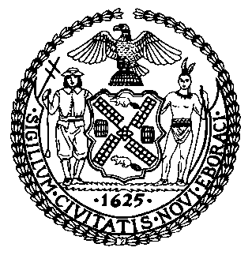 | The Council of the City of New York  Finance Division  Latonia Mckinney, Director  Fiscal Impact Statement  Proposed Int. No. 1389-A  Committee: Committee on General Welfare
Title: A Local Law to amend the administrative code of the city of New York, in relation to requiring the department of social services/human resources administration to report on termination of public assistance | Sponsors: The Public Advocate (Mr. Williams) and Council Members Rosenthal, Lander, Adams, Richards, Ayala, Salamanca, Chin, Kallos, and Constantinides
Summary of Legislation: Proposed Introduction Number 1389-A would require the Department of Social Services (DSS) to issue a quarterly report on instances in which public assistance cases were terminated and instances in which applications for public assistance were denied. The first report would be due on November 15, 2019. The reports would submitted to the Council and published on the DSS website.
Effective Date: This local law would take effect immediately.
Fiscal Year In Which Full Fiscal Impact Anticipated: Fiscal 2021
Fiscal Impact Statement:

 | Effective FY20 | FY Succeeding  Effective FY21 | Full Fiscal  Impact FY21
Revenues (+) | $0 | $0 | $0
Expenditures (-) | $0 | $0 | $0
Net | $0 | $0 | $0

Impact on Revenues: It is anticipated that there would be no impact on revenues resulting from the enactment of this legislation.
Impact on Expenditures: It is anticipated that there would be no impact on expenditures resulting from the enactment of this legislation because DSS would utilize existing resources to fulfill the requirements of this legislation.
Source of Funds To Cover Estimated Costs: N/A
Source of Information: New York City Council Finance Division
Estimate Prepared by: Julia K. Haramis, Financial Analyst
Estimate Reviewed by: Noah Brick, Assistant Counsel
Regina Poreda Ryan, Deputy Director
Legislative History: This legislation was introduced to the Council on January 24, 2019 as Intro. No. 1389, and was referred to the Committee on General Welfare (Committee). A hearing was held by the Committee on February 4, 2019, and the legislation was laid over. The legislation was subsequently amended and the amended version, Proposed Intro. No. 1389-A, will be voted on by the Committee at a hearing on August 13, 2019. Upon a successful vote by the Committee, Proposed Intro. No. 1389-A will be submitted to the full Council for a vote on August 14, 2019.
Date Prepared: August 9, 2019

