THE COUNCIL OF THE CITY OF NEW YORK
RESOLUTION NO. 498

Resolution approving with modifications the decision of the City Planning Commission on Application No. N 220275 ZRQ, for an amendment of the text of the Zoning Resolution (L.U. No. 161).

By Council Members Salamanca and Riley

WHEREAS, Werber Management, Inc. and Reform Temple of Forest Hills, filed an application pursuant to Section 201 of the New York City Charter, for an amendment of the Zoning Resolution of the City of New York, modifying APPENDIX F for the purpose of establishing a Mandatory Inclusionary Housing area, which in conjunction with the related action would facilitate the development of a 10-story residential and community facility use building that would include space for the RTFH on the ground floor and 153 residential units on the floors above, 38 to 46 units of which would be permanently affordable, located at 71-11 112th Street in the Forest Hills neighborhood of Queens, Community District 6 (ULURP No. N 220275 ZRQ) (the “Application”);

WHEREAS, the City Planning Commission filed with the Council on January 3, 2023, its decision dated December 14, 2022 (the “Decision”), on the Application;

WHEREAS, the Application is related to application C 220274 ZMQ (L.U. No. 160), a zoning map amendment to change an R1-2A zoning district to an R7D zoning district;

WHEREAS, the Decision is subject to review and action by the Council pursuant to Section 197-d of the City Charter;

WHEREAS, upon due notice, the Council held a public hearing on the Decision and Application on January 5, 2023;

WHEREAS, the Council has considered the land use implications and other policy issues relating to the Decision and Application; and

WHEREAS, the Council has considered the relevant environmental issues, including the Negative Declaration issued August 19, 2022 (CEQR No. 22DCP188Q) (the “Negative Declaration”), which includes an (E) designation for significant adverse impacts related to hazardous materials and air quality (E-685).

RESOLVED:

The Council finds that the action described herein will have no significant impact on the environment.

Pursuant to Sections 197-d and 200 of the City Charter and on the basis of the Decision and Application, and based on the environmental determination and consideration described in the report, N 220275 ZRQ, incorporated by reference herein, and the record before the Council, the Council approves the Decision of the City Planning Commission, with the following modifications.

Matter underlined is new, to be added;
Matter struck out is to be deleted;
Matter within # # is defined in Section 12-10;
* * * indicates where unchanged text appears in the Zoning Resolution
Matter double struck out is old, deleted by the City Council;
Matter double-underlined is new, added by the City Council

* * *
APPENDIX F
Inclusionary Housing Designated Areas and Mandatory Inclusionary Housing Areas

* * *
QUEENS

Queens Community District 6
* * *

Map 1 – [date of adoption]

MAP
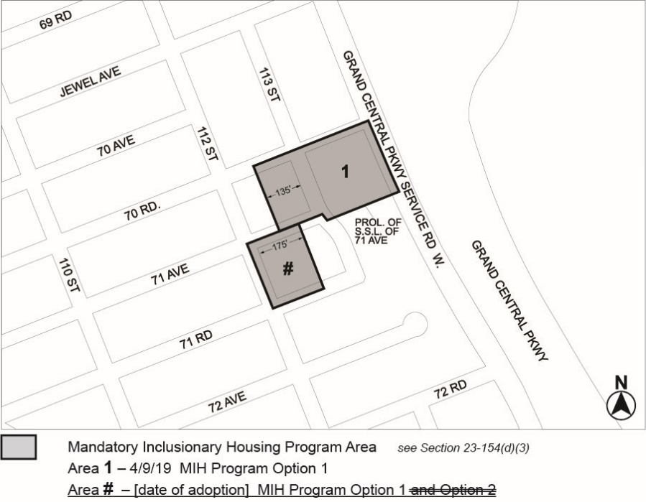
Portion of Community District 6, Queens

* * *

Adopted.

Office of the City Clerk, }
The City of New York, } ss.:

I hereby certify that the foregoing is a true copy of a Resolution passed by The Council of The City of New York on __________, 2023, on file in this office.

.....................................................
City Clerk, Clerk of The Council

