Environmental Protection Committee Staff
Samara Swanston, Legislative Counsel
Nadia Johnson, Senior Policy Analyst
Ricky Chawla, Policy Analyst
Jonathan Seltzer, Senior Finance Analyst

The New York City Council
Jeffrey Baker, Legislative Director

Briefing Paper of the Infrastructure Division
Terzah Nasser, Deputy Director

Committee on Environmental Protection
Hon. Costa Constantinides, Chair

January 26, 2021

Int. No. 960: By Council Members Constantinides, Reynoso, Chin, Kallos, and Cornegy
Title: A Local Law to amend the administrative code of the city of New York, in relation air quality monitoring at designated “heavy use” thoroughfares
Administrative Code: Adds a new subdivision g to 24-108

Int. No. 980: By Council Member Constantinides and the Public Advocate (Mr. Williams) (by request of the Queens Borough President

Title: A Local Law to amend the administrative code of the city of New York, in relation to phasing out the use of fuel oil grade no. 4

Administrative Code: Amends subdivision d of 24-168

Int. No. 992: By Council Member Constantinides

Title: A Local Law to amend the New York city charter, in relation to monitoring power plant performance

CHARTER: Adds section 20-f to chapter 1

- Introduction
On January 26, 2021, the Committee on Environmental Protection, chaired by Council Member Costa Constantinides, will hold a hearing on Int. No. 960, in relation to air quality monitoring at designated “heavy use thoroughfares,” Int. No. 980, in relation to the phasing out of fuel oil grade no.4, and Int. No. 992, in relation to monitoring power plant performance. The Committee expects to hear testimony from the New York City Department of Environmental Protection (DEP), public health and environmental advocates, and interested members of the public.
- Background
The United States Environmental Protection Agency (EPA), under authority granted by the Clean Air Act, sets regulations on the permissible levels for six classes of commonly encountered airborne pollutants. Permissible particulate matter, ground-level ozone, carbon monoxide, sulfur oxides, nitrogen oxides, and lead levels are regulated under both ‘primary standards,’ which aim to prevent deleterious effects to human health, and ‘secondary standards,’ which are aimed at protecting the environment and property. Air quality data is plotted over a map of the various regions of the United States, and geographical areas where levels of specific pollutants exceed levels outlined in the Clean Air Act’s regulations are said to be in non-attainment. As of January 21, 2021, New York City (NYC or City) is considered to be in attainment for 5 out of 6 criteria pollutants, with the exception of ozone, where the City is considered to be in moderate non-attainment.
Exposure to Airborne Pollutants and Effects on Human Health
According to the EPA, exposure to airborne pollutants has been linked to a variety of negative health outcomes, both physical and psychological. Positive correlations have been found between exposure to elevated levels of airborne particulate matter and mental health concerns such as suicide attempts, as well as exacerbated symptoms in populations afflicted with schizophrenia. Children can be particularly vulnerable to the effects of exposure to airborne pollutants because they consume more air and water per unit of body size compared to adults, are more likely to be active outdoors during peak traffic hours, tend to play closer to the ground where particulate matter concentrations are highest, and because the membrane barriers in their respiratory tract are not fully developed. Childhood exposure to nitrous oxide, airborne particulate matter, and polycyclic aromatic hydrocarbons have been linked to low scores in intelligence and intellectual development tests applied to infants, preschoolers, and school age children, a pattern that persists in both cross sectional and longitudinal studies. See Figure 1 for an illustration of these potential effects. Prenatal exposure has been positively correlated with heightened incidences of heart wall defects, valve defects, aortal defects, and low birth weight in babies, heightened risk of preeclampsia in mothers, and a significant increase in the likelihood of childhood obesity for children born to mothers who were exposed to polycyclic aromatic hydrocarbons during pregnancy.
Figure 1: Current hypothesized pathways of urban air pollution effects
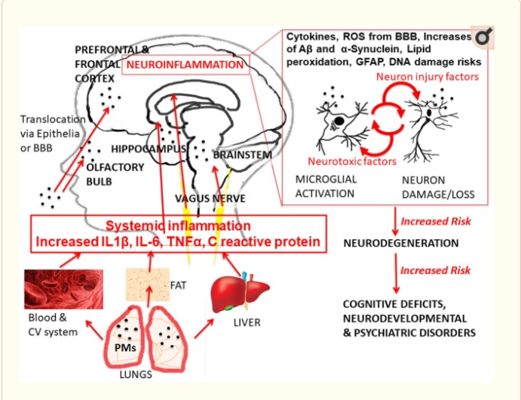
The graphic shows the head and organs of a human body and possible pathways through which exposure to urban outdoor air pollution [with specific example of exposure to particulate matter (PM)], can lead to the different health effects, with particular focus on healthy brain development outcomes. Abbreviations: IL-6, interleukin 6; IL-1β, interleukin 1 beta; TN F-α, tumor necrosis factor alpha; BBB, brain–blood barrier; ROS, reactive oxygen species; GFAP, astrogliosis; Aβ, beta amyloids. The anatomical illustrations (blood cells, liver, and adipose tissue) are modified versions of copyright- and attribution-free public domain images downloaded from https://pixabay.com/.
People living in environments with a high level of sulfate particles (23.5 micro-g/m3) were 36% more likely to have lung cancer compared to those living in a community with lower levels of sulfate particle pollution, and positive correlations have been found between ambient concentrations of nitrous oxide and incidences of breast cancer in women.
Cardiovascular events and rates of hospitalization for cardiovascular issues are positively correlated with increases in ambient particulate matter, with a 10 microgram per square meter increase in black smoke averaging a 4.8% increase in hospitalizations for populations 65 and over. A 10 microgram per square meter increase in PM2.5 levels was associated with a 24% increase in the risk of a heart attack or stroke, and a 76% increase in the risk of death from cardiovascular disease in postmenopausal women. Exposures to PM2.5, PM10, and nitrous oxide are strongly associated with increases in blood pressure, while long term exposure to PM2.5 and nitrous oxide has been linked to heightened levels of inflammation biomarkers in the bloodstream. Inflammation and oxidative stress on the brain has been linked to the manifestation of symptoms of depression, while inflammation in the airways can contribute to the development of asthma as well as an increase in the severity of symptoms.
Exposure to black carbon increases the likelihood of airway inflammation, and research suggests that high incidences of childhood and adult asthma rates in communities of low socioeconomic status and higher proportion of racial and ethnic minority residents is related to the higher ambient levels of airborne pollutants such as black carbon and PM2.5 in these areas.
The City’s community air survey findings from 2009 to 2017 confirm the presence of high levels of fine particulate matter, nitrogen dioxide, and nitric oxide in areas with high traffic density, building density, and in industrial areas. See Figure 2 for a map of mean PM 2.5 levels in neighborhoods throughout New York City, obtained from community air survey findings for 2017
Figure 2: Distribution of PM 2.5 by UHF (United Hospital Fund Neighborhoods)
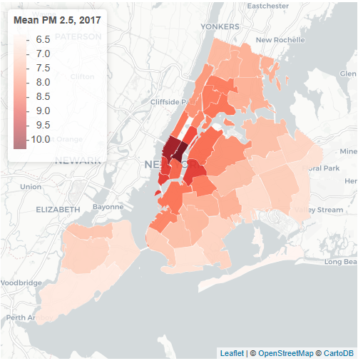
The graphic shows a map of PM 2.5 concentrations across New York City neighborhoods according to figures from the 2017 community air quality survey, with midtown and lower Manhattan showing the highest concentrations, around 10 micrograms per cubic meter of air
Ambient levels of sulfur dioxide have been positively associated with increases in hospital admissions for chronic bronchitis and emphysema, and nitrous oxide, nitrogen dioxide, and PM10 levels are negatively associated with lung function. Overall, there is a strong correlation between exposure to air pollution, especially fine particulate matter, and various causes of mortality.
A study of six cities found that an average of 3% fewer people died for every reduction of one micro-g/m3 in the average levels of PM2.5 fine particulate matter, meaning that each micro-g/m3 reduction is approximate to saving 75,000 people per year in the United States (U.S.). Although New York City is considered to be in moderate non-attainment for ozone levels, the statewide estimated benefits of achieving attainment are significant. See figure 3 for a table of estimated statewide benefits of achieving attainment.
Figure 3: Estimated Statewide Health benefits of attainment status with regard to EPA ozone level standards
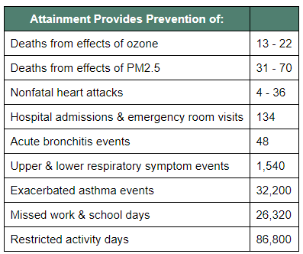
Table shows estimated statewide health benefits of achieving attainment status with regard to EPA ozone level standards.
Air Quality and Fuel Oil Combustion for Heating
New York City’s air quality has improved drastically since the passage of clean heat regulations banning the combustion of No. 6 fuel oil after 2015, and mandating the phase out the combustion of No. 4 fuel oil for heating purposes by 2030, with citywide annual averages of black carbon declining 30% between 2009 and 2017, nitric oxide levels declining 44% during the same time period, nitrogen dioxide levels declining 26%, fine particulate matter levels declining 30%, and sulfur dioxide levels below air quality monitor detection limits across much of the city. While the overall air quality in New York City has been improving, the improvements have not been equitably distributed across the board. After the banning of the combustion of No. 6 fuel oil, studies showed that communities in upper Manhattan and the Bronx, many at the intersection of high rates of poverty (above 20%) and racial and ethnic minority composition (above 51%) were less likely to convert to No. 2 fuel oil or natural gas combusting systems, and more likely to transition to combusting No. 4 fuel oil. As of 2015, more than 50% of the buildings burning No. 4 fuel oil were clustered in Manhattan north of 110th street, and the Bronx, communities that represent approximately 20% of the city’s total population, meaning the city’s efforts to improve air quality by phasing out fuel oils with the highest particulate emissions have made the least progress in neighborhoods already burdened by some of the highest rates of asthma in the nation.
Air Quality and Environmental Justice Communities
When pollutant concentration estimates were combined with data and used to calculate cancer risks by census tracts in the United States, such cancer risks were then compared to socioeconomic status (SES) measures from the 1990 Census, and a pattern emerged showing that estimated cancer risks associated with ambient air toxics were highest in tracts located in metropolitan areas that were highly segregated. Statistical analysis in California suggests that environmentally damaging infrastructure such as peaker plants, (plants that generally only run when there is high demand), are more likely to be sited in economically disadvantaged communities. Plotting the location of NYC’s in-city power plants over a map showing concentrations of self-identified minority status persons and percentages of communities at or below the federal poverty guideline suggests a similar trend. See figure 4 for a map showing proximity of NYC’s in city power plants to communities with high concentrations of self identified minority status persons and percentages of communities at or below the federal poverty line .

Figure 4: Proximity of Environmental Justice Communities to in-City Power Plants
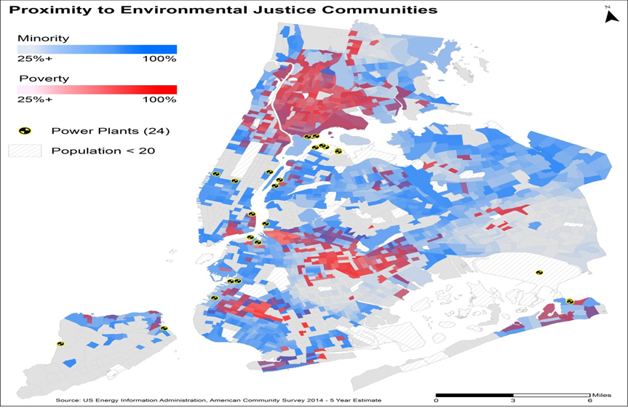
Graphic shows map plotting concentrations of self-identified minority status persons overlaid with percentages of communities at or below the federal poverty guideline, and the location of New York City power plants. The map shows a correlation between power plant locations and neighborhoods with high concentrations of self-identified minority status persons and percentages of communities at or below federal poverty guidelines.
High levels of fine particulate matter (PM2.5), nitrogen dioxide (NO₂), nitrous oxide (NO_{x}), and black carbon (BC), are associated with areas of high traffic activity, higher density of buildings with heat and hot water boilers, and industrial areas, whereas the highest ozone levels are found in the outer boroughs, downwind of high emissions areas, and in areas with fewer combustion emissions. The combustion of fuel for transportation and the production of heat and hot water are responsible for a significant portion of the airborne pollutants in the city. However, simple cycle and regenerative combustion turbines at power plants across the state, many of them used as peaker plants, can account for over a third of New York City’s daily power plant nitrous oxide (NOx) emissions while producing less electricity for consumers than cleaner sources. The Calpine JFK Emergency Generation Center has six emergency boilers that burn natural gas. The newest of these boilers is 32 years old, while the oldest is 63 years old. Because these turbines emit approximately 30 times more NOx than modern turbines, monitoring and upgrading obsolete technology has the potential to significantly improve air quality in the region.
- Legislation
Int No. 960 would add four definitions to Title 24 of the administrative code, including “heavy use thoroughfare,” “recreational area,” “regulated air contaminant,” and “at risk populations.” The bill would require the installation of street level air monitors along designated heavy use thoroughfares and at every recreation area. It would also require the issuance of a report to the Mayor and the Speaker of the City Council containing the results of those monitoring efforts, including whether they indicate levels of regulated air contaminants in violation of existing standards. The bill would also require the NYC Departments of Environmental Protection, Transportation, and Education to develop and implement mitigation measures for exposure risks. The local law would take effect ninety days after enactment, provided that the Commissioner of Environmental Protection shall take such measures as are necessary for its implementation, including the promulgation of rules prior to its effective date.
Int. No. 980 would amend Section 24-168 of the Administrative Code of the City of New York, which currently permits use of No. 4 fuel oil in buildings until 2030, to mandate the gradual phase out of No. 4 fuel oil by January 1, 2025, starting with buildings that can switch to natural gas use immediately, followed by those buildings that must clean out fuel tanks, and finally those buildings that must excavate their fuel tanks or undertake remediation prior to replacing such tanks. This local law would take effect immediately.
Int. No. 992 would amend the New York City Charter in relation to monitoring power plant performance, by requiring the Office of Long Term Planning and Sustainability to track all New York State Department of Environmental Conservation reports on Title V power plants, and to submit comments on proposed permit renewals including proposed technical improvements, possible mitigation measures, and other recommendations with regard to continued operation. This local law would take effect immediately.

Int. No. 960

By Council Members Constantinides, Reynoso, Chin, Kallos and Cornegy

A Local Law to amend the administrative code of the city of New York, in relation air quality monitoring at designated “heavy use” thoroughfares.

Be it enacted by the Council as follows:

Section 1. Section 24-108 of the administrative code of the city of New York is amended by adding a new subdivision g to read as follows:
(g) (1) For purposes of this subdivision the following terms shall have the following meanings:
(i) “Heavy use thoroughfare” means any highway, roadway or other traffic corridor that has traffic volume greater than the fiftieth percentile of the average New York city roadway corridors or have traffic in excess of 100,000 vehicles on an annual basis. Designation of heavy use thoroughfares shall be based upon verifiable usage and traffic volume data obtained from transportation planning agencies including, but not limited to, the New York metropolitan transportation council, the New York city department of transportation and the New York state department of transportation.
(ii) “Recreational area” means any park, playground, ball field and school playground that abuts a heavy use thoroughfare.
(iii) "Regulated air contaminant" means oxides of nitrogen, volatile organic compounds, sulfur dioxide, particulate matter, carbon monoxide, carbon dioxide, polycyclic aromatic hydrocarbons or any other air contaminant for which a national ambient air quality standard has been promulgated; or any air contaminant that is regulated under section 112 of the Clean Air Act, as amended.
(iv) “At risk populations” means infants and children sixteen years of age or younger, pregnant women, adults sixty years of age or older, and persons with weakened immune systems.
(2) The department shall, no later than December thirtieth, two thousand eighteen, designate heavy use thoroughfares in every borough.
(3) The department shall install street level air monitors at a minimum at two major intersections on every designated heavy use thoroughfare and at every recreational area by December thirtieth, two thousand nineteen. Commencing on December thirtieth, two thousand twenty and every December thirtieth thereafter, the department shall issue a report to the mayor and to the speaker of the council containing the results of the air quality monitoring of designated heavy use thoroughfares. Such report shall also be posted on the department’s website annually.
(4) Where the results of the air quality monitoring on adjoining heavy use thoroughfares indicate that levels of any regulated air contaminant constitute a violation of an existing standard for that regulated air contaminant or contribute to an actual or potential danger to public health or the environment or present a health risk to at-risk populations based upon the most recent research available, the department of environmental protection along with the departments of transportation and education shall collaboratively identify, develop and require the implementation of corrective mitigation measures that significantly reduce or eliminate short-term and long term exposure risks.
§3. This local law shall take effect ninety days after enactment, provided, however, that the commissioner of environmental protection shall take such measures as are necessary for its implementation, including the promulgation of rules, prior to such effective date
[SS] LS 6630
Int. 297-2014
5/15/18 11:18 a.m.

Int. No. 980

By Council Member Constantinides and the Public Advocate (Mr. Williams) (by request of the Queens Borough President)

A Local Law to amend the administrative code of the city of New York, in relation to phasing out the use of fuel oil grade no. 4

Be it enacted by the Council as follows:
Section 1. Subdivision d of section 24-168 of the administrative code of the city of New York, as amended by a local law for the year 2017, amending the administrative code of the city of New York, in relation to phasing out the use of residual fuel oil and fuel oil grade no. 4 in boilers in in-city power plants, as proposed in introduction number 1465-A, is amended to read as follows:
(d) Except as provided in subdivision (f), no person shall cause or permit a boiler to burn fuel oil grade no. 4 on or after [January 1, 2030, or for a boiler used to generate electricity and/or steam in an electric, steam, or combined electric and steam generation facility, on or after] (i) March 1, 2018, for a boiler that uses natural gas as primary fuel and fuel oil grade no. 4 as a backup fuel, other than a boiler used to generate electricity and/or steam in an electric, steam, or combined electric and steam generation facility, (ii) January 1, 2024, for a boiler that uses an above-ground oil storage tank, other than a boiler used to generate electricity and/or steam in an electric, steam, or combined electric and steam generation facility or (iii) January 1, 2025 for all other boilers.
§ 2. This local law takes effect immediately.

SS LS #1608
5/23/2018 11:50AM

Int. No. 992

By Council Member Constantinides

A Local Law to amend the New York city charter, in relation to monitoring power plants performance

Be it enacted by the Council as follows:

Section 1. Chapter 1 of the New York city charter is amended by adding a new section 20-f to read as follows:
20-f. Monitor power plant performance. 1. The office of long-term planning and sustainability shall track all department of environmental conservation reports on Title V power plants including, but not limited to, draft and final permit issuance, permit comment periods, permit renewals, permit compliance and whether any permit is not in attainment for any criteria pollutant.
2. When any power plant is not in compliance with its permits when renewal for that permit is being considered, the office of long term planning and sustainability shall submit comments on the proposed renewal including proposed technical improvements, suggested mitigation measures or recommendations respecting continued operation.
§ 2. This local law takes effect immediately.

LS #9537
SS
3/6/17 3:17 p.m.

United States Environmental Protection Agency. Clean Air Act Plain Language Guide. https://www.epa.gov/sites/production/files/2015-08/documents/peg.pdf (last accessed 1/21/21)
Id.
Id.
U.S. Environmental Protection Agency. Green Book. Non-Attainment Areas for Criteria Pollutants. https://www.epa.gov/green-book (last accessed 1/21/21)
U.S. Environmental Protection Agency. 8 Hour Ozone (2015) Designated Area/State Information. https://www3.epa.gov/airquality/greenbook/jbtc.html (last accessed 1/21/21)
Id.
Yackerson NS et al. 2014. The influence of air-suspended particulate concentration on the incidence of suicide attempts and exacerbation of schizophrenia. International journal of biometeorology, 58(1): 61-7.
D’Anguilli A. Severe Urban Outdoor Air Pollution and Children’s Structural and Functional Brain Development, From Evidence to Precautionary Strategic Action. Frontiers in Public Health. April, 2018. https://www.frontiersin.org/articles/10.3389/fpubh.2018.00095/full (last accessed 1/21/21)
Id.
Ritz B, F Yu, et al 2002. Ambient air pollution and risk of birth defects in Southern California. American Journal of Epidemiology 155(1): 17-25.
Ebisu, K et al. Airborne PM2.5 Chemical Components and Low Birth Weight in the Northeastern and Mid-Atlantic Regions of the United States. Environmental Health Perspectives. December 2012. https://ehp.niehs.nih.gov/doi/pdf/10.1289/ehp.1104763 (last accessed 1/21/21)
Wu YT, AM Prina, & C Brayne. 2015. The association between community environment and cognitive function: a systematic review. Social psychiatry and psychiatric epidemiology, 50(3): 351-62.
D’Anguilli A. Severe Urban Outdoor Air Pollution and Children’s Structural and Functional Brain Development, From Evidence to Precautionary Strategic Action. Frontiers in Public Health. April, 2018. https://www.frontiersin.org/articles/10.3389/fpubh.2018.00095/full (last accessed 1/21/21)
Id.
Hystad P, PJ Villeneuve, et al. 2015. Exposure to traffic-related air pollution and the risk of developing breast cancer among women in eight Canadian provinces: a case-control study. Environment international, 74: 240-8.
Prescott GJ, GR Cohen, et al. 1998. Urban air pollution and cardiopulmonary ill health: a 14.5 year time series study. Occupational and Environmental Medicine 55(10): 697-4.
Miller KA, DS Siscovick, et al. 2007. Long-term exposure to air pollution and incidence of cardiovascular events in women. New England Journal of Medicine 356(5): 447-58.
U.S Environmental Protection Agency. EnviroAtlas Eco-Health Relationship Browser. https://enviroatlas.epa.gov/enviroatlas/Tools/EcoHealth_RelationshipBrowser/index.html (last accessed 1/21/21)
Id.
MohanKumar SM et al. Particulate matter, oxidative stress and neurotoxicity. Neurotoxicology. May, 2008. https://www.sciencedirect.com/science/article/pii/S0161813X07002720 (last accessed 1/21/21)
Air Pollution May Explain Asthma Hot Spots in NYC. Columbia Mailman School of Public Health. CHILD AND ADOLESCENT HEALTH, ENVIRONMENTAL HEALTH Mar. 27 2012 https://www.mailman.columbia.edu/public-health-now/news/air-pollution-may-explain-childhood-asthma-hot-spots-nyc (last accessed 1/21/21)
Cornell, AG, et al. Domestic airborne black carbon and exhaled nitric oxide in children in NYC. Journal of Exposure Science & Environmental Epidemiology. 2012. https://www.nature.com/articles/jes20123 (last accessed 1/21/21/)
New York City Community Air Survey. Neighborhood Air Quality 2008-2017 https://nyc-ehs.net/besp-report/web/nyccas (last accessed 1/21/21)
Mean PM 2.5, 2017, UHF 42 Air samples collected at specific NYCCAS monitoring sites along with information about emissions sources were incorporated into a statistical model that predicted pollutant concentrations at all locations in NYC for the specified time period. The results were then assigned to the appropriate NYC neighborhood and averaged. In NYC, fine particulate matter is measured in units of micrograms per cubic meter of air.
U.S Environmental Protection Agency. EnviroAtlas Eco-Health Relationship Browser. https://enviroatlas.epa.gov/enviroatlas/Tools/EcoHealth_RelationshipBrowser/index.html (last accessed 1/21/21)
Id.
Laden et al. Reduction in Fine Particulate Air Pollution and Mortality, Extended Follow-up of the Harvard Six Cities Study. The American Journal of Respiratory and Critical Care Medicine. March, 2006. https://www.ncbi.nlm.nih.gov/pmc/articles/PMC2662950/ (last accessed 1/21/21)
New York Department of Environmental Conservation. Proposed Subpart 227-3 Regulatory Impact Statement Summary. http://www.dec.ny.gov/regulations/116180.html#13 (last accessed 1/21/21)
Id.
NYC Clean Heat. https://www.nyccleanheat.org/content/what-nyc-clean-heat (last accessed 1/21/21)
New York City Community Air Survey. Neighborhood Air Quality 2008-2017 https://nyc-ehs.net/besp-report/web/nyccas (last accessed 9/18/2019)
Id.
Id.
Id.
Id.
New York City Community Air Survey. Neighborhood Air Quality 2008-2017 https://nyc-ehs.net/besp-report/web/nyccas (last accessed 9/18/19)
Carrion et al. Residential Inequity: Assessing the Unintended Consequences of New York City’s Clean Heat Transition. International Journal of Environmental Research and Public Health. January, 2018. https://www.mdpi.com/1660-4601/15/1/117/pdf-vor (last accessed 1/21/21)
Id.
Columbia University Mailman School of Public Health. Use of Dirty Heating Oil in NYC is Concentrated Uptown. January 22, 2018. https://www.publichealth.columbia.edu/public-health-now/news/use-dirty-heating-oil-nyc-concentrated-uptown (last accessed 1/21/21)
Morello Frosch, R, and Jesdale, B. Separate and Unequal: Residential Segregation and Estimated Cancer Risks Associated with Ambient Air Toxics in U.S. Metropolitan Areas Environmental Health Perspectives. October, 2005. https://www.ncbi.nlm.nih.gov/pmc/articles/PMC1392233/ (last accessed 1/21/21)
Physicians, Scientists, and Engineers for Healthy Energy “Natural Gas Power Plants in California’s Disadvantaged Communities” (April 2017), https://www.psehealthyenergy.org/our-work/publications/archive/natural-gas-power-plants-in-californias-disadvantaged-communities/ (last accessed 1/21/21)
Based on data illustrated in Figure 3
This map shows the location of in-City power plants, and their proximity to environmental justice communities, which are defined by the percentage of each community that identifies as belonging to minority groups, and the percentage of each community that is at the federal poverty guidelines. Source of Data: US Energy Information Administration and the American Community Survey (2014).
New York City Community Air Survey. Neighborhood Air Quality 2008-2017 https://nyc-ehs.net/besp-report/web/nyccas (last accessed 1/21/21)
Id.
NYSERDA. Governor Cuomo Announces Proposed Regulations to Improve Air Quality and Reduce Harmful Ozone Caused by Power Plant Emissions. February 28, 2019. https://www.nyserda.ny.gov/About/Newsroom/2019-Announcements/2019-02-28-Governor-Cuomo-Announces-Proposed-Regulations-to-Improve-Air-Quality-and-Reduce-Harmful-Ozone (last accessed 1/21/21)
New York Department Of Environmental Conservation. Permit Review Report. Permit ID: 2-6308-00096/00009. https://www.dec.ny.gov/dardata/boss/afs/permits/prr_263080009600009_r2_1.pdf (last accessed 1/21/21)
NYSERDA. Governor Cuomo Announces Proposed Regulations to Improve Air Quality and Reduce Harmful Ozone Caused by Power Plant Emissions. February 28, 2019. https://www.nyserda.ny.gov/About/Newsroom/2019-Announcements/2019-02-28-Governor-Cuomo-Announces-Proposed-Regulations-to-Improve-Air-Quality-and-Reduce-Harmful-Ozone (last accessed 1/21/21)

