THE COUNCIL OF THE CITY OF NEW YORK
RESOLUTION NO. 1267

Resolution approving the decision of the City Planning Commission on Application No. N 200065 ZRM, for an amendment of the text of the Zoning Resolution (L.U. No. 608).

By Council Members Salamanca and Moya

WHEREAS, GO Broome, LLC and Chinatown Planning Council Development Fund, Inc., filed an application pursuant to Section 201 of the New York City Charter, for an amendment of the text of the Zoning Resolution of the City of New York, modifying the Quality Housing provisions of Article II, Chapters 3 and 8, and related provisions, and APPENDIX F for the purpose of establishing a Mandatory Inclusionary Housing area, which in conjunction with the related actions would facilitate the development of two new mixed-use developments containing mostly residential uses, and community facility and commercial uses (the proposed development) in Manhattan Community District 3 (Application No. N 200065 ZRM), (the "Application");

WHEREAS, the City Planning Commission filed with the Council on January 21, 2020, its decision dated January 21, 2020 (the "Decision"), on the Application;

WHEREAS, the Application is related to applications C 200061(A) ZSM (L.U. No. 606), a zoning special permit pursuant to Zoning Resolution (ZR) Section 78-312 to waive height, setback, and distance between buildings regulations of ZR Section 23-60 and 23-70; and C 200064 ZMM (L.U. No. 607), a zoning map amendment to change an R8 district to an R9-1 district with a C2-5 overlay;

WHEREAS, the Decision is subject to review and action by the Council pursuant to Section 197-d of the City Charter;
WHEREAS, upon due notice, the Council held a public hearing on the Decision and Application on January 30, 2020;

WHEREAS, the Council has considered the land use implications and other policy issues relating to the Decision and Application; and

WHEREAS, the Council has considered the relevant environmental issues, including the positive declaration, issued on January 25, 2019 (CEQR No. 19DCP119M) and a Final Environmental Impact Statement (FEIS) for which a Notice of Completion was issued on January 10, 2020 which identified significant adverse impacts with respect to construction (vehicular traffic and noise) and transportation (vehicular traffic and pedestrian traffic) and significant adverse impacts related to hazardous materials, air quality, and noise would be avoided through the placement of (E) designations (E-548) on the project sites. In addition, the FEIS analyzed the amended application and concluded that the amended application would not change the conclusions of the FEIS and the significant adverse impact categories would remain the same and the identified significant adverse impacts and proposed mitigation measures are included in the Restrictive Declaration attached as Exhibit A and Exhibit B to the Decision.

RESOLVED:

Having considered the FEIS with respect to the Decision and Application, the Council finds that:

- The FEIS meets the requirements of 6 N.Y.C.R.R. Part 617;

- Consistent with social, economic and other essential considerations from among the reasonable alternatives available, the action is one that avoids or minimizes adverse environmental impacts to the maximum extent practicable; and

- The adverse environmental impacts identified in the FEIS will be minimized or avoided to the maximum extent practicable by incorporating as conditions to the approval, pursuant to two Restrictive Declarations marked as Exhibit A and Exhibit B, those project components related to the environment and mitigation measures that were identified as practicable and the placement of (E) designation (E-548) for hazardous materials, air quality, and noise; and

- No development pursuant to this resolution shall be permitted until the Restrictive Declarations attached as Exhibit A and Exhibit B, as same may be modified with any necessary administrative or technical changes, all as acceptable to Counsel to the Department of City Planning and Counsel to the Landmarks Preservation Commission, as executed by GO Broome LLC and The Chinatown Planning Council Housing Development Fund Company or its successor, and such Restrictive Declaration shall have been recorded and filed in the Office of the Register of the City of New York, County of New York.

The Decision, together with the FEIS constitute the written statement of facts, and of social, economic and other factors and standards that form the basis of this determination, pursuant to 6 N.Y.C.R.R. §617.11(d).

Matter underlined is new, to be added;
Matter struck out is old, to be deleted;
Matter within # # is defined in Section 12-10;
* * * indicates where unchanged text appears in the Zoning Resolution.

Matter underlined is new, to be added.
Matter struckout is to be deleted.
Matter with # # is defined in Section 12-10.
* * * indicates where unchanged text appears in the Zoning Resolution.

Article II – Residence District Regulations

* * *

Chapter 3
Residential Bulk Regulations in Residence Districts

* * *

23-011
Quality Housing Program

R5D R6A R6B R7A R7B R7D R7X R8A R8B R8X R9A R9D R9X R10A R10X

(a) In R6A, R6B, R7A, R7B, R7D, R7X, R8A, R8B, R8X, R9A, R9D, R9X, R10A or R10X Districts, any #building or other structure# shall comply with the #bulk# regulations for #Quality Housing buildings# set forth in this Chapter and any #building# containing #residences# shall also comply with the requirements of Article II, Chapter 8 (Quality Housing Program). However, the provisions of Article II, Chapter 8, shall not apply to #buildings converted# pursuant to Article I, Chapter 5.

In R5D Districts, only certain requirements of Article II, Chapter 8, shall apply as set forth in Section 28-01 (Applicability of This Chapter).

R6 R7 R8 R9 R10

(b) In the districts indicated without a letter suffix, the #bulk# regulations applicable to #Quality Housing buildings# may, as an alternative, be applied to #zoning lots# where #buildings# are #developed# or #enlarged# pursuant to all of the requirements of the Quality Housing Program. Such #buildings# may be subsequently #enlarged# only pursuant to the Quality Housing Program. In these districts, the Quality Housing #bulk# regulations may apply to #developments# or #enlargements# on #zoning lots# with existing #buildings# to remain, if:

(1) the existing #buildings# contain no #residences# and the entire #zoning lot# will comply with the #floor area ratio# and density standards applicable to #Quality Housing buildings#; or

(2) the existing #buildings# contain #residences#, and:

(i) such #buildings# comply with the maximum base heights and maximum #building# heights listed in the tables in Section 23-662 for the applicable district, and the entire #zoning lot# will comply with the #floor area ratio# and #lot coverage# standards applicable to #Quality Housing buildings#; or

(ii) for #developments# or #enlargements# on #zoning lots# meeting the criteria set forth in paragraph (a) of Section 23-664 (Modified height and setback regulations for certain Inclusionary Housing buildings or affordable independent residences for seniors):

(a) the entire #zoning lot# will comply with the #floor area ratio# set forth in Sections 23-154 (Inclusionary Housing) or 23-155 (Affordable independent residences for seniors), as applicable;

(b) the entire #zoning lot# will comply with the #lot coverage# regulations for the applicable zoning district set forth in Section 23-153 (For Quality Housing buildings); and the #development# or #enlargement#:

(1) will comply with the maximum base height and maximum #building# height of the applicable zoning district set forth in Table 1 of paragraph (b) of Section 23-664;

(2) in R6, R7, R8 and R9-1 Districts, where the #zoning lot# meets the criteria set forth in paragraph (a)(3) of Section 23-664 will comply with the maximum base height and maximum #building# height of the applicable zoning district set forth in Table 2 of paragraph (c) of Section 23-664; or

(3) in R6, R7, R8 and R9-1 Districts, where the #zoning lot# meets the criteria set forth in paragraph (a)(4) of Section 23-664 and is located within 150 feet of the types of transportation infrastructure listed in paragraphs (c)(2)(i) through (c)(2)(iv) of Section 23-664, will comply with the maximum base height and maximum #building# height of the applicable zoning district set forth in Table 2 of paragraph (c) of Section 23-664. Such 150-foot measurement shall be measured perpendicular to the edge of such infrastructure.

All #Quality Housing buildings# shall also comply with additional provisions set forth in Article II, Chapter 8.

R6 R7 R8 R9 R10

(c) In the districts indicated without a letter suffix, the optional Quality Housing #bulk# regulations permitted as an alternative pursuant to paragraph (b) of this Section, shall not apply to:

(1) Article VII, Chapter 8 (Special Regulations applying to Large Scale Residential Developments);, except that they may be permitted as an alternative to apply within #Large Scale Residential Developments# located:

(i) in C2-5 Districts mapped within R9-1 Districts in Community District 3 in the Borough of Manhattan.

(2) Special Purpose Districts

However, such optional Quality Housing #bulk# regulations are permitted as an alternative to apply in the following Special Purpose Districts:

#Special 125th Street District#;

#Special Downtown Brooklyn District#;

#Special Downtown Far Rockaway District#;

#Special Downtown Jamaica District#;

#Special East Harlem Corridors District#;

#Special Grand Concourse Preservation District#;

#Special Harlem River Waterfront District#;

#Special Limited Commercial District#;

#Special Long Island City Mixed Use District#;

#Special Lower Manhattan District#, as modified in Section 91-05;

#Special Ocean Parkway District#;

#Special Transit Land Use District#; or

#Special Tribeca Mixed Use District#.

R6 R7 R8 R9 R10

(d) In the districts indicated, for #Quality Housing buildings# in which at least 50 percent of the #dwelling units# are #income-restricted housing units#, or at least 50 percent of the total #floor area# is a #long-term care facility# or philanthropic or non-profit institution with sleeping accommodation, the applicable #bulk# regulations of this Chapter may be modified for #zoning lots# with irregular site conditions or site planning constraints by special permit of the Board of Standards and Appeals, pursuant to Section 73-623 (Bulk modifications for certain Quality Housing buildings on irregular sites).

R6 R7 R8 R9 R10

(e) In the districts indicated, where a Special Purpose District modifies the #bulk# regulations for #Quality Housing buildings# set forth in this Chapter, the additional provisions for #Quality Housing buildings# set forth in Article II, Chapter 8 shall continue to apply. In addition, where any Special Purpose District that requires elements of Article II, Chapter 8 to apply to non-#Quality Housing buildings#, all associated #floor area# exemptions shall apply.

* * *

Chapter 8
The Quality Housing Program

28-00
GENERAL PURPOSES

The Quality Housing Program is established to foster the provision of multifamily housing and certain #community facilities# that:

(a) are compatible with existing neighborhood scale and character;

(b) provide on-site amenity spaces to meet the needs of its residents; and

(c) are designed to promote the security and safety of its residents.

28-01
Applicability of this Chapter

The Quality Housing Program is a specific set of standards and requirements that, in conjunction with the #bulk# provisions for #Quality Housing buildings# set forth in Article II, Chapter 3, and Article III, Chapter 5, as applicable, apply to #buildings# containing #residences#, #long-term care facilities# or philanthropic or non-profit institutions with sleeping accommodations, or some combination thereof as follows:

(a) In R6A, R6B, R7A, R7B, R7D, R7X, R8A, R8B, R8X, R9A, R9D, R9X, R10A or R10X Districts, and in the equivalent #Commercial Districts# listed in Sections 34-111 and 34-112, all such #buildings# shall comply with the Quality Housing Program standards and requirements as set forth in this Chapter.

(b) In other R6, R7, R8, R9 or R10 Districts, and in the equivalent #Commercial Districts# listed in Sections 34-111 and 34-112, all #developments# and #enlargements# of such #buildings# utilizing the Quality Housing #bulk# regulations in Article II, Chapter 3, shall comply with the Quality Housing Program standards and requirements set forth in this Chapter.

(c) In R5D Districts, only the requirements set forth in Sections 28-12 (Refuse Storage and Disposal), 28-23 (Planting Areas) and 28-43 (Location of Accessory Parking) shall apply.

(d) In R6 through R10 Districts, and in the equivalent #Commercial Districts# listed in Sections 34-111 and 34-112, for #developments# and #enlargements# of #community facility buildings# containing #long-term care facilities# or philanthropic or non-profit institutions with sleeping accommodations, or portions of #buildings# containing such #uses#, where such #buildings# utilize the #bulk# regulations for #Quality Housing buildings# in Article II, Chapter 3, in R6 through R10 Districts with a letter suffix, or the height and setback regulations for #Quality Housing buildings# in Article II, Chapter 3, in R6 through R10 Districts without a letter suffix, the Quality Housing Program standards and requirements of this Chapter shall apply, except that the provisions of Section 28-12 shall be optional.

(e) The provisions of Article VII, Chapter 8 (Special Regulations Applying to Large-Scale Residential Developments), are not applicable to #Quality Housing buildings#.

(fe) The provisions of this Chapter shall not apply to #dwelling units converted# pursuant to Article I, Chapter 5, unless such #conversions# meet the requirements for #residential developments# of Article II (Residence District Regulations).

* * *

Article VII - Administration

Chapter 8
Special Regulations Applying to Large-Scale Residential Developments

78-00
GENERAL PURPOSES, DEFINITIONS AND GENERAL PROVISIONS

78-01
General Purposes

The regulations set forth in this Chapter are designed to deal with certain types of problems which arise only in connection with large-scale residential developments and to promote and facilitate better site planning and community planning through modified application of the district regulations in such developments.

For large-scale residential developments involving several zoning lots but planned as a unit, the district regulations may impose unnecessary rigidities and thereby prevent achievement of the best possible site plan within the overall density and bulk controls. For such developments, the regulations of this Chapter are designed to allow greater flexibility for the purpose of securing better site planning for development of vacant land and to provide incentives toward that end while safeguarding the present or future use and development of surrounding areas and, specifically, to achieve more efficient use of increasingly scarce land within the framework of the overall bulk controls, to enable open space in large-scale residential developments to be arranged in such a way as best to serve active and passive recreation needs of the residents, to protect and preserve scenic assets and natural features such as trees, streams and topographic features, to foster a more stable community by providing for a population of balanced family sizes, to encourage harmonious designs incorporating a variety of building types and variations in the siting of buildings, and thus to promote and protect public health, safety and general welfare.

* * *

78-03
Applicability of This Chapter

#Large-scale residential developments# are governed by all the #use#, #bulk#, off-street parking and loading, and other applicable regulations of this Resolution, except for such special provisions as are specifically set forth in this Chapter and apply only to such #large-scale residential developments#. However, the Quality Housing Program is inapplicable in #large-scale residential development#.

Any #large-scale residential development# having a total of at least 500 #dwelling units# shall be subject to the provisions of Section 78-11 (General Provisions), relating to Provision of Public Facilities in Connection with Large-Scale Residential Developments.

#Large-scale residential developments# within the #waterfront area# shall be subject to the provisions of Section 62-132 (Applicability of Article VII, Chapters 4, 8 and 9).

* * *

APPENDIX F
Inclusionary Housing Designated Areas and Mandatory Inclusionary Housing Areas

* * *

MANHATTAN

* * *

Manhattan Community District 3

* * *

Map 3 – [date of adoption]

[PROPOSED MAP]

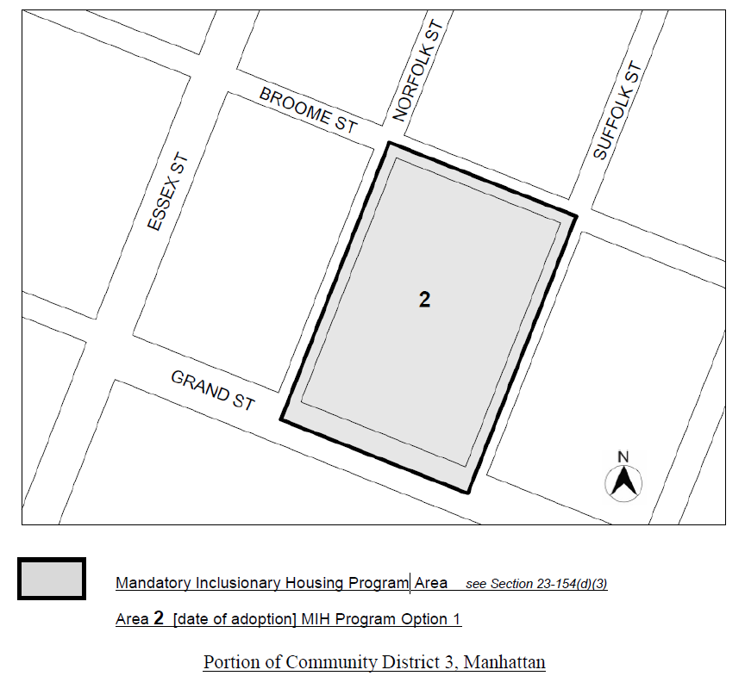
* * *

END

Adopted.

Office of the City Clerk, }
The City of New York, } ss.:

I hereby certify that the foregoing is a true copy of a Resolution passed by The Council of The City of New York on February 27, 2020, on file in this office.

.....……......................................... City Clerk, Clerk of The Council

