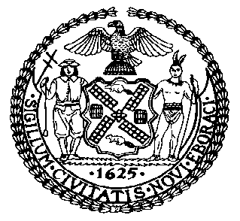 | The Council of the City of New York  Finance Division  Latonia McKinney, Director  Fiscal Impact Statement  Proposed Intro. No: 1168-A  Committee: Housing and Buildings
Title: A Local Law to amend the administrative code of the city of New York, in relation to improperly conditioning residential occupancy on medical treatment | Sponsors: Council Members Torres, Richards, Williams, Barron, Rose, Koslowitz, Salamanca, Cornegy, Gibson, Espinal, Levin, Reynoso, Rosenthal, Gentile, Chin, Rodriguez, Levine, Kallos, Lander and the Public Advocate (Ms. James)
Summary of Legislation: Proposed Intro. 1168-A would prohibit landlords from mandating medical treatment as a condition of occupancy, with the exception of family members and legitimate programs, such as rehabilitation clinics. This legislation also includes the imposition of such a mandate in the definition of harassment under the Housing Maintenance Code. As such, the bill would also provide a cause of action to tenants who face such a mandate, allowing them to challenge the violation in housing court, and if applicable, receive $1,000 in damages and reasonable attorney’s fees and court costs.

Effective Date: This local law would take effect 90 days after it becomes law.
Fiscal Year In Which Full Fiscal Impact Anticipated: Fiscal 2018
Fiscal Impact Statement:

 | Effective FY17 | FY Succeeding Effective FY18 | Full Fiscal Impact FY18
Revenues | $0 | $0 | $0
Expenditures | $0 | $0 | $0
Net | $0 | $0 | $0

Impact on Revenues: It is estimated that there would be no impact on revenues resulting from the enactment of this legislation.
Impact on Expenditures: It is anticipated that there would be no impact on expenditures resulting from the enactment of this legislation because existing resources would be used to implement the provisions of this local law and non-City entities would bear the costs of violating the prohibition of conditioning occupancy pursuant to the legislation.
Source of Funds To Cover Estimated Costs: Not applicable.

Source of Information: New York City Council Finance Division

Estimate Prepared by: Sarah Gastelum, Senior Legislative Financial Analyst

Estimated Reviewed by: Chima Obichere, Unit Head
Nathan Toth, Deputy Director
Eric Bernstein, Counsel

Legislative History: This legislation was introduced to the full Council on April 20, 2016 as Intro. No. 1168 and was referred to the Committee on Housing and Buildings. A joint hearing was held by the Committee on Housing and Buildings and the Committee on General Welfare on October 6, 2016 and the bill was laid over. The legislation was subsequently amended, and the amended version, Proposed Intro. 1168-A, will be considered by the Committee on Housing and Buildings on January 31, 2017. Following a successful Committee vote, the bill will be submitted to the full Council for a vote on February 1, 2017.

Date Prepared: January 26, 2017

