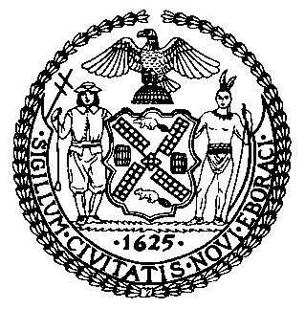 | The Council of the City of New York  Finance Division  Latonia Mckinney, Director  Fiscal Impact Statement  Proposed Intro. No: 1171-A  Committee: Housing and Buildings
Title: A Local Law to amend the administrative code of the city of New York, in relation to identifying unlawful statements in submissions to the Department of Buildings | Sponsors: Council Members Torres, The Public Advocate (Mr. Williams), Powers, Rivera, Kallos, Chin, Lancman and Rosenthal
Summary of Legislation: Proposed Intro. No. 1171-A would require the Department of Buildings (DOB) and the Department of Finance (DOF) to share certain information in order to identify cases of false statements regarding occupied and rent-regulated housing. It would also require DOB to request information from the Division of Housing & Community Renewal to identify false statements regarding occupied and rent-regulated housing. The legislation would require DOB to conduct an audit of an owner’s whole portfolio of properties using information obtained from DOF if the owner has been caught either failing to obtain a building permit or submitting false statements regarding occupied and rent-regulated housing on an application for a building permit. Lastly, when DOB has made a finding that an owner made a false statement, the legislation would require DOB to: (a) send written notice to the NYC Council, the Department of Investigations, the Division of Housing and Community Renewal, and the Tenant Protection Unit; (b) refer the matter to the relevant District Attorney and the Attorney General for potential criminal prosecution; and (c) report on the punitive actions it took in every case in which it found evidence of a falsified application for a building permit.

Effective Date: This legislation would take effect 180 days after it becomes law, except that the Commissioner of the Department of Buildings may take such measures as are necessary for its implementation, including the promulgation of rules, before such date.

Fiscal Year In Which Full Fiscal Impact Anticipated: Fiscal 2021
Fiscal Impact Statement:

 | Effective FY20 | FY Succeeding Effective FY21 | Full Fiscal Impact FY21
Revenues | $0 | $0 | $0
Expenditures | $0 | $0 | $0
Net | $0 | $0 | $0
Impact on Revenues: It is estimated that there would be no impact on revenues resulting from the enactment of this legislation.
Impact on Expenditures: It is estimated that there would be no impact on expenditures resulting from the enactment of this legislation because existing resources would be used by DOB to implement the provisions of this legislation.
Source of Funds To Cover Estimated Costs: N/A
Source of Information: New York City Council Finance Division
Estimate Prepared by: Luke Zangerle, Financial Analyst

Estimate Reviewed by: Stephanie Ruiz, Assistant Counsel
Chima Obichere, Unit Head
Legislative History: This legislation was introduced to the Council on October 17, 2018 as Intro. No. 1171 and was referred to the Committee on Housing and Buildings (Committee). The Committee heard the legislation on December 13, 2018, and the legislation was laid over. The legislation was subsequently amended and the amended version, Proposed Intro. No. 1171-A, will be considered by the Committee on May 7, 2019. Upon a successful vote by the Committee, the legislation will be submitted to the full Council for a vote on May 8, 2019.
Date Prepared: April 30, 2019

