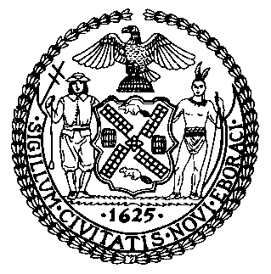 | The Council of the City of New York  Finance Division  Latonia McKinney, Director  Fiscal Impact Statement  Proposed Intro. No: 2264-A  Committee: Housing and Buildings
Title: A Local Law to amend the New York city building code, in relation to cold-formed steel construction | Sponsors: Council Members Cornegy and Chin (by request of the Mayor)
Summary of Legislation: Proposed Intro. No. 2264-A would amend certain existing requirements and establish new requirements for the use of cold-formed steel light-frame construction. In addition, this bill would amend special inspection requirements for the use of such construction and create new requirements for the installation of cold-formed steel light-frame construction, the installation of decking on cold-formed steel light-frame construction, and the use of such framing and decking during construction and demolition.

Effective Date: This local law would take effect on the same date as a local law amending the administrative code of the city of New York, the New York city plumbing code, the New York city building code, the New York city mechanical code and the New York city fuel gas code, relating to bringing such codes and related provisions of law up to date with the 2015 editions of the international building, mechanical, fuel gas and plumbing codes, as proposed in introduction number 2261 for the year 2021, takes effect, and would apply to work related to applications for construction document approval filed on and after such effective date, except that: (i) this local law would apply to all work on major buildings as defined in section BC 202 of the New York city building code, for which a site safety plan is approved by the department of buildings on or after such effective date; and (ii) the commissioner of buildings may promulgate rules or take other actions for the implementation of this local law prior to such effective date.

Fiscal Year In Which Full Fiscal Impact Anticipated: Fiscal 2024
Fiscal Impact Statement:
 | Effective FY23 | FY Succeeding Effective FY24 | Full Fiscal Impact FY24
Revenues | $0 | $0 | $0
Expenditures | $0 | $0 | $0
Net | $0 | $0 | $0
Impact on Revenues: It is estimated that there would be no impact on revenues resulting from the enactment of this legislation.

Impact on Expenditures: It is estimated that there would be no impact on expenditures resulting from the enactment of this legislation.
Source of Funds to Cover Estimated Costs: N/A
Source of Information: New York City Council Finance Division
Mayor’s Office of Legislative Affairs
Estimate Prepared by: John Basile, Senior Financial Analyst

Estimate Reviewed by: Chima Obichere, Unit Head
Noah Brick, Assistant Counsel
Legislative History: This legislation was first introduced to the full Council as Intro. No. 2264 on April 22, 2021 and referred to the Committee on Housing and Buildings (Committee). A hearing was held by the Committee on September 13, 2021 and the bill was laid over. The legislation was subsequently amended and the amended version, Proposed Intro. No. 2264-A, will be considered by the Committee on November 10, 2021. Upon a successful vote by the Committee, Proposed Intro. No. 2264-A will be submitted to the full Council for a vote on November 10, 2021.
Date Prepared: November 4, 2021

