Committee on Education
Malcom M. Butehorn, Senior Counsel
Jan Atwell, Senior Policy Analyst
Kalima Johnson, Senior Policy Analyst
Chelsea Baytemur, Financial Analyst

THE COUNCIL OF THE CITY OF NEW YORK

COMMITTEE REPORT OF THE HUMAN SERVICES AND

GOVERNMENTAL AFFAIRS DIVISION
Jeffrey Baker, Legislative Director
Andrea Vazquez, Deputy Director for Human Services

COMMITTEE ON EDUCATION
Hon. Mark Treyger, Chair

October 29, 2019

PROPOSED INT. NO. 1541-B: By The Speaker (Council Member Johnson) and Council Members Treyger, Cornegy, Powers, Lander and Louis

TITLE: A Local Law in relation to creating a specialized high school taskforce

Introduction
On Tuesday, October 29, 2019, the Committee on Education, chaired by Council Member Mark Treyger, held a vote on Proposed Introduction Number 1541-B, sponsored by The Speaker (Council Member Johnson). The Committee previously heard testimony on this bill on May 1, 2019. At that hearing, the Committee received testimony from the Department of Education (DOE), advocates, and other members of the public. In the prior Legislative Session, the Council held hearings on the issue of diversity in NYC schools in December 2014 and December 2017. On Tuesday, October 29, 2019 the Committee passed Proposed Introduction Number 1541-B by a vote of eleven in the affirmative, one in the negative, with zero abstentions.
Specialized High Schools
The nine Specialized High Schools are New York City’s most prestigious public schools, with students scoring at the 99th percentile of the state SAT distribution and accounting for the majority of NYC students attending Harvard, Princeton, and Yale. In 1971, a State law known as the Hecht-Calandra Act was passed with the purpose of blocking the diversification of the elite schools by requiring that admission to the schools “be solely and exclusively” gained by taking a specialized, voluntary admissions test, which is called the Specialized High Schools Admissions Test (SHSAT).
The sponsors of the legislation, Senator John D. Calandra (R-BX) and Assemblymember Burton G. Hecht (D-BX) asserted at the time of introduction that the bill was motivated by “the most insidious attack thus far upon the finest educational schools in New York City. [The Chancellor’s…] attempt to destroy these schools must be stopped immediately.” Early in 1971, only two years after a NYC teachers strike and the new decentralization law, the superintendent of one of the new NYC community school districts, Alfredo O. Mathew, Jr., of District 3 in Manhattan’s Upper West Side, asserted that Bronx High School of Science “…was a privileged educational center for children of the white middle class because ‘culturally’ oriented examinations worked to ‘screen out’ black [sic] and Puerto Rican students who could succeed at the school.” On these grounds of racial discrimination, the Superintendent and his local school board members asked the Chancellor’s office (then Chancellor Harvey Scribner) to change the policy to eliminate the entrance examination and to move to admission based on the recommendation of elementary school personnel. At the time, the Chancellor asserted “there is a questions as to the extent any test of academic achievement tends to be culturally biased.” He announced he would appoint a committee to examine the admissions procedure. These actions precipitated the legislative responses by Calandra and Hecht.
The law named three test-in specialized schools (Stuyvesant, Bronx Science, and Brooklyn Tech), and “such further high schools which the Board of Education may designate from time to time.” Today, eight schools continue to operate as exam schools; the original three as well as Brooklyn Latin School; Staten Island Technical High School; Queens High School for the Sciences; High School of American Studies; and the High School of Mathematics, Science and Engineering. Fiorello H. LaGuardia High School of Music & Art, does not use the test but rather admits students on the basis of auditions and students' academic records.
On March 18, 2019, students across the city received high school offer letters. According to DOE, approximately 27,500 8th graders took the SHSAT this year. A total of 5,830 students received an offer to one of the City’s nine specialized high schools. Of those, 4,798 received an offer to a specialized high school based on their exam score and 1,432 students received one or more offers to programs at LaGuardia. The distribution of offers by ethnicity was: 51.1% Asian; 28.5% white; 6.6% Hispanic, 4% black; 2.3% Multi-racial; and 7% Unknown.
The lack of representation of the racial makeup of the City’s schools system in the admissions offers to the test-based specialized high schools is also reflected in the overall student bodies for these schools. See Chart 3 below.

Chart 3
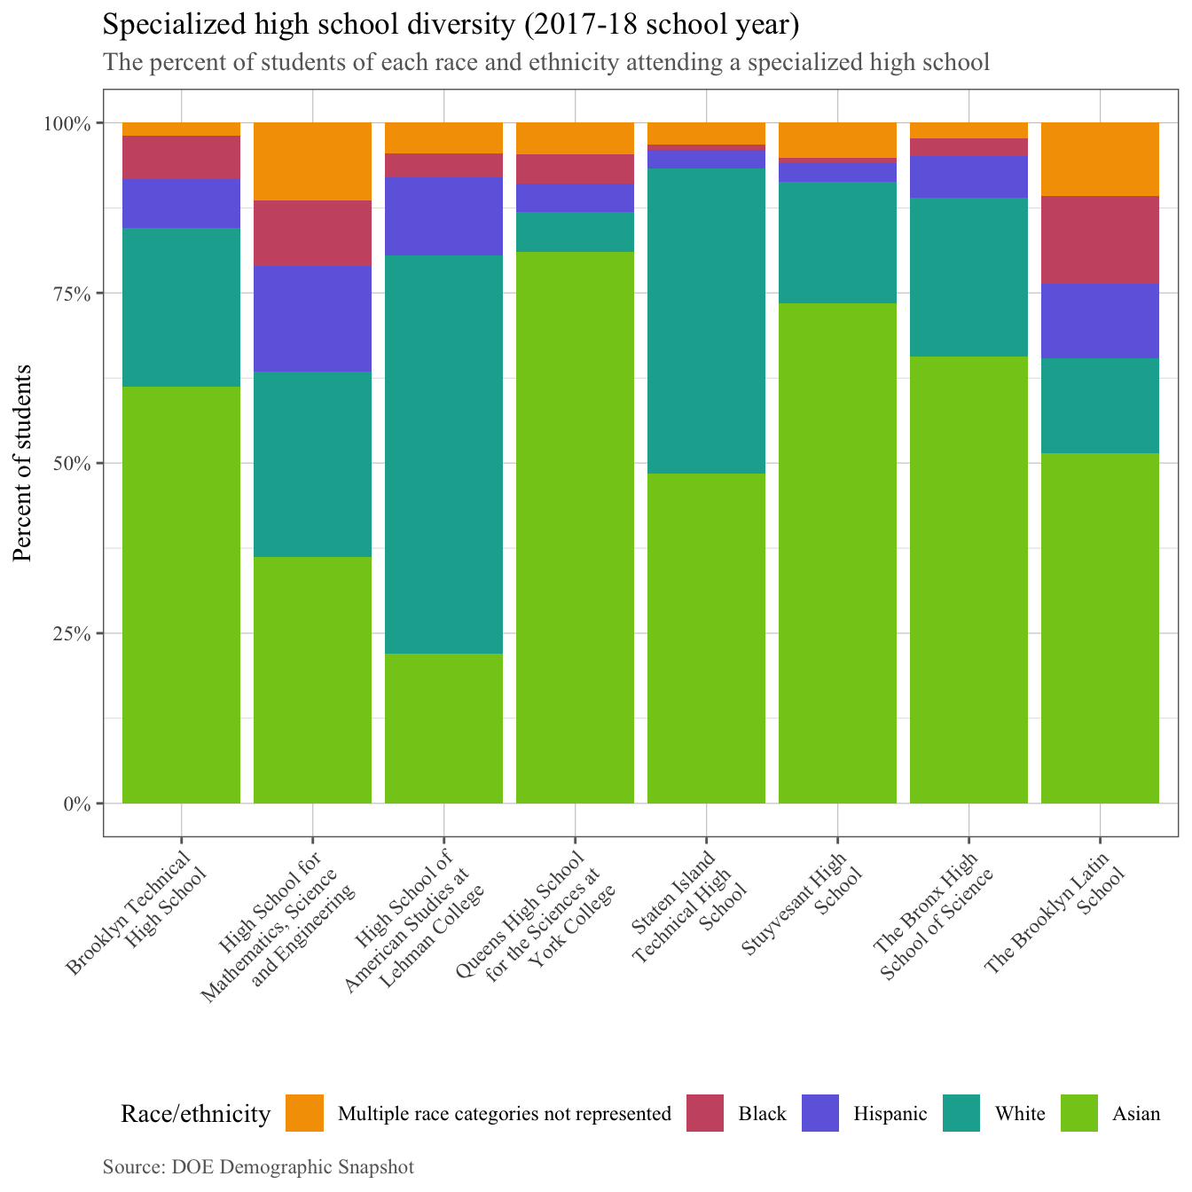
These inequities exist despite DOE’s recent enhanced test preparation and outreach efforts to increase diversity of the specialized high schools. In 2019, approximately 2,300 8th graders participated in the DREAM program, as compared with approximately 1,800 students in 2018. The DREAM (Determination, Resiliency, Enthusiasm, Ambition, Motivation) program is an extracurricular academic program that prepares eligible New York City public school students for the SHSAT. DREAM participants comprised 10% of black and Hispanic testers, but 29% of black and Hispanic offers. Additionally, DOE expanded SHSAT School Day, a program that offers the SHSAT during the school day, to 50 middle schools, up from 15 the prior year. Furthermore, DOE continues its Discovery program, which is a summer program that supports high-need students who obtained a SHSAT score within a certain range below the minimum cut off score to be admitted to a specialized school. According to the DOE, by the summer of 2020, 20% of seats at each specialized high school will be reserved for participants of the Discovery program.
Table 1 below contains the ENI for each of the test-based specialized high schools. For context, the citywide ENI is 70.7%.

Table 1
School | % of Students Experiencing Poverty | Economic Need Index
Stuyvesant High School | 44.3% | 41.8%
High School for Mathematics, Science and Engineering | 42.6% | 41.5%
The Bronx High School of Science | 44.2% | 39.5%
High School of American Studies at Lehman College | 20.3% | 24.1%
Brooklyn Technical High School | 60.8% | 52.0%
The Brooklyn Latin School | 61.7% | 52.7%
Queens High School for the Sciences at York College | 60.5% | 47.1%
Staten Island Technical High School | 40.8% | 35.1%

ANALYSIS OF PROPOSED INT. NO. 1541-B
A Local Law in relation to creating a specialized high school taskforce.
The proposed legislation would require the establishment of a task force to issue recommendations regarding the admissions standards for specialized high schools. The task force would be comprised of at least 17 members and would be charged with considering and developing recommendations for alternative admissions criteria for the eight test-based specialized high schools in New York City. The proposed legislation would provide that recommendations for such criteria could be eliminating the specialized high school admissions test, the department discovery program, the department dream program, state standardized examinations, grade point average, and other measures. The legislation would provide that the task force would be required to meet no less than monthly, and to hold at least one public hearing every quarter to solicit feedback. The task force would be required to submit a report of its findings and recommendations to the Mayor and the Speaker of the Council, and post the report on the Department of Education’s website. The proposed bill would provide that the local law would take effect immediately and would be deemed repealed upon submission of the required report.
Update to B version: Since the initial hearing on this bill, the bill has been amended by expanding the minimum number of members of the taskforce to 19, clarifying the topics that the taskforce is required to examine and make recommendations on, and requiring that the taskforce issue its report of recommendations no later than May 1, 2020.

UPDATE: On Tuesday, October 29, 2019 the Committee passed Proposed Introduction Number 1541-B by a vote of eleven in the affirmative, one in the negative, with zero abstentions.

Proposed Int. No. 1541-B

By The Speaker (Council Member Johnson) and Council Members Treyger, Cornegy, Powers, Lander and Louis

A LOCAL LAW

In relation to creating a specialized high school taskforce

Be it enacted by the Council as follows:
Section 1. Specialized high school taskforce. a. Definitions. For purposes of this local law, the following terms have the following meanings:
Chancellor. The term “chancellor” means the chancellor of the city school district of the city of New York.
Department. The term “department” means the New York city department of education.
School. The term “school” means a school of the city school district of the city of New York.
Specialized high schools. The term “specialized high schools” has the same meaning as such term is defined in paragraph b of subdivision 1 of section 2590-h of the education law.
b. The mayor shall establish a taskforce to issue recommendations for improving the admissions standards for specialized high schools. The taskforce shall consist of at least 19 members as follows:
1. The mayor, or the mayor’s designee;
2. The speaker of the council, or the speaker’s designee;
3. The chancellor, or the chancellor’s designee;
4. Nine members appointed by the mayor, including 1 member who shall be a parent of a child enrolled in a school; 5 members who shall be departmental employees, at least 1 of whom shall have experience in departmental admissions policies and at least 1 of whom shall be a teacher; 1 member who shall have expertise in the fields of education policy and child development; 1 member who shall have expertise in standardized testing and 1 member who shall have expertise in assessment, evaluation, testing and other aspects of educational measurement; and
5. Seven members appointed by the speaker of the council, including 1 member who shall be a current high school student who is not enrolled in a specialized high school; 1 member who shall be a current high school student who is enrolled in a specialized high school; 1 member who shall be a parent of a child enrolled in a school; 1 member who shall have expertise in the fields of education policy and child development; 1 member who shall have expertise in standardized testing; 1 member who shall have expertise in assessment, evaluation, testing and other aspects of educational measurement and 1 member who shall be a representative of a specialized high school alumni organization.
c. No member shall be removed except for cause by the appointing authority. In the event of a vacancy during the term of an appointed member, a successor shall be selected in the same manner as the original appointment.
d. Membership on the taskforce shall not constitute holding of a public office, and members of the taskforce shall not be required to take or file oaths of office before serving on the taskforce. Each member of the taskforce shall serve without compensation.
e. The taskforce shall be required to hold no fewer than 3 meetings. The taskforce shall also be required to hold at least 1 public hearing to solicit public comment and recommendations on the admissions process for specialized high schools. The taskforce shall designate 1 member to take minutes at each public hearing.
f. The taskforce shall examine, with the goal of increasing diversity:
1. The current admissions system for specialized high schools, including the specialized high school admissions test and whether such test should be changed or eliminated;
2. Existing programs such as the department’s discovery program and the department’s dream program, and whether such programs should be expanded and whether new programs or policies for increasing diversity should be created; and
3. The use of alternative admissions methods, including state standardized examinations, grade point average or other criteria.
g. The mayor may designate 1 or more agencies to provide staffing and other administrative support to the taskforce.
h. No later than May 1, 2020, the taskforce shall submit to the mayor and the speaker of the council, and post on the city’s website, a report on its findings and recommendations. For each recommendation in the report, the taskforce shall include the number of taskforce members who voted in the affirmative, voted in the negative and abstained. Such report shall also include a description of any engagement with the department or stakeholders, and a summary of the public hearings held pursuant to subdivision e of this local law. Such report shall be submitted to the New York state assembly committee on education and the New York state senate committee on New York city education. The taskforce shall dissolve upon submission of the report to all parties required pursuant to this subdivision.
§ 2. This local law takes effect immediately and is deemed repealed upon issuance of the report required by section one of this local law.
MMB
LS #10445; LS #4213; LS #6543; and LS #7339
10/25/19; 5:52 p.m.

Stuyvesant High School, Bronx High School of Science, Brooklyn Technical High School, Brooklyn Latin School, Staten Island Technical High School, Queens High School for the Sciences, High School of American Studies, the High School of Mathematics, Science and Engineering, and LaGuardia High School of Music and the Arts.
Dynarski, S., “Evidence on New York City and Boston exam schools,” Brookings Evidence Speaks Report Series, July 19, 2017, accessed at: https://www.brookings.edu/research/evidence-on-new-york-city-and-boston-exam-schools/.
Laws of New York, Chapter 1212 §12 (1971); codified as Education Law § 2590-h. See also Shapiro, E., “De Blasio has means, if not will, to reform specialized high school admissions,” Politico. March 15, 2018, accessed at: https://www.politico.com/states/new-york/albany/story/2018/03/15/de-blasio-has-means-if-not-will-to-reform-specialized-school-admissions-317675
“Paths to Legislation or Litigation for Educational Privilege: New York and San Francisco Compared,” page 16, available at: https://steinhardt.nyu.edu/scmsAdmin/uploads/005/432/The%20Hecht-Calandra%20Bill.AJE3.doc
Id.
Malcolm, A.H. “Scribner to Name Unit to Study Special-school Entrance Tests.” The New York Times, February 24, 1971, page 50.
Id.
Id.
Learning Curve, “Text of Calandra-Hecht Bill Amending SEC.2590G, Subdivision 12 of the Education Law.” Available at: https://learning-curve.blogspot.com/2012/10/text-of-calandra-hecht-bill-amending.html.
New York City Department of Education. “Re: High School Admissions.” 19 March 2019. E-mail on file with Council staff.
Id.
Id.
Id.
Id.
See New York City Department of Education, “Diversity in Admissions,” Accessed at: https://www.schools.nyc.gov/enrollment/enrollment-help/meeting-student-needs/diversity-in-admissions.
New York City Department of Education. “Re: High School Admissions.” 19 March 2019. E-mail on file with Council staff.
Id.
See New York City Department of Education, “Diversity in Admissions,” Accessed at: https://www.schools.nyc.gov/enrollment/enrollment-help/meeting-student-needs/diversity-in-admissions..
See New York City Department of Education, “Demographic Snapshot.” Accessed at: https://infohub.nyced.org/reports-and-policies/citywide-information-and-data/information-and-data-overview.

