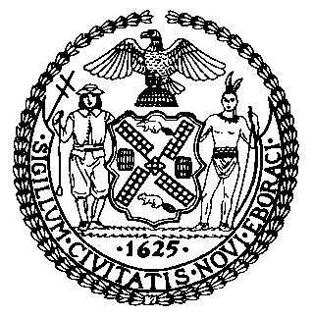 | The Council of the City of New York  Finance Division  Latonia McKinney, Director  Fiscal Impact Statement  Proposed Intro. No.: 461-A  Committee: Education
Title: A Local Law to amend the administrative code of the city of New York, in relation to information regarding summer meals. | Sponsors: Council Members Vacca, Barron, Constantinides, Eugene, Johnson, Koo, Mendez, Cohen, Rodriguez, Rosenthal, Menchaca, Rose, Kallos and the Public Advocate (Ms. James) (by request of the Manhattan Borough President)
Summary of Legislation: Proposed Intro. 461-A would require the Department of Education (DOE) to post and distribute by June 1st of each year (with the first posting and distribution to be done no later than June 1, 2018) information about the availability of the upcoming summer meal program. Information would include where and when summer meals are available, as well as eligibility requirements for such meals. Intro. 461-A would require DOE to post the information on DOE’s website, the website of any city agency collaborating with DOE to provide meals, and the 311 website; and to distribute the information to council members, borough presidents, community boards, community education councils, parent associations, and parent teacher associations.
Effective Date: This local law would take effect immediately

Fiscal Year in Which Full Fiscal Impact Anticipated: Fiscal 2018
Fiscal Impact Statement:

 | Effective FY18 | FY Succeeding Effective FY19 | Full Fiscal Impact FY19
Revenues | $0 | $0 | $0
Expenditures | $0 | $0 | $0
Net | $0 | $0 | $0

Impact on Revenues: It is estimated that there would be no impact on revenues resulting from the enactment of this legislation.
Impact on Expenditures: It is anticipated that this legislation would have no impact on expenditures as DOE can use existing resources.
Source of Funds to Cover Estimated Costs: None
Source of Information: New York City Finance Division; New York City Department of Education
Estimate Prepared by: Elizabeth Hoffman, Principal Financial Analyst

Estimate Reviewed by: Dohini Sompura, Unit Head
Eric Bernstein, Counsel
Legislative History: This legislation was introduced to the Council on August 21, 2014 as Int. No. 461 and was referred to the Committee on Education (Committee). The legislation was considered by the Committee at a hearing on October 30, 2017, and the bill was laid over. The legislation was subsequently amended, and the amended version, Proposed Int. No. 461-A, will be voted on by the Committee on November 29, 2017. Upon successful vote by the Committee, Proposed Intro. No. 461-A will be submitted to the full Council for a vote on November 30, 2017.
Date Prepared: November 27, 2017

