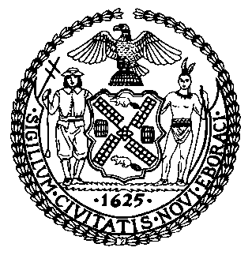 | The Council of the City of New York  Finance Division  Latonia Mckinney, Director  Fiscal Impact Statement  Proposed Int. No. 2068-A  Committee: Cultural Affairs, Libraries and International Intergroup Relations
Title: A Local Law in relation to the temporary use of outdoor space for artistic and cultural events | Sponsors: By Council Members Van Bramer, Cumbo, Reynoso, Kallos, Rose, Menchaca, Powers, Lancman, Cabrera, Vallone, Holden, Salamanca, Gjonaj, Chin, Cornegy, Rosenthal, Adams, Lander and Levine
Summary of Legislation: Proposed Int. No. 2068-A would require the City to create an “Open Culture” program that would allow eligible art and cultural institutions or cultural venues to use approved open space for artistic or cultural events. The Mayor’s Office of Citywide Event Coordination and Management (CECM), in consultation with the Department of Transportation (DOT), the Department of Buildings (DOB), the Police Department (NYPD), the Fire Department (NYFD), and any other agency designated by the Mayor, would establish the program by March 1, 2021. There would be an application fee of $20 for participation in the program and the DOT would be required to share a list of eligible open spaces by February 1, 2021. The program would remain in effect until October 31, 2021, with the possibility of extension, but it would expire by March 31, 2022.
Effective Date: This local law would take effect immediately and will expire and be deemed repealed on March 31, 2022.

Fiscal Year In Which Full Fiscal Impact Anticipated: Fiscal 2022
Fiscal Impact Statement:

 | Effective FY21 | FY Succeeding  Effective FY22 | Full Fiscal  Impact FY22
Revenues (+) | $0 | $0 | $0
Expenditures (-) | $0 | $0 | $0
Net | $0 | $0 | $0

Impact on Revenues: It is anticipated that the impact on revenue would be de minimis. The revenue generated from the $20 application fee would offset the loss of revenue from the permit application fees.

Impact on Expenditures: It is estimated that there would be no fiscal impact on expenditures resulting from the enactment of this legislation as the designated agencies would use existing resources to fulfill its requirements.
Source of Funds To Cover Estimated Costs: N/A
Source of Information: New York City Council Finance Division
Estimate Prepared by: Aliya Ali, Principal Financial Analyst

Estimate Reviewed by: Stephanie Ruiz, Assistant Counsel
Nathan Toth, Deputy Director
Crilhien Francisco, Unit Head
Legislative History: This legislation was introduced to the Council on August 27, 2020 as Int. No. 2068, and was referred to the Committee on Cultural Affairs, Libraries and International Intergroup Relations (Committee). A hearing was held by the Committee jointly with the Committee on Economic Development on September 24, 2020, and the legislation was laid over. The legislation was subsequently amended and the amended version, Proposed Int. No. 2068-A, will be voted on by the Committee at a hearing on December 10, 2020. Upon successful vote by the Committee, Proposed Int. No. 2068-A will be submitted to the full Council for a vote on December 10, 2020.
Date Prepared: December 7, 2020

