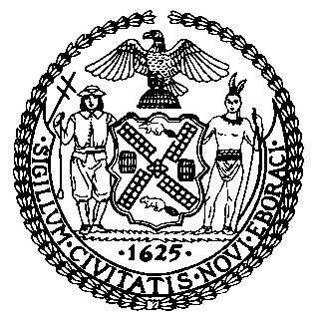 | The Council of the City of New York  Finance Division  Latonia Mckinney, Director  Fiscal Impact Statement  Proposed Int. No: 371-B  Committee: Women
Title: A Local Law to amend the administrative code of the city of New York, in relation to outreach to help cosmetologists recognize signs of domestic violence in their clients | Sponsors: Council Members Salamanca, Jr., Brannan, Rosenthal, Gibson, Kallos, and Cumbo
Summary of Legislation: Proposed Int. No. 371-B would require the Mayor’s Office to End Gender-Based Violence (“ENDGBV”) to conduct regular outreach to cosmetologists that includes: trainings, an online toolkit to help them recognize the signs of domestic violence, and offer information to cosmetologists on resources that are available for survivors across all five boroughs with the intention of relaying this information to their clients. This legislation would also require ENDGBV to submit a report to the Mayor and the Speaker of the Council no later than November 1, 2019, and annually thereafter, and to make public on their website information about outreach activities.

Effective Date: This local law would take effect 120 days after it becomes law.
Fiscal Year In Which Full Fiscal Impact Anticipated: Fiscal 2019
Fiscal Impact Statement:

 | Effective FY19 | FY Succeeding Effective FY20 | Full Fiscal Impact FY20
Revenues | $0 | $0 | $0
Expenditures | $0 | $0 | $0
Net | $0 | $0 | $0

Impact on Revenues: It is anticipated that there would be no impact on revenues resulting from the enactment of this legislation.
Impact on Expenditures: It is anticipated that there would be no impact on expenditures resulting from the enactment of this legislation because The Mayor’s Office to ENDGBV could utilize existing resources to implement the requirements of this legislation.
Source of Funds To Cover Estimated Costs: N/A
Source of Information: City Council Finance Division
Estimate Prepared by: Monica Pepple, Financial Analyst
Estimate Reviewed by: Regina Poreda Ryan, Deputy Director
Eisha Wright, Unit Head
Stephanie Ruiz, Assistant Counsel

Legislative History: This legislation was introduced to the Council as Int. No. 371 on January 31, 2018 and was referred to the Committee on Women (“Committee”). This legislation was subsequently amended and the amended version, Int. No. 371-A, was heard at a hearing held by the Committee on October 24, 2018 and the legislation was laid over. Subsequently, this legislation was amended and the amended legislation, Proposed Int. No. 371-B, will be considered by the Committee on January 23, 2019. Upon a successful vote by the Committee, Proposed Int. No. 371-B will be submitted to the full Council for a vote on January 24, 2019.
Date Prepared: January 17, 2019

