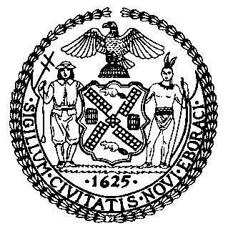 | The Council of the City of New York  Finance Division  Latonia McKinney, Director  Fiscal Impact Statement  Proposed Intro. No: 572-A  Committee: General Welfare
Title: A local law to amend the administrative code of the city of New York, in relation to requiring the department of homeless services to post shelter census data | Sponsors: Council Members Crowley, Cabrera, Eugene, Gentile, Koo, Miller, Johnson, Cohen, Cornegy, Mealy, Mendez, Maisel, King, Vallone, Constantinides, Menchaca and Ulrich
Summary of Legislation: Proposed Int. 572-A would require the department of Homeless Services (DHS) to post a daily report on its website with information on the daily shelter census no later than January 31, 2018, and every weekday, Monday through Friday, thereafter. This information would include the total number of individuals in shelter broken down by the number of single adults, children, the number of families with children, and the number of adult families in the shelter system.

Effective Date: This local law would take effect immediately.

Fiscal Year In Which Full Fiscal Impact Anticipated: Fiscal 2019
Fiscal Impact Statement:

 | Effective FY18 | FY Succeeding Effective FY19 | Full Fiscal Impact FY19
Revenues | $0 | $0 | $0
Expenditures | $0 | $0 | $0
Net | $0 | $0 | $0

Impact on Revenues: It is anticipated that there would be no impact on revenues resulting from this legislation.

Impact on Expenditures: It is anticipated that there would be no impact on expenditures resulting from the enactment of this legislation because DHS already collects the aforementioned information and can use existing resources to implement the provisions of this local law.

Source of Funds To Cover Estimated Costs: N/A
Source of Information: New York City Council Finance Division
Estimate Prepared By: Nameera Nuzhat, Financial Analyst

Estimate Reviewed By: Regina Poreda Ryan, Deputy Director
Rebecca Chasan, Counsel
Dohini Sompura, Unit Head
Legislative History: This legislation was introduced to the Council on December 8, 2014 as Intro. No. 572 and was referred to the Committee on General Welfare. The Committee on General Welfare considered the legislation at a hearing held jointly with the Committee on Education on October 11, 2017, and the legislation was laid over. The legislation was subsequently amended and the amended version, Proposed Intro. No. 572-A, will be voted on by the Committee on General Welfare at a hearing on December 18, 2017. Upon successful vote by the Committee, Proposed Intro. No. 572-A will be submitted to the full Council for a vote on December 19, 2017.
Date Prepared: December 13, 2017

