Committee on Cultural Affairs, Libraries and
International Intergroup Relations
Brenda McKinney, Counsel
Cristy Dwyer, Legislative Policy Analyst
Aliya Ali, Principal Financial Analyst

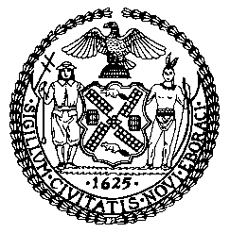

The Council of the City of New York

COMMITTEE REPORT OF THE HUMAN SERVICES DIVISION
Jeffrey Baker, Legislative Director
Andrea Vazquez, Deputy Director for Human Services

COMMITTEE ON CULTURAL AFFAIRS, LIBRARIES

AND INTERNATIONAL INTERGROUP RELATIONS

Hon. Jimmy Van Bramer, Chair

July 28, 2020

INT. NO. 1967-A: | By Council Members Cumbo,Van Bramer, Kallos, Brannan, Perkins, Ayala, Rose, Gibson, Louis, Barron, Chin and Vallone
TITLE: | A Local Law in relation to requiring the department of cultural affairs to publish information on COVID-19 reopening plans and resources for art and cultural institutions in New York city
ADMINISTRATIVE CODE: | None.
- INTRODUCTION
On Tuesday, July 28, 2020, the Committee on Cultural Affairs, Libraries and International Intergroup Relations, chaired by Council Member Jimmy Van Bramer, held a hearing to consider Introduction No. 1967-A, sponsored by Council Member Cumbo, related to requiring the department of cultural affairs to publish information on COVID-19 reopening plans and resources for art and cultural institutions in New York city. The first hearing on this legislation was held on Monday, June 22, 2020. Representatives of the Department of Cultural Affairs (DCLA) testified, in addition to advocacy groups, various arts and cultural organizations, and other interested stakeholders.
Update
On Tuesday, July 28, 2020, the Committee on Cultural Affairs, Libraries and International Intergroup Relations adopted this local law by a vote of five in the affirmative, zero in the negative, and zero abstentions.

- BACKGROUND
COVID-19
On February 11, 2020, the World Health Organization (WHO) announced an official name for the disease that is causing the current novel coronavirus outbreak: coronavirus disease 2019, abbreviated as COVID-19. The first confirmed case in New York State (NYS) was identified on March 1, 2020, in the borough of Manhattan in New York City (NYC). According to data provided by the NYS Department of Health, as of June 4, 2020, there have been a total of 374,085 positive cases in NYS and 24,079 fatalities in NYS since the onset of the pandemic. On March 7, 2020, New York’s Governor Andrew M. Cuomo issued Executive Order Number 202, declaring a state disaster emergency for the entire state.
Closing Cultural Institutions
On March 12, 2020, in response to COVID-19 and in an effort to curb the spread of the disease, Governor Cuomo barred gatherings of more than 500 people and placed restrictions on other gatherings, prompting Broadway to close all 31 of its current shows and NYC’s cultural institutions—including the Metropolitan Museum of Art (The Met), the Museum of Modern Art (MoMA), the Whitney Museum of American Art, the Guggenheim, the Metropolitan Opera, Carnegie Hall and the NY Philharmonic—which shut their doors and postponed all programming. In a press conference the same day, NYC Mayor Bill de Blasio stressed the importance of the restrictions, which he conveyed as “difficult but necessary.”
While many performance spaces had already closed in Asia and Europe, also due to COVID-19, venues across the United States followed NYC’s lead—with theaters from Los Angeles’s famed Center Theater Group to the Kennedy Center in Washington, DC —and large concert organizers like Live Nation Entertainment and AEG Presents suspending all national tour engagements, including the California music festival Coachella. On March 20, 2020, Governor Cuomo announced an executive order creating "New York State on PAUSE" restrictions, an effort assure uniform safety for the state. This 10-point policy plan included a new directive that all non-essential businesses statewide close in-office personnel functions, and temporarily banned all non-essential gatherings of individuals of any size for any reason, resulting in a de-facto shelter in place order. At the same time, museums began pivoting to provide programming, materials and concerts online, with artists, institutions, cultural groups and galleries exploring creative ways to keep people engaged with art, culture and commerce while observing safety precautions.

The Economic Impact of Cultural Closures and Uncertainty Around Returning from PAUSE
The cultural sector in NYC is one of the largest industries in NYC, employing nearly 400,000 workers, paying them $31 billion in wages and generating $110 billion in economic activity. Last year the theater industry in NYC alone grossed $1.8 billion and drew 14.8 million patrons, while the dance sector contributed over $300 million to the City's economy. In NYS, the cultural sector as a whole contributes more than $120 billion to the economy annually.
The economic impact of this mandatory shutdown has been unlike any in recent history. The pandemic also has not hit all industries equally (see Figure 1).
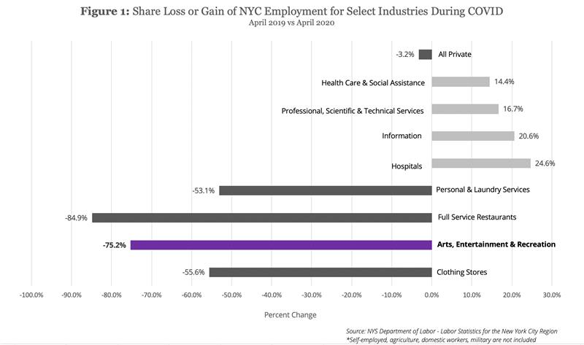
As seen in Figures 2 and 3, the arts and cultural communities, in particular, have been disproportionately and negatively impacted by the COVID-19 pandemic, as compared with other sectors. In fact, recent data suggests that the arts and cultural sector in NYC has been the second hardest hit industry with regard to job loss, after restaurants, losing 67,200 jobs in April alone.

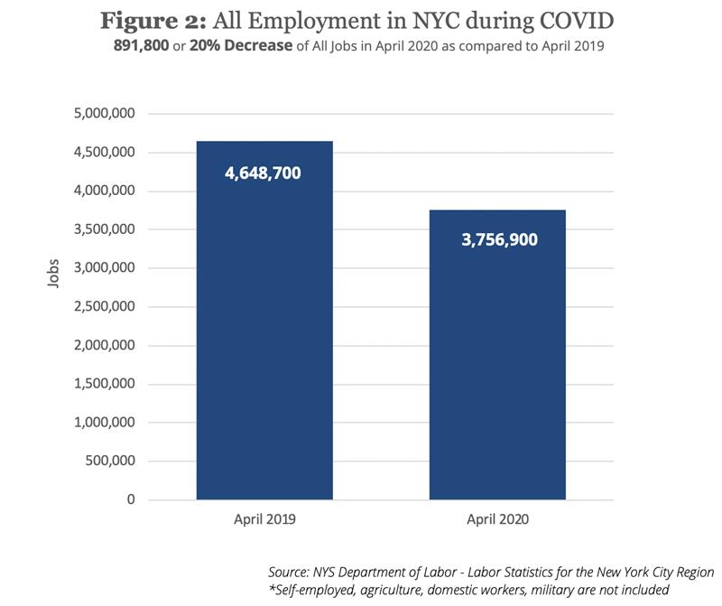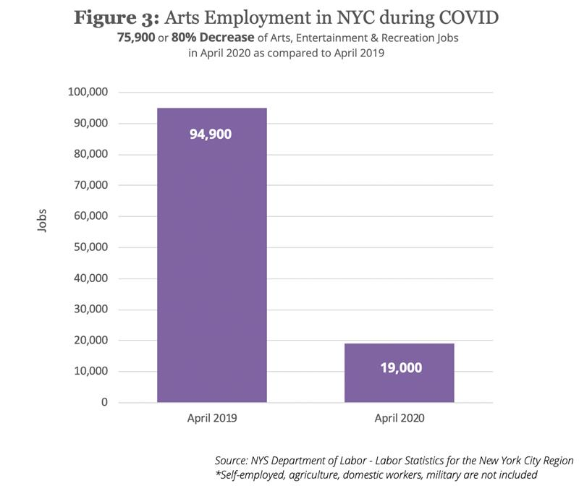
Further, early financial loss projections for the sector were projected to be over $600 million, a number that has likely grown.
When cultural institutions closed their doors in March 2020, the City’s artists, actors, musicians, stagehands and freelancers suddenly found themselves unemployed and severed from their communities and livelihoods. No institution or employer was immune. On March 19th, the Metropolitan Opera laid off all of its union employees and on March 31st, The Met announced it would look at its $3.6 billion endowment to cover costs and maintain employees, something the museum had not previously done, even during World Wars, 9/11 or Hurricane Sandy. By early April, the Queens Museum had laid off 30 employees, the Whitney Museum of Art laid off 20 percent of its staff and other institutions expressed they may have to lay off staff – in some cases by up to 68 percent. Further, while some institutions have asked staff to take pay cuts to postpone lay-offs, cultural organizations of all types and sizes have expressed the difficulty of planning given the uncertain timeframe and effects of the pandemic. In fact, while culture was one of the first sectors to close, cultural institutions are currently not slated to re-open until the final phase of the State’s reopening plan, or Phase 4.
It also remains unclear how groups within the arts and cultural community will need to adapt to safety precautions, including with regard to adhering to social-distancing procedures in theaters, which some institutions have said creates a possibility that some groups will never recover. Additionally, while NYC and NYS are considering plans for reopening, there is currently a lack of representation from sections of the cultural community. Both the City’s Advisory Council on Arts, Culture and Tourism, formed by Mayor de Blasio to consider a sector recovery plan, as well as the State-level “New York Forward” advisory board do not include comprehensive representation.
Strategies for Re-Opening and Assistance from DCLA and Other Sources
During this time of uncertainty, federal, state, and local government have provided some, albeit limited, support to struggling institutions, while cultural groups have come together to support each other in unprecedented ways. On March 27, 2020, Congress passed a $2.2 trillion emergency relief package designed to support the U.S. economy and to help communities contend with the COVID-19 outbreak. Recognizing that the arts community is struggling, the federal relief package appropriated $75 million to the National Endowment for the Arts, of which 40 percent is directed to state and regional arts organizations. Other provisions within the bill that could benefit cultural organizations include loan forgiveness for companies that retain workers and an expansion of unemployment benefits. In addition, NYS and various philanthropic organizations have also provided funding opportunities, while others have compiled comprehensive lists of COVID-19 resources for members of the arts and cultural community.
On March 13, 2020, DCLA and the leaders of the Cultural Institutions Group (CIG) began convening daily calls to discuss concerns and responses to the COVID-19 crisis. The calls, hosted by CIG representatives, were quickly opened to the wider cultural community and now consist of over 200 individuals and organizations that meet daily. The group continues to discuss funding, advocacy and ongoing issues related to issues like insurance and technical support. This daily “Culture @3” group has also created volunteer working groups, within the larger group of regular attendees, which track and provide regular updates on various issues areas, including those related to: (1) city & state advocacy, (2) federal advocacy, (3) communications and messaging, (4) data collection, (5) employment / HR, (6) corporate and foundation support, (7) insurance, (8) online programming, (9) diversity and (10) re-opening plans. Despite this community engagement and aid, cultural leaders and advocates have expressed concern related to financial uncertainty and the unprecedented nature of this period, stressing that the field will likely face challenges beyond the end of the pandemic.

- Int. No. 1967-A
Int. No. 1967-A would require the Department of Cultural Affairs (DCLA) to publish information and resources related to art and cultural institutions affected by COVID-19 on its website, including information related to: federal/state/city/union requirements and guidelines related to COVID-19; guidance on where to direct questions about guidelines; resources known to the department related to financial support; guidance and resources relating to alternative uses for space that art and cultural institutions will not utilize when reopening; strategies for the development and continuation of digital platforms and remote programming; sample reopening plans; and any other information deemed by the department to be relevant.
Section two of Int. No. 1967-A would provide that the local law take effect immediately after it becomes law, except that the commissioner of cultural affairs may take such measures as are necessary for the implementation of this local law, including the promulgation of rules, before such date.
Since introduction, Int. No. 1967-A was amended to clarify several definitions, required DCLA to post information and resources online, rather than issue a one-time report on reopening plans, and to change the enactment date of the legislation from 60 days from the effective date of the local law to immediately. The legislation was also amended to change the information and resources that DCLA must provide under the requirements of the proposed law, including: (1) that rather than providing information related to steps institutions should take for reopening and on how guidelines should be incorporated into reopening plans, DCLA would be required to provide COVID-19-related guidelines at different levels and information on where to find more guidance on conflicts between various guidelines; (2) to clarify that the resources and information does not only relate to a post-COVID-19 setting but to guidance during the pandemic; (3) that strategies related to digital platforms and remote programming should relate to both continuing but also developing remote digital programming; and (4) that DCLA would not be required to create sample plans and would only endeavor to include at least plans from certain categories.

Int. No. 1967-A

By Council Members Cumbo, Van Bramer, Kallos, Brannan, Perkins, Ayala, Rose, Gibson, Louis and Barron

A LOCAL LAW

In relation to requiring the department of cultural affairs to publish information on COVID-19 reopening plans and resources for art and cultural institutions in New York city

Be it enacted by the Council as follows:
Section 1. Posting of COVID-19 reopening plans and resources for art and cultural institutions. a. Definitions. For purposes of this local law, the following terms have the following meanings:
Art and cultural institution. The term “art and cultural institution” means any not-for-profit art or cultural group, organization, gallery, venue or institution within the city of New York that receives funding from the department.
Commissioner. The term “commissioner” means the commissioner of cultural affairs.
COVID-19. The term “COVID-19” means the disease caused by the severe acute respiratory syndrome coronavirus 2 (SARS-CoV-2).
Department. The term “department” means the department of cultural affairs.
Reopening plans. The term “reopening plans” means plans or protocols related to the opening of art and cultural institutions that were ordered closed due to the state disaster emergency declared by the governor of the state of New York in executive order number 202, dated March 7, 2020, as amended and extended.
Close high-risk interactive exhibit. The term “close high-risk interactive exhibit” means an exhibit within an art and cultural institution that encourages patrons or visitors to touch or wear objects.
b. The department shall post on its website information related to reopening plans and other resources for art and cultural institutions affected by COVID-19. Such information shall include, but not be limited to:
1. Information on federal, state, city and union requirements and guidelines related to preventing the spread of COVID-19, including information on where art and cultural institutions can direct questions relating to such requirements and guidelines;
2. Resources known to the department relating to federal, state and city financial support available to art and cultural institutions affected by COVID-19, including, but not limited to, funding sources and rent-relief programs;
3. Guidance and resources relating to alternative uses for space that art and cultural institutions will not utilize when reopening;
4. Information on strategies for the development and continuation of digital platforms and remote programming;
5. Any sample reopening plans made available to the department by the New York state department of health or any art and cultural institution, provided that the department shall redact any identifying information of such institution, unless such institution has made such reopening plan publicly available or consents to publication by the department without such redaction. The department shall endeavor to include a reopening plan for at least each of the following types of art and cultural institutions: (i) museum, (ii) museum with one or more close high-risk interactive exhibits, including children’s museums or science museums; (iii) arts education organization; (iv) theater or performance venue; (v) dance organization; (vi) garden or outdoor venue; and (vii) historical site. Any such reopening plans shall take into account relevant differences between such types of institutions, including size; and
6. Any other information deemed by the department to be relevant to reopening plans for art and cultural institutions.
§ 2. This local law takes effect immediately, except that the commissioner of cultural affairs may take such measures as are necessary for the implementation of this local law, including the promulgation of rules, before such date.

BM
LS # 14989
7/20/20 5:00pm

United States Centers for Disease Control and Prevention (hereinafter “CDC”), Frequently Asked Questions, available at https://www.cdc.gov/coronavirus/2019-ncov/faq.html#Coronavirus-Disease-2019-Basics (explaining that the disease originated in Wuhan, China and that scientists believe that COVID-19 is spread from human to human through the respiratory tract when a person coughs or sneezes).
Melanie West, First Case of Coronavirus Confirmed in New York State, Wall Street Journal (Mar. 1, 2020), available at https://www.wsj.com/articles/first-case-of-coronavirus-confirmed-in-new-york-state-11583111692.
See New York State Department of Health COVID-19 Tracker, available at https://covid19tracker.health.ny.gov/views/NYS-COVID19-Tracker/NYSDOHCOVID-19Tracker-Map?%3Aembed=yes&%3Atoolbar=no&%3Atabs=n.
See New York State Department of Health COVID-19 Fatality Tracker, available at https://covid19tracker.health.ny.gov/views/NYS-COVID19-Tracker/NYSDOHCOVID-19Tracker-Fatalities?%3Aembed=yes&%3Atoolbar=no&%3Atabs=n.
See No. 202.31: Continuing Temporary Suspension and Modification of Laws Relating to the Disaster Emergency (May 14, 2020), available at https://www.governor.ny.gov/news/no-20231-continuing-temporary-suspension-and-modification-laws-relating-disaster-emergency.
Jesse McKinley and Michael Gold, Ban on Large Gatherings in N.Y. as Coronavirus Cases Rise Sharply (Mar. 12, 2020), available at https://www.nytimes.com/2020/03/12/nyregion/coronavirus-nyc-event-ban.html; See Executive Order 202.31 (May 14, 2020), available at https://www.governor.ny.gov/news/no-20231-continuing-temporary-suspension-and-modification-laws-relating-disaster-emergency (describing previous orders); Michael Paulson, Broadway, Symbol of New York Resilience, Shuts Down Amid Virus Threat (Mar. 12, 2020), available at https://www.nytimes.com/2020/03/12/theater/coronavirus-broadway-shutdown.html,
Robin Pogrebin and Michael Cooper, New York’s Major Cultural Institutions Close in Response to Coronavirus (Mar. 12, 2020), available at https://www.nytimes.com/2020/03/12/arts/design/met-museum-opera-carnegie-hall-close-coronavirus.html.
Transcript: Mayor de Blasio Holds Media Availability on COVID-19 (Mar. 12, 2020), available at https://www1.nyc.gov/office-of-the-mayor/news/137-20/transcript-mayor-de-blasio-holds-media-availability-covid-19 (“That’s really, really painful for the many, many people who work in that field, let alone so many New Yorkers and people all over the country who really look forward to these events, these concerts, these sports events, and it’s really going to be kind of a hole in our lives and it’s painful,” he said. “It’s not something we would ever want to do but it’s something we have to do.”); Michael Paulson, Broadway, Symbol of New York Resilience, Shuts Down Amid Virus Threat (Mar. 12, 2020), available at https://www.nytimes.com/2020/03/12/theater/coronavirus-broadway-shutdown.html,
Ben Sisario, Coachella, Influential Music Festival, Is Postponed Amid Virus Fears (Mar. 10, 2020), available at https://www.nytimes.com/2020/03/10/arts/music/coronavirus-coachella-postponed.html,
BWW News Desk, All CTGLA Theatre Closed (Mar. 12, 2020), available at https://www.broadwayworld.com/article/All-CTGLA-Theatre-Closed-Over-COVID19-Concerns-20200312,
Jane Recker, The Kennedy Center is Closing Through March 31 (Mar. 12, 2020), available at https://www.washingtonian.com/2020/03/12/the-kennedy-center-is-closing-through-march-31/,
Michael Paulson, Broadway, Symbol of New York Resilience, Shuts Down Amid Virus Threat (Mar. 12, 2020), available at https://www.nytimes.com/2020/03/12/theater/coronavirus-broadway-shutdown.html,
Ben Sisario, Coachella, Influential Music Festival, Is Postponed Amid Virus Fears (Mar. 10, 2020), available at https://www.nytimes.com/2020/03/10/arts/music/coronavirus-coachella-postponed.html,
Governor Cuomo Signs the ‘New York State on PAUSE’ Executive Order (Mar. 20, 2020), available at https://www.governor.ny.gov/news/governor-cuomo-signs-new-york-state-pause-executive-order.
See New York State on Pause, available at https://coronavirus.health.ny.gov/new-york-state-pause
Governor Cuomo Signs the ‘New York State on PAUSE’ Executive Order (mar. 20, 2020), available at https://www.governor.ny.gov/news/governor-cuomo-signs-new-york-state-pause-executive-order.
Information shared during the daily “Culture @3” call, hosted by the CIG; See NYC City & Co., VirtualNYC (n.d.), available at https://www.nycgo.com/virtual-nyc/.
Information shared during the daily “Culture @3” call, hosted by the CIG; See Judd Grossman, Michael Straus, Catherine K. B. Lucas and Sarah E. Schuster, What Legal Rights Do Artists and Galleries Have During a Pandemic? (May 13, 2020), available at https://www.artnews.com/art-news/news/artists-galleries-legal-rights-coronavirus-1202687028/.
NYC Comptroller Scott Stringer, The Creative Economy: Art, Culture and Creativity in New York City (Oct. 25, 2019), available at https://comptroller.nyc.gov/reports/the-creative-economy/.
NYC Comptroller Scott M. Stringer, New York by the Numbers: Weekly Economic and Fiscal Outlook (May 26, 2020), available at https://comptroller.nyc.gov/newsroom/new-york-by-the-numbers-weekly-economic-and-fiscal-outlook-no-2-may-26-2020/.
Broadway’s Box Office Keeps Booming. Now Attendance is Surging, Too. (May 29, 2019), available at https://www.nytimes.com/2019/05/29/theater/broadway-box-office.html.
Dance NYC and New York City Dance Makers and Organizations, Letter to Mayor Bill de Blasio RE: Advisory Council on Arts, Culture, and Tourism (May 13, 2020), available at https://www.dance.nyc/news/2020/05/Letter-to-Mayor-Bill-de-Blasio-Re-Advisory-Council-on-Arts-Culture-and-Tourism/.
National Assembly of Art Organizations, Creative Economy State Profiles: New York (n.d.), available at https://nasaa-arts.org/nasaa_research/creative-economy-state-profiles/; National Endowment for the Arts, State-Level Estimates of the Arts’ Economic Value and Employment (2001-2017) (Mar. 2020), available at https://www.arts.gov/artistic-fields/research-analysis/arts-data-profiles/arts-data-profile-25.
Abigail Savitch-Lew, Eli Dvorkin, and Laird Gallagher, Art in the Time of Coronavirus: NYC’s Small Arts Organizations Fighting for Survival (April 2020), available at https://nycfuture.org/research/art-in-the-time-of-coronavirus.
NYC Comptroller Scott M. Stringer, New York by the Numbers: Weekly Economic and Fiscal Outlook (May 26, 2020), available at https://comptroller.nyc.gov/newsroom/new-york-by-the-numbers-weekly-economic-and-fiscal-outlook-no-2-may-26-2020/ (explaining that “private employers in New York City shed 823,500 jobs in April – one in every five private sector jobs; dine-in restaurants were the hardest hit, dropping by 119,000 jobs – an 85% decline in a single month; and the arts, entertainment and recreation sector saw the largest decline after restaurants, losing 67,200 jobs, or 78%”).
Information shared during the daily “Culture @3” call, hosted by the CIG; See New Yorkers for Culture and Arts, Impact of COVID19 on NYC Art and Culture - Impact Survey Results (Mar. 17, 2020), available at https://drive.google.com/file/d/1NleKgGanBWNq2mB1mXUt83rcBesDUfGx/view; Sarah Cascone, In a Surprise Move, the Metropolitan Museum of Art Is Looking to Its $3.6 Billion Endowment to Cover Costs (Mar. 31, 2020), available at https://news.artnet.com/art-world/met-endowment-paying-staff-1820772.
Information shared during the daily “Culture @3” call, hosted by the CIG.
See, e.g., Peter Marks and Geoff Edgers, New York is one of the world’s great cities for the arts — but the damage from the pandemic is proving to be catastrophic (Mar. 31, 2020), available at https://www.washingtonpost.com/entertainment/theater_dance/new-york-is-one-of-the-worlds-great-cities-for-the-arts-but-the-damage-from-the-pandemic-is-proving-to-be-catastrophic/2020/03/31/b0f300f4-71e5-11ea-85cb-8670579b863d_story.html.
Anastasia Tsioulcas for NPR, Tweet: https://twitter.com/anastasiat/status/1240645951309701120?s=21.
Sarah Cascone, In a Surprise Move, the Metropolitan Museum of Art Is Looking to Its $3.6 Billion Endowment to Cover Costs (Mar. 31, 2020), available at https://news.artnet.com/art-world/met-endowment-paying-staff-1820772.
Information shared during the daily “Culture @3” call, hosted by the CIG.
Information shared during the daily “Culture @3” call, hosted by the CIG.
Id.
Robin Pogrebin and Michael Cooper, New York’s Major Cultural Institutions Close in Response to Coronavirus (Mar. 12, 2020), available at https://www.nytimes.com/2020/03/12/arts/design/met-museum-opera-carnegie-hall-close-coronavirus.html?action=click&module=RelatedLinks&pgtype=Article.
According to April 2020 research by the Center for an Urban Future (CUF), nearly “all small and mid-sized arts organizations [in NYC] are facing slashed budgets and reduced staffing, and many are teetering on the brink of insolvency.” Abigail Savitch-Lew, Eli Dvorkin, and Laird Gallagher, Art in the Time of Coronavirus: NYC’s Small Arts Organizations Fighting for Survival (April 2020), available at https://nycfuture.org/research/art-in-the-time-of-coronavirus.
New York Forward: A Guide to Re-Opening New York & Building Back Better (May 2020), available at https://www.governor.ny.gov/sites/governor.ny.gov/files/atoms/files/NYForwardReopeningGuide.pdf.
See, e.g., Julia Jacobs, Poll Shows One Hurdle to Reopening Broadway: Fear of Jerks (May 26, 2020), available at https://www.nytimes.com/2020/05/26/theater/broadway-coronavirus-poll.html.
Abigail Savitch-Lew, Eli Dvorkin, and Laird Gallagher, Art in the Time of Coronavirus: NYC’s Small Arts Organizations Fighting for Survival (April 2020), available at https://nycfuture.org/research/art-in-the-time-of-coronavirus; Peter Marks and Geoff Edgers, New York is one of the world’s great cities for the arts — but the damage from the pandemic is proving to be catastrophic (Mar. 31, 2020), available at https://www.washingtonpost.com/entertainment/theater_dance/new-york-is-one-of-the-worlds-great-cities-for-the-arts-but-the-damage-from-the-pandemic-is-proving-to-be-catastrophic/2020/03/31/b0f300f4-71e5-11ea-85cb-8670579b863d_story.html.
See Letter to Mayor Bill de Blasio, Re: Advisory Council on Arts, Culture, and Tourism, available at https://www.dance.nyc/news/2020/05/Letter-to-Mayor-Bill-de-Blasio-Re-Advisory-Council-on-Arts-Culture-and-Tourism/.
This includes any representation from the dance community. See Alejandra O'Connell-Domenech, Mayor announces more sector advisory councils to help reopening and recovery from COVID-19 pandemic (May 2020), available at https://www.amny.com/coronavirus/mayor-announces-more-sector-advisory-councils-to-help-reopening-and-recovery-from-covid-19-pandemic/.
Governor Cuomo released the names of over 100 individuals who will serve on an advisory board that will help shape the state’s reopening policy. Advocates have noted the absence of cultural organizations and leaders from the New York Forward Committee. See New York Forward Advisory Board: https://forward.ny.gov/ny-forward-advisory-board; See, e.g., Nicole Goodkind, Governor Andrew Cuomo is relying on the advice of CEOs and billionaires to reopen New York Governor Andrew Cuomo is relying on the advice of CEOs and billionaires to reopen New York (May 12, 2020), available at https://fortune.com/2020/05/12/governor-andrew-cuomo-is-relying-on-the-advice-of-ceos-and-billionaires-to-reopen-new-york/.
Judd Grossman, Michael Straus, Catherine K. B. Lucas and Sarah E. Schuster, What Legal Rights Do Artists and Galleries Have During a Pandemic? (May 13, 2020), available at https://www.artnews.com/art-news/news/artists-galleries-legal-rights-coronavirus-1202687028/.
Jacob Pramuk, Trump Signs $2 Trillion Coronavirus Relief Bill as the US Tries to Prevent Economic Devastation (Mar. 27, 2020), available at https://www.cnbc.com/2020/03/27/house-passes-2-trillion-coronavirus-stimulus-bill-sends-it-to-trump.html; Judd Grossman, Michael Straus, Catherine K. B. Lucas and Sarah E. Schuster, What Legal Rights Do Artists and Galleries Have During a Pandemic? (May 13, 2020), available at https://www.artnews.com/art-news/news/artists-galleries-legal-rights-coronavirus-1202687028/.
Judd Grossman, Michael Straus, Catherine K. B. Lucas and Sarah E. Schuster, What Legal Rights Do Artists and Galleries Have During a Pandemic? (May 13, 2020), available at https://www.artnews.com/art-news/news/artists-galleries-legal-rights-coronavirus-1202687028/.
Judd Grossman, Michael Straus, Catherine K. B. Lucas and Sarah E. Schuster, What Legal Rights Do Artists and Galleries Have During a Pandemic? (May 13, 2020), available at https://www.artnews.com/art-news/news/artists-galleries-legal-rights-coronavirus-1202687028/.
See New York State Council on the Arts, COVID-19 and the Arts (n.d.), available at https://arts.ny.gov.
Judd Grossman, Michael Straus, Catherine K. B. Lucas and Sarah E. Schuster, What Legal Rights Do Artists and Galleries Have During a Pandemic? (May 13, 2020), available at https://www.artnews.com/art-news/news/artists-galleries-legal-rights-coronavirus-1202687028/.
The Cultural Institutions Group (CIG) is a group of 34 institutions throughout the five boroughs that including The Met, MoMA, the Botanic Gardens and the Zoos, that receive 75% of DCLA’s annual operating budget. See NYC Department of Cultural Affairs, Cultural Institutions Group (CIG) (n.d.), available at https://www1.nyc.gov/site/dcla/cultural-funding/city-owned-institutions.page.
Peter Marks and Geoff Edgers, New York is one of the world’s great cities for the arts — but the damage from the pandemic is proving to be catastrophic (Mar. 31, 2020), available at https://www.washingtonpost.com/entertainment/theater_dance/new-york-is-one-of-the-worlds-great-cities-for-the-arts-but-the-damage-from-the-pandemic-is-proving-to-be-catastrophic/2020/03/31/b0f300f4-71e5-11ea-85cb-8670579b863d_story.html; Robin Pogrebin and Michawel Paulson, The Daily Call that 200 Arts Groups Hope Will Help Them Survive (May 12, 2020), available at https://www.nytimes.com/2020/05/12/arts/coronavirus-new-york-culture.html.
Peter Marks and Geoff Edgers, New York is one of the world’s great cities for the arts — but the damage from the pandemic is proving to be catastrophic (Mar. 31, 2020), available at https://www.washingtonpost.com/entertainment/theater_dance/new-york-is-one-of-the-worlds-great-cities-for-the-arts-but-the-damage-from-the-pandemic-is-proving-to-be-catastrophic/2020/03/31/b0f300f4-71e5-11ea-85cb-8670579b863d_story.html; Robin Pogrebin and Michawel Paulson, The Daily Call that 200 Arts Groups Hope Will Help Them Survive (May 12, 2020), available at https://www.nytimes.com/2020/05/12/arts/coronavirus-new-york-culture.html.
Peter Marks and Geoff Edgers, New York is one of the world’s great cities for the arts — but the damage from the pandemic is proving to be catastrophic (Mar. 31, 2020), available at https://www.washingtonpost.com/entertainment/theater_dance/new-york-is-one-of-the-worlds-great-cities-for-the-arts-but-the-damage-from-the-pandemic-is-proving-to-be-catastrophic/2020/03/31/b0f300f4-71e5-11ea-85cb-8670579b863d_story.html; Robin Pogrebin and Michawel Paulson, The Daily Call that 200 Arts Groups Hope Will Help Them Survive (May 12, 2020), available at https://www.nytimes.com/2020/05/12/arts/coronavirus-new-york-culture.html.
Information shared during the daily “Culture @3” call, hosted by the CIG; Peter Marks and Geoff Edgers, New York is one of the world’s great cities for the arts — but the damage from the pandemic is proving to be catastrophic (Mar. 31, 2020), available at https://www.washingtonpost.com/entertainment/theater_dance/new-york-is-one-of-the-worlds-great-cities-for-the-arts-but-the-damage-from-the-pandemic-is-proving-to-be-catastrophic/2020/03/31/b0f300f4-71e5-11ea-85cb-8670579b863d_story.html; Robin Pogrebin and Michawel Paulson, The Daily Call that 200 Arts Groups Hope Will Help Them Survive (May 12, 2020), available at https://www.nytimes.com/2020/05/12/arts/coronavirus-new-york-culture.html.
Information shared during the daily “Culture @3” call, hosted by the CIG.

